

ASHLEY COUNTY MEDICAL CENTER
ACMC FAMILY HOME HEALTH
ASHLEY FAMILY CLINIC
ASHLEY HEALTH SERVICES
FAMILY CLINIC OF ASHLEY COUNTY
HAMBURG HEALTH CLINIC

2021

EMERGENCY PREPAREDNESS MANUAL

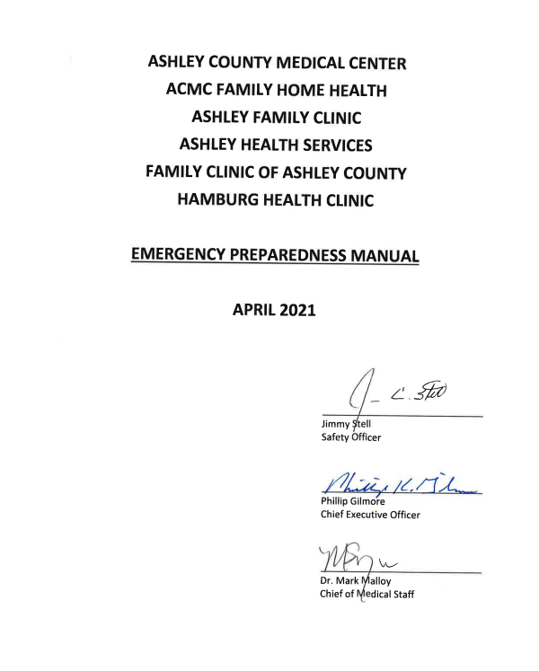

EMERGENCY PREPAREDNESS MANUAL

TABLE OF CONTENTS

0.10 NIMS Compliance

0.20 Emergency Codes

CASCADE CALL

1.00 Hospital-Wide Cascade Call System

1.50 Emergency Phone Numbers

MEDIA COVERAGE

2.00 Media Coverage in Emergency Situations

EVACUATION PLAN

3.00 Evacuation Plan

FIRE ZONES & PLANS

4.00 Fire Zone Locations & Evacuation Exits

4.01 Fire Zone Map

4.02 Location of Fire Extinguishers

4.03 Oxygen Shut-Off Locations

4.10 Employee Discovering a Fire, or Sign of Fire

4.20 Special Assignments for Managing Fire/Suspected Fire

4.30 General Employee Duties in a Fire

DEPARTMENT SPECIFIC RESPONSIBILITIES IN A FIRE/EVACUATION

4.40 Administrative Office

4.41 Admitting/Financial Counseling

4.42 Accounting Office

4.43 Dietary

4.44 Engineering

4.45 Health Information

4.46 Ashley IOP

4.47 Housekeeping

4.48 Information Management Services

4.49 Laboratory

4.50 Materials Management

4.52 Nursing

4.55 Pharmacy

4.56 Physical Therapy

4.57 Radiology

TABLE OF CONTENTS
CONTINUED

4.58 Respiratory Therapy

4.59 Social Services

4.60 Switchboard

4.61 Utilization Review

4.62 Home Health

INTERRUPTION OF VITAL SERVICES

5.00 Electricity

5.10 Water

5.20 Telephone

INTERNAL DISASTER

6.00 Internal Disaster

6.10 Kidnapping

6.15 Code Purple

6.18 Active Shooter

6.20 Riot Control

6.30 Bomb Threat

6.40 Code Yellow

NUCLEAR/CHEMICAL ACCIDENT

7.00 Nuclear/Chemical Accident

7.50 Bioterrorism Plan

7.60 Point of Distribution (POD) Plan

7.70 Code C – care of Ebola patient

TORNADO/WINDSTORM DISASTER

8.00 Tornado/Windstorm Disaster

8.10 Code White Critique Form

MASS CASUALTY

9.00 Mass Casualty Plan

9.01 Mass Fatality Plan

9.05 Attachment “A”

10.00 Alternate Care Site Plan
TABLE OF CONTENTS
CONTINUED

Home Health

11.00 ACMC Family Home Health Hazard Vulnerability
ACMC Family Home Hazard

11.01 Emergency Operations Plan

11.02 Equipment and Supplies

11.03 Management of Patients During Disaster

11.04 Notification to Patients

11.05 Abbreviated Assessment Tool

11.06 Utility Systems Failure or Disruption

11.07 Communication Processes

11.08 Emergency Management Handout

11.09 Tornado Windstorm for Home Health Building

11.10 Flooding of Roadways

11.11 Winter Weather Management

11.12 Evacuations of Agency

11.13 Contingency Plan in Case of Agency Closure

11.14 Influenza Pandemic Outbreak

11.15 Covid-19 Pandemic

11.16 Fire – Discovering or Sign of Fire

RURAL HEALTH & FAMILY CLINICS EMERGENCY PREPAREDNESS PLAN

12.00 Electrical

12.01 Ice Storm

12.02 Sewer

12.03 Thunderstorm

12.04 Tornado

12.05 Hazard Vulnerability Assessment

SUBJECT: | NIMS COMPLIANCE | FILING #: EMG 0.10
 |  | PAGE: 1
DEPARTMENT: ALL DEPARTMENTS |  | OF: 1
 |  | EFFECTIVE: FEBRUARY 2010
APPROVED BY: SAFETY COMMITTEE |  | REVISED:

Disasters affecting the community will be managed at Ashley County Medical Center in accordance with Incident Command System (ICS) organizational structures, doctrines and procedures. Emergency policies will be National Incident Management System (NIMS) compliant, and employees will be trained according to these guidelines. In the event of a disaster, the Command Center will be located in the Board Room in Administration and will be set up according to NIMS guidelines. ACMC will have written Memorandums of Agreement with other hospitals and organizations that have agreed to provide assistance to ACMC in the event of a disaster.

Communications with County offices, law enforcement, and other hospitals in the Region during a disaster situation may be by AWINS radios, or Tandberg, in addition to telephone. Communications on AWINS radios will be by common language, not radio codes.

All designated employees will receive training in ICS courses.

SUBJECT: | EMERGENCY CODES | FILING #: EMG 0.20
 |  | PAGE: 1
DEPARTMENT: ALL DEPARTMENTS |  | OF: 1
 |  | EFFECTIVE: DECEMBER 2014
APPROVED BY: SAFETY COMMITTEE |  | REVISED:

Emergency Color Code designations for alerting personnel to a situation and minimize anxiety for patients and visitors will be assigned as follows:

CODE BLACK | If Evacuation is necessary
CODE ORANGE | Bomb Threat
CODE RED | Fire or Fire Drill
CODE BLUE | Cardiac Arrest
CODE GREEN | Mass Casualty
CODE PINK | Kidnapping
CODE PURPLE | Combative Patient/Visitor in any area of the Hospital
CODE YELLOW | Generations Escape
CODE WHITE | Tornado Warning
CODE SILVER | Active Shooter
CODE C | Ebola patient

SUBJECT: | CASCADE CALL LIST | FILING #: EMG 1.00
 |  | PAGE: 1
DEPARTMENT: ALL DEPARTMENTS |  | OF: 1
 |  | EFFECTIVE:
APPROVED BY: SAFETY COMMITTEE |  | REVISED: 5/20/2021

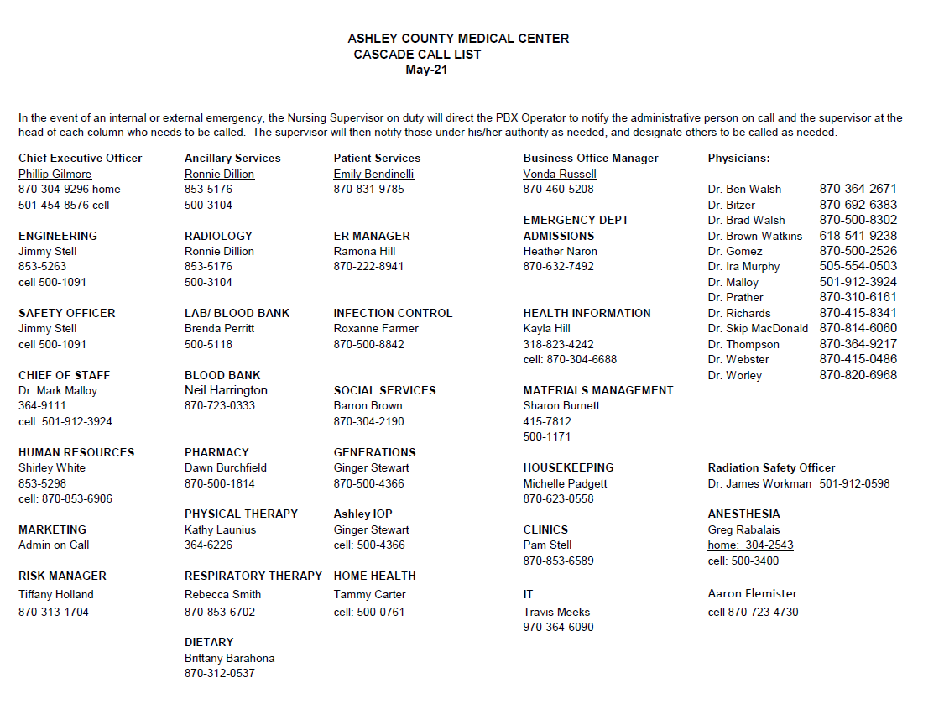

SUBJECT: | EMERGENCY PHONE NUMBERS | FILING #: EMG 1.50
 |  | PAGE: 1
DEPARTMENT: ALL DEPARTMENTS |  | OF: 1
 |  | EFFECTIVE: MARCH 2013
APPROVED BY: SAFETY COMMITTEE |  | REVISED:

Phone Numbers Possibly Needed in an Emergency Situation:
Crossett Police Department | (870)-364-4131
Crossett Fire Department | (870)-364-2121
Crossett Ambulance Service | (870)-364-2121
South Ark Ambulance Service | (870)-853-8033
Medical Center of South Arkansas | (870)-864-3200
St. Francis Medical Center (Monroe, LA) | (318)-327-4196
Morehouse General Hospital (Bastrop, LA) | (318)-283-3609
Bradley County Hospital | (870)-226-3731
Drew Memorial Hospital | (870)-367-2411
Chicot Memorial Hospital | (870)-256-5351
Arkansas Children’s Hospital, Little Rock, AR | (501)-370-1100
Air Evac | (800)-247-3822
Pafford Air One | (800)-435-7663
Angel Flight | (800)-372-3637
Baptist Med Flight | (800)-227-1000 or (800)-632-5433
Ashley County OEM (Office of Emergency Management) | day (870)-853-2004 (501)-661-2136
Ashley County Emergency Coordinator (Tawana Miller) | 870-940-0342
National Guard | (870)-364-2023
Sheriff’s office | (870)-853-2040
Ashley County Judge | (870)-853-2000
FBI Field office | (501)-221-9100
Arkansas Dept. of Emergency Management | (870)-853-2070
Local Red Cross Coordinator | (870)-863-8196
Local Red Cross Director Sandy Matheney | (870)-866-5243 (cell)
North Crossett Gas and Water | (870)-364-2188
Ashley County Health Department | (870)-364-2115 or (870)-500-2630
Arkansas State Health Department | (501)-661-2417
CDC Hospital Infections Program | (404)-639-6413
Arkansas Bioterrorism Response Line  After hours and weekends | (501)-280-4817  (800)-554-5738
Bioterrorism Emergency Number | (770)-488-7100
Arkansas Hospital Association | (501)-224-7878

SUBJECT: | MEDIA COVERAGE IN EMERGENCY SITUATIONS | FILING #: EMG 2.00
 | MEDIA COVERAGE IN EMERGENCY SITUATIONS | PAGE: 1
DEPARTMENT: ALL DEPARTMENTS |  | OF: 2
 |  | EFFECTIVE: OCTOBER 2003
APPROVED BY: SAFETY COMMITTEE |  | REVISED:
NO INFORMATION concerning patients or the hospital shall be released during any emergency situations without permission of the hospital CEO or his designee.

- During disasters, general information will be released when possible, to help reduce undue anxiety. (e.g., the number of patients by age group or gender who have been brought to the facility.)

- Before information about a specific patient is released to the media, the patient’s wishes regarding listing in the hospital’s directory will be verified with the Health Information Department, or Nursing.

- If the patient has been unable to state his preference as to listing in the directory due to his medical condition, he/she will not be listed and no personally identifiable information will be released to individuals or the media. Family members may not consent to this, except that a parent may consent for a minor. Personally-identifiable patient information will not be released to the media in disaster situations before next of kin is notified.

- If the patient has not requested that information be withheld, the patient’s location and one-word condition may be released. No information will be released that might embarrass or endanger the patient.

- Inquiries from the media must contain the patient’s name, but inquiries from clergy need not contain the patient’s name.

Definition of Patient Conditions:

- Undetermined: patient awaiting physician assessment

- Good: Vital signs are stable and within normal limits. Patient is conscious and comfortable. Indicators are excellent.

- Fair: Vital signs are stable and within normal limits. Patient is conscious, but may be uncomfortable. Indicators are favorable.

SUBJECT: | MEDIA COVERAGE IN EMERGENCY SITUATIONS | FILING #: EMG 2.00
 | MEDIA COVERAGE IN EMERGENCY SITUATIONS | PAGE: 2
DEPARTMENT: ALL DEPARTMENTS |  | OF: 2
 |  | EFFECTIVE: OCTOBER 2003
APPROVED BY: SAFETY COMMITTEE |  | REVISED:

- Serious: Vital signs may be unstable and not within normal limits. Patient is acutely ill. Indicators are questionable.

- Critical: Vital signs are unstable and not within normal limits. Patient may be unconscious. Indicators are unfavorable.

The term “stable” should not be used in reporting a patient’s condition to the media.

- The following media activities require written authorization from the patient:

- Drafting a detailed statement for approval by the patient or the patient’s legal representative.
- Taking photographs of patients.
- Interviewing patients

- A representative of the Ashley County Medical Center will accompany the media at all times while they are in the hospital. Access to any area of ACMC may be denied to the media if the need arises.

- No information will be released regarding a patient who is being treated for a psychiatric problem, alcohol or substance abuse.

- In matters of public record, news media calls will be directed to the appropriate public authority.

SUBJECT: | EVACUATION PLAN | FILING #: EMG 3.00
 |  | PAGE: 1
DEPARTMENT: ALL DEPARTMENTS |  | OF: 1
 |  | EFFECTIVE: OCTOBER 2010
APPROVED BY: SAFETY COMMITTEE |  | REVISED:
In the event that evacuation of part of the building or all of the building is ordered or necessary, follow the evacuation procedures listed below.

- The decision to evacuate the Hospital will be given from one of the following persons:

ACMC Administrator
Director of Nursing
Maintenance Engineer
Crossett Fire Department
Shift Charge Nurse

- Switchboard Operator will announce “Code Black” 4 times over the PA System.

- First choice of evacuation will be to Ashley Health Services. If that location is not safe or not possible, evacuation will be to First Baptist Multi-Ministry Center, or other location.

- Switchboard will notify Ashley Health Services office staff or First Baptist of the evacuation.
Ext. 500 (Ashley Health Services)
(870)-364-4167 (First Baptist)
(870)-304-3182 (First Baptist after hours and weekends)
(870)-364-4166 (First Baptist Multi-Ministry Center)

- Persons evacuated will be transferred to Ashley Health Services or to First Baptist for assembly and evaluation, until transfer arrangements can be made.

***In the event of the hospital being evacuated, the Communication Center will then be located at Ashley Health Services or First Baptist.

***Evacuation exits according to Zone # are included within this Emergency Preparedness Manual.

SUBJECT: | FIRE ZONE LOCATIONS AND EVACUATIONS EXITS | FILING #: EMG 4.00
 | FIRE ZONE LOCATIONS AND EVACUATIONS EXITS | PAGE: 1
DEPARTMENT: ALL DEPARTMENTS |  | OF: 3
 |  | EFFECTIVE: MARCH 2011
APPROVED BY: SAFETY COMMITTEE |  | REVISED: 04/17/19

ZONE | LOCATION | EXIT
ZONE 1 | Administration  Admissions  Financial Counseling  Surgical Office  Gift Shop  Laboratory  Out-Patient Clinic  Physical Therapy  Respiratory Therapy  Payroll | EXIT THROUGH THE MAIN ENTRANCE
ZONE 2 | Anesthesia  Operating Rooms  Recovery Room | EXIT THROUGH THE AMBULATORY SURGERY DEPARTMENT DOOR, EAST STAFF ENTRANCE, OR ER AMBULATORY ENTRANCE.
ZONE 2 | Emergency Department  Office outside ER | EXIT THROUGH THE AMBULATORY EMERGENCY ENTRANCE OR THE AMBULANCE ENTRANCE
ZONE 2 | Endoscopy | EXIT THROUGH THE AMBULATORY EMERGENCY ENTRANCE OR THE RADIOLOGY DEPARTMENT DOOR.
ZONE 2 | Pharmacy | EXIT THROUGH THE AMBULATORY SURGERY DEPARTMENT DOOR OR THE EAST STAFF ENTRANCE.
ZONE 2 | Radiology | EXIT THROUGH THE RADIOLOGY DEPARTMENT DOOR.
ZONE 2 | Sterile Central Supply | EXIT THROUGH THE AMBULATORY EMERGENCY ENTRANCE.

SUBJECT: | FIRE ZONE LOCATIONS AND EVACUATION EXITS | FILING #: EMG 4.00
 | FIRE ZONE LOCATIONS AND EVACUATION EXITS | PAGE: 2
DEPARTMENT: ALL DEPARTMENTS |  | OF: 3
 |  | EFFECTIVE: MARCH 2011
APPROVED BY: SAFETY COMMITTEE |  | REVISED: 04/17/19, 05/20/21

ZONE 3 | Chapel  CCU  CCU Waiting Area  Social Services | EXIT THROUGH THE STAFF ENTRANCE DOOR NEAR CCU.
ZONE 4 | Dining Room  Conference Room | EXIT CONFERENCE ROOM DOOR TO OUTSIDE.
ZONE 4 | Dietary  Generations  Health Information  Restrooms (Men and Women)  Vending Area | EXIT THROUGH THE WEST DOOR.
ZONE 5 | Labor and Delivery Rooms  Nursery  Patient Rooms #208 -225 | EXIT DOWN THE EAST STAIRWELL.
ZONE 6 | Classroom  Mechanical/Electrical Room  Infection Control  Nurse Manager  Patient Rooms #201 – 207  Staffing Coordinator  Utilization Review | EXIT DOWN THE WEST STAIRWELL.
ZONE 7  ZONE 8 | East Penthouse  West Penthouse | EXIT DOWN THE WEST STAIRWELL

SUBJECT: | FIRE ZONE LOCATIONS AND EVACUATION EXITS | FILING #: EMG 4.00
 | FIRE ZONE LOCATIONS AND EVACUATION EXITS | PAGE: 3
DEPARTMENT: ALL DEPARTMENTS |  | OF: 3
 |  | EFFECTIVE: MARCH 2011
APPROVED BY: SAFETY COMMITTEE |  | REVISED: 04/14/19

ZONE 9 | Engineering  Orthopedics  Housekeeping  Materials Management  Information Management Systems | EXIT THROUGH THEIR OWN DEPARTMENTAL DOORS.
ASHLEY HEALTH SERVICES HAS 4 EXITS, AND EMPLOYEES AND PATIENTS WILL EVACUATE THROUGH THE NEAREST EXIT AND ASSEMBLE OUTSIDE IN FRONT OF THE BUILDING.
ACMC FAMILY HOME HEALTH HAS 2 EXITS, AND EMPLOYEES AND VISITORS WILL EVACUATE THROUGH THE NEAREST EXIT AND ASSEMBLE OUTSIDE IN FRONT OF THE BUILDING.
THE ACCOUNTING DEPARTMENT HAS 2 EXITS, AND EMPLOYEES AND VISITORS WILL EVACUATE THROUGH THE NEAREST EXIT AND ASSEMBLE OUTSIDE IN FRONT OF THE BUILDING.

SUBJECT: | FIRE ZONE MAP | FILING #: EMG 4.01
 | FIRE ZONE MAP | PAGE: 1
DEPARTMENT: ALL DEPARTMENTS |  | OF: 2
 |  | EFFECTIVE:
APPROVED BY: SAFETY COMMITTEE |  | REVISED:
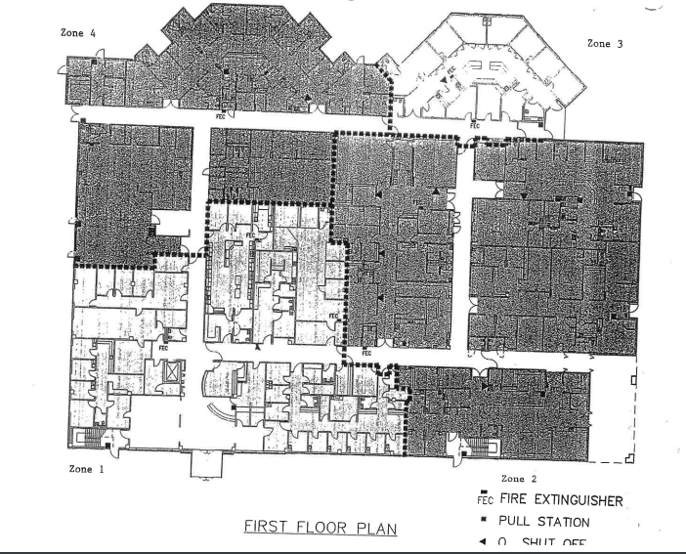

SUBJECT: | FIRE ZONE MAP | FILING #: EMG 4.01
 | FIRE ZONE MAP | PAGE: 2
DEPARTMENT: ALL DEPARTMENTS |  | OF: 2
 |  | EFFECTIVE:
APPROVED BY: SAFETY COMMITTEE |  | REVISED:

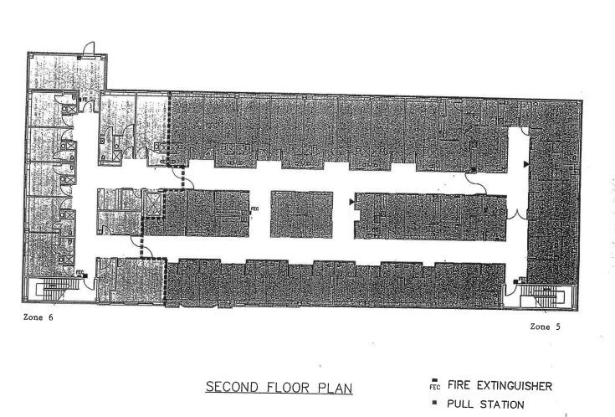

SUBJECT: | LOCATIONS OF FIRE EXTINGUISHERS | FILING #: EMG 4.02
 |  | PAGE: 1
DEPARTMENT: ALL DEPARTMENTS |  | OF: 2
 |  | EFFECTIVE: JANUARY 2017
APPROVED BY: SAFETY COMMITTEE |  | REVISED: 06/10/21

NUMBER | LOCATION | ZONE
1  2  3 | Across from Elevator #1  Lab, South Wall by Microbiology  South Wall of Physical Therapy Gym | 1
4  5  6  7  8 | North Wall by Endoscopy  South Wall of O.R. by East Entrance  O.P. Surgery, East Wall by Exit Door  Radiology, East Wall by Exit Door  Emergency Department, West Wall by the East Entrance | 2
9  10 | Outside Chapel  Intensive Care | 3
11  12  13  14 | Kitchen, North Wall  Beside the West Exit, South Wall  North Wall near West entrance to Generations  Generations | 4
15  16  17 | West Wall across from Nursing Station  Inside Electrical Room  Beside East Stairwell | 5
18  19 | Beside West Stairwell  Inside Mechanical Room | 6
20 | East Penthouse, inside the Entrance | 7
21 | West Penthouse, inside the Entrance | 8
22  23  24  25  26  27 | IMS Office Storage Room East Wall by Entrance  Central Supply, East Wall by Entrance  Engineering Shop, West Wall by Entrance  Engineering Office  Boiler Room, East Wall Main Entrance  Orthopaedics | 9

SUBJECT: | LOCATIONS OF FIRE EXTINGUISHERS | FILING #: EMG 4.02
 |  | PAGE: 2
DEPARTMENT: ALL DEPARTMENTS |  | OF: 2
 |  | EFFECTIVE: JANUARY 2017
APPROVED BY: SAFETY COMMITTEE |  | REVISED: 06/10/21

28  29  30  21  32 | Ground Storage  Ground Storage  Ashley Health Services, near Dr. Brown’s office, south end of west hall.  Ashley Health Services, near Dr. Richards’ office, south end of the hall.  Ashley IOP, in rear of building outside Director’s office

- New Business Office, Alabama Street: 1 fire extinguisher (located near the southeast office).
- Wellness Center: 3 fire extinguishers (1 located by the Zumba room exit, 1 located on the northwest wall of the large workout room, and 1 located on the east wall of the small workout area).
- ACMC Family Home Health: 2 fire extinguishers (located by the security alarm and door leading to medical record room).
- IOP-Outreach/Ashley Family Clinic: 6 fire extinguishers (1 located in the waiting room near front entrance, 1 located in the hallway near north exit, 1 located in the hallway near south exit, 1 located in the hallway near nurses station/training room door, 1 located on the northeast wall of the kitchen, 1 located on the southeast wall of the back hallway)
- Oak Street: 1 fire extinguisher (located on the west wall of the breakroom).
- CARTI, Alabama Street: 3 fire extinguishers (1 located in the waiting area near exit, 1 located near the rear exit of the building, and 1 located in the breakroom near the exit).

New fire alarm systems have been installed in the New Business Office and in CARTI.

SUBJECT: | OXYGEN SHUT-OFF LOCATIONS | FILING #: EMG 4.03
 |  | PAGE: 1
DEPARTMENT: ALL DEPARTMENTS |  | OF: 1
 |  | EFFECTIVE: JULY 2005
APPROVED BY: SAFETY COMMITTEE |  | REVISED:

MAIN Engineering Department

2nd Floor East Wall across from the Nursing Station

SUBS
North Wall by Respiratory Therapy
East Wall by West Entrance to Emergency Department
West Wall by the Endoscopy Door
West Wall by the Recovery Room Door
West Wall by Operating Room #1
North Wall by Operating Room #2
South Wall of Out-patient Surgery
South Wall of ICU by Utilization Review Office
South Wall of Generations by the East Exit
2nd Floor East Wall between the L&D Suites

SUBJECT: | EMPLOYEE DISCOVERING A FIRE OR SIGN OF FIRE | FILING #: EMG 4.10
 | EMPLOYEE DISCOVERING A FIRE OR SIGN OF FIRE | PAGE: 1
DEPARTMENT: ALL DEPARTMENTS |  | OF: 1
 |  | EFFECTIVE: JULY 2005
APPROVED BY: SAFETY COMMITTEE |  | REVISED:
*ALL FIRE DRILLS WILL BE REGARDED AS ACTUAL FIRES.

- Remove patients, visitors from immediate danger.

- Close all doors to confine fire to immediate area.

- Activate nearest fire alarm. (Pull lever down on nearest fire alarm box.)

- Notify Switchboard of CODE RED, give zone, type of fire and approximate size.

- If you determine size of fire controllable, and you have a way of escape, reenter area with fire extinguisher, pull pin to activate, point at base of fire while standing 8-10 feet away and attempt to extinguish fire.

- If you determine fire not controllable, remain in safe area and wait for Fire Department assistance.

- When fire alarm is activated, the elevator will automatically go to the opposite floor that the fire is located, if it is that zone. Otherwise, it will go to the bottom floor.

- If the fire alarm goes off, the elevator can only be activated by a key. The Fire Department, Engineering, and Security have a key.

SUBJECT: | SPECIAL ASSIGNMENTS FOR MANAGING FIRE OR SUSPECTED FIRE | FILING #: EMG 4.20
 | SPECIAL ASSIGNMENTS FOR MANAGING FIRE OR SUSPECTED FIRE | PAGE: 1
DEPARTMENT: ALL DEPARTMENTS |  | OF: 1
 |  | EFFECTIVE: JULY 2005
APPROVED BY: SAFETY COMMITTEE |  | REVISED:

STATEMENT OF PURPOSE: To establish special assignments in case of fire or suspected fire.

- Fire Marshall

The Fire Marshall is the Engineering Department Supervisor or Nursing Supervisor on duty.

Duties of the Fire Marshall:
  - Goes to the fire site at once and takes charge of all activities there.
  - Assigns a person to meet Fire Department personnel and directs them to fire site.
  - Transfers duties to Fire Chief when appropriate. Remains at site to assist Fire Chief as necessary concerning building safety.
  - In consultation with Fire Chief, may activate Evacuation. May authorize evacuation of hospital areas.
  - Reports to switchboard when fire has been extinguished.
  - Request’s page all clear after conferring with Engineering personnel.
  - Conducts the required fire drills monthly.

- Nursing Supervisor

Duties of Nursing Supervisor:
- Goes to alarm site at once.
- Assess effect of fire emergency on patient safety. Takes appropriate actions to assure patient safety, including shutoff of gases.

- When the Fire Chief and Fire Director determine it is necessary, the Nursing Supervisor may authorize evacuation of hospital areas.

SUBJECT: | GENERAL EMPLOYEE DUTIES IN A FIRE | FILING #: EMG 4.30
 |  | PAGE: 1
DEPARTMENT: ALL DEPARTMENTS |  | OF: 2
 |  | EFFECTIVE: JULY 2005
APPROVED BY: SAFETY COMMITTEE |  | REVISED:

Besides flames and heat, fire creates two other dangers: Smoke and Panic. It is important for every hospital employee to know exactly what to do in case of fire. There must be no panic. Your actions in the first few minutes can make the difference between a minor disturbance and a major tragedy. All actions must be orderly. This will protect patients, visitors, and fellow staff members.

YOU MUST KNOW
    - This fire plan.
    - Where a complete copy of this Fire Plan is kept in your work area. (In the Red Emergency Procedure Manual in each department.
    - Location of smoke detectors or remote alarm lamps in your working area and the location of all Fire Pull Boxes and fire equipment in your working area. Know how to use this equipment.
    - Location of any combustible materials in your area.
    - Location of all exits from your work area.
    - The hospital code for fire is CODE RED. Never say “fire”. This causes panic. Always use CODE RED even if you have to call for help. Call “CODE RED.”

IF YOU HEAR A CODE RED ALARM:
- Close all doors to keep out smoke.
- Do not transport patients. If you are transporting a patient, take the patient to the nearest supervised enclosure. If providing patient care, one employee stays with the patient; another verifies actual fire or drill.
- Do not use phone except to report an emergency.
- Obey supervisor’s instructions.

SUBJECT: | GENERAL EMPLOYEE DUTIES IN A FIRE | FILING #: EMG 4.30
 |  | PAGE: 2
DEPARTMENT: ALL DEPARTMENTS |  | OF: 2
 |  | EFFECTIVE: JULY 2005
APPROVED BY: SAFETY COMMITTEE |  | REVISED:
FIRE ALARM BOXES
There are red fire alarm boxes in each zone throughout the hospital. They are in corridors and at exits. Know the location of alarm boxes in your area.
To operate a fire alarm box, put one or two fingers in the hole in front of the pull box, and pull lever out and down.

EXTINGUISHERS
Know the location of extinguishers in your area. Know how to use this equipment.

TRAFFIC
Do not travel through fire zone doors during a Code Red alarm without specific orders from your supervisor. A patient in transport is to be taken to the nearest supervised enclosed area. Employees who are in another area of the hospital other than their own should follow procedure for the department they are in at the time.

EVACUATIONS
Leave the building through designated exits. Senior person in the department or switchboard paging will notify you of action to take.

END OF ALARM
The alarm is ended when this announcement is made over the address system:
CODE RED ALL CLEAR.

ONLY THE FOLLOWING PERSONNEL MAY ORDER THE CANCELLATION OF A FIRE ALARM:

Engineering Personnel
Fire Department

SUBJECT: | DEPARTMENT SPECIFIC RESPONSIBILITIES/FIRE & EVAC. | FILING #: EMG 4.40
 | DEPARTMENT SPECIFIC RESPONSIBILITIES/FIRE & EVAC. | PAGE: 1
DEPARTMENT: ADMINISTRATION |  | OF: 1
 |  | EFFECTIVE: JULY 2005
APPROVED BY: SAFETY COMMITTEE |  | REVISED:

      - Direct all visitors in the office to the zone 1 exit.

      - Turn off lights.

      - Close doors.

      - Report to the Zone 1 exit.

      - Obtain department census.

      - If CODE BLACK is called, assist with evacuation of patients through any exit. Report to Alternate Care Site as instructed.

SUBJECT: | DEPARTMENT SPECIFIC RESPONSIBILITIES/FIRE & EVAC. | FILING #: EMG 4.41
 | DEPARTMENT SPECIFIC RESPONSIBILITIES/FIRE & EVAC. | PAGE: 1
DEPARTMENT: ADMITTING/FINANCIAL COUNSELING |  | OF: 1
 |  | EFFECTIVE: JANUARY 2017
APPROVED BY: SAFETY COMMITTEE |  | REVISED:
      - Direct all visitors in the office to the Zone 1 exit.

      - Turn off lights.

      - Retrieve cash box and carry with you.

      - Close doors.

      - Report to the Zone 1 exit.

      - Obtain department census.

      - If CODE BLACK is called, assist with the evacuation of patients at the outside exits. Report to Alternate Care Site as instructed.

      - Assist with care and treatment of evacuated patients.

SUBJECT: | DEPARTMENT SPECIFIC RESPONSIBILITIES/FIRE & EVAC. | FILING #: EMG 4.42
 | DEPARTMENT SPECIFIC RESPONSIBILITIES/FIRE & EVAC. | PAGE: 1
DEPARTMENT: ACCOUNTING OFFICE |  | OF: 1
 |  | EFFECTIVE: JANUARY 2017
APPROVED BY: SAFETY COMMITTEE |  | REVISED:
- Direct all visitors in the office to the nearest exit.

- Turn off lights.

- Close doors.

- Report to the nearest exit.

- Obtain department census.

- Call Crossett Fire Department with cell phones or any available phone.

- Notify ACMC Switchboard of Code Red

SUBJECT: | DEPARTMENT SPECIFIC RESPONSIBILITIES/FIRE & EVAC. | FILING #: EMG 4.43
 | DEPARTMENT SPECIFIC RESPONSIBILITIES/FIRE & EVAC. | PAGE: 1
DEPARTMENT: DIETARY |  | OF: 1
 |  | EFFECTIVE: JANUARY 2017
APPROVED BY: SAFETY COMMITTEE |  | REVISED:
- Direct all visitors in the office to the Zone 4 exit.

- Turn off lights and unplug any electrical equipment.

- Close doors.

- Report to the Zone 4 exit.

- Obtain department census.

- If CODE BLACK is called, assist with evacuation of patients through any outside exit. Report to Alternate Care Site as instructed.

- Assist with care and treatment of evacuated patients.

SUBJECT: | DEPARTMENT SPECIFIC RESPONSIBILITIES/FIRE & EVAC. | FILING #: EMG 4.44
 | DEPARTMENT SPECIFIC RESPONSIBILITIES/FIRE & EVAC. | PAGE: 1
DEPARTMENT: ENGINEERING |  | OF: 1
 |  | EFFECTIVE: JANUARY 2017
APPROVED BY: SAFETY COMMITTEE |  | REVISED:
- Direct all visitors in the office to the Zone 9 exit.

- Turn off lights.

- Close doors.

- Check fire alarm panels for exact location.

- Report to fire location.

- If the fire is in another department, the Engineering Secretary will remain in the department to maintain communication between Engineering employees and the other departments.

- Help in removing patients from immediate danger.

- Try to control fire with fire extinguisher.

- Work with fire department in controlling the fire.

- Authorize oxygen shut off, if needed.

SUBJECT: | DEPARTMENT SPECIFIC RESPONSIBILITIES/FIRE & EVAC. | FILING #: EMG 4.45
 | DEPARTMENT SPECIFIC RESPONSIBILITIES/FIRE & EVAC. | PAGE: 1
DEPARTMENT: HEALTH INFORMATION |  | OF: 1
 |  | EFFECTIVE: JANUARY 2017
APPROVED BY: SAFETY COMMITTEE |  | REVISED:
- Direct all visitors in the office to the Zone 4 exit.

- Obtain evacuation stationary supplies.

- Print out patient census.

- Turn off lights.

- Close doors.

- Report to the Zone 4 exit.

- Obtain department census.

- If CODE BLACK is called, assist with evacuation of patients through outside exits. Report to Alternate Care Site as instructed.

- List patients as they arrive at evacuation destination.

SUBJECT: | DEPARTMENT SPECIFIC RESPONSIBILITIES/FIRE & EVAC. | FILING #: EMG 4.46
 | DEPARTMENT SPECIFIC RESPONSIBILITIES/FIRE & EVAC. | PAGE: 1
DEPARTMENT: ASHLEY IOP |  | OF: 1
 |  | EFFECTIVE: JANUARY 2017
APPROVED BY: SAFETY COMMITTEE |  | REVISED:
If there are no patients in the Ashley IOP area when the Code Red is called, staff will assemble outside the building in a safe area and listen for the call for “Code Red clear.”

If Code Red is called in any area of the hospital except Zone 9, staff will continue patient care and be on the alert for further instructions from Switchboard or “Code Red clear.”

If Code Red is called in Zone 9, staff will assemble patients near the exits, and follow further instructions, either “Code Red clear,” or prepare to evacuate.

In the event that evacuation is necessary, this procedure will be followed:

- Direct all visitors in the office to the Zone 9 exits.

- Obtain patient log book and records.

- Turn off lights.

- Close doors.

- Report to the Zone 9 exit.

- Obtain department census.

- If CODE BLACK is called, assist with evacuation of patients through any outside exit. Report to Alternate Care Site as instructed.

- Assist with care and treatment of evacuated patients.

SUBJECT: | DEPARTMENT SPECIFIC RESPONSIBILITIES/FIRE & EVAC. | FILING #: EMG 4.47
 | DEPARTMENT SPECIFIC RESPONSIBILITIES/FIRE & EVAC. | PAGE: 1
DEPARTMENT: HOUSEKEEPING |  | OF: 1
 |  | EFFECTIVE: JANUARY 2017
APPROVED BY: SAFETY COMMITTEE |  | REVISED:
HOUSEKEEPING MAY BE IN ANY AREA OF THE HOSPITAL. ALL PERSONNEL NEED TO KNOW FIRE ZONES AND EXITS FOR EACH AREA.

- Direct all visitors in the office to the exit.

- Obtain emergency linen supply.

- Close doors.

- Place cleaning carts in closets or areas out of main hallways.

- Employees should report to appropriate exit for the zone that they are in, or remain on standby as appropriate for that area.

- Obtain department census.

- If CODE BLACK is called, assist with evacuation of patients through any outside exit. Report to Alternate Care Site as instructed.

- Assist with care and treatment of evacuated patients.

SUBJECT: | DEPARTMENT SPECIFIC RESPONSIBILITIES/FIRE & EVAC. | FILING #: EMG 4.48
 | DEPARTMENT SPECIFIC RESPONSIBILITIES/FIRE & EVAC. | PAGE: 1
DEPARTMENT: INFORMATION MANAGEMENT |  | OF: 1
 |  | EFFECTIVE: JANUARY 2017
APPROVED BY: SAFETY COMMITTEE |  | REVISED:
- Direct all visitors in the office to the Zone 9 exit.

- Take backup disc for computer.

- Turn off lights.

- Close doors.

- Report to the Zone 9 exit.

- Obtain department census.

- If CODE BLACK is called, assist with evacuation of patients through any outside exits. Report to Alternate Care Site as instructed.

- Assist with care and treatment of evacuated patients.

SUBJECT: | DEPARTMENT SPECIFIC RESPONSIBILITIES/FIRE & EVAC. | FILING #: EMG 4.49
 | DEPARTMENT SPECIFIC RESPONSIBILITIES/FIRE & EVAC. | PAGE: 1
DEPARTMENT: LABORATORY |  | OF: 1
 |  | EFFECTIVE: JANUARY 2017
APPROVED BY: SAFETY COMMITTEE |  | REVISED:

- If alarm sounds, one employee stays in department while another verifies fire or drill.

- If evacuation is required, remove all patients and/or visitors from the department through Zone 1 exit.

- Turn off lights.

- Close doors.

- Report to Zone 1 exit.

- Obtain department census.

- If CODE BLACK is called, assist with evacuation of patients through any outside exit. Report to Alternate Care Site as instructed.

SUBJECT: | DEPARTMENT SPECIFIC RESPONSIBILITIES/FIRE & EVAC. | FILING #: EMG 4.50
 | DEPARTMENT SPECIFIC RESPONSIBILITIES/FIRE & EVAC. | PAGE: 1
DEPARTMENT: MATERIALS MANAGEMENT |  | OF: 1
 |  | EFFECTIVE: JANUARY 2017
APPROVED BY: SAFETY COMMITTEE |  | REVISED:
1. Direct all visitors in the office to the Zone 9 exit.

2. Turn off lights.

3. Close doors.

4. Report to the Zone 9 exit.

5. Obtain department census.

6. If CODE BLACK is called, assist with evacuation of patients through any outside exit. Report to Alternate Care Site as instructed.

7. Assist with care and treatment of evacuated patients.

SUBJECT: | DEPARTMENT SPECIFIC RESPONSIBILITIES/FIRE & EVAC. | FILING #: EMG 4.52
 | DEPARTMENT SPECIFIC RESPONSIBILITIES/FIRE & EVAC. | PAGE: 1
DEPARTMENT: NURSING |  | OF: 2
 |  | EFFECTIVE: JANUARY 2017
APPROVED BY: SAFETY COMMITTEE |  | REVISED:
Charge Nurse
1. Obtain forms for paper charting and physician 24-hour summary. Check census, location and condition of patients in your assigned area.
2. Alert employees if evacuation is necessary.
3. Assist with evacuation of patients.
4. Function as Triage Officer, if patient injuries or emergency condition exists.
5. Summon Physicians and/or extra Nursing Personnel.
Activate the Nursing Service Cascade Call System
6. Arrange for transfer of patients through:
Crossett Ambulance Service (Crossett Fire Department)
ProMed Ambulance Service
Private car transportation
7. If CODE BLACK is called, report to Alternate Care Site.
8. The IT Department will assist with accessing electronic record information.

Staff Registered Nurse/Licensed Practical Nurse
1. Upon order of Engineering Department, shut off oxygen valves.
2. Assist with evacuation of patients.
3. Report to Charge Nurse for further instructions.
4. Obtain count and condition of hospital Nursing employees, and report this to Charge Nurse.
5. Assist in emergency patient care.
6. If CODE BLACK is called, report to Alternate Care Site as instructed.
7. Document transfer information in patient records.

Nurse Techs/Student Nurses
1. Report to assigned area.
2. Close all doors.
3. Assist with evacuation of patients.
4. If CODE BLACK is called, report to Alternate Care Site as instructed.
5. Assist with care of assigned patients.

SUBJECT: | DEPARTMENT SPECIFIC RESPONSIBILITIES/FIRE & EVAC. | FILING #: EMG 4.52
 | DEPARTMENT SPECIFIC RESPONSIBILITIES/FIRE & EVAC. | PAGE: 2
DEPARTMENT: NURSING |  | OF: 2
 |  | EFFECTIVE: JANUARY 2017
APPROVED BY: SAFETY COMMITTEE |  | REVISED: 04/17/19

Unit Clerks
1. Report to assigned area.
2. Monitor telephone calls and patient intercom calls.
3. Be prepared to assist Charge Nurse.
4. If evacuation is ordered/necessary, direct the removal of forms for paper patient charts on assigned unit.
5. Report to Alternate Care Site as instructed.
6. Assist with transfer documentation and be available to use the telephone for public notification and communication.
____________________________________________________________________________

If CODE RED is in another zone, and evacuation is not called:
1. Close all doors.
2. Turn off electrical equipment that is not necessary for patient care.
3. Remain on standby for further instructions.
4. Do not go through smoke doors, except as is essential for patient care.

SUBJECT: | DEPARTMENT SPECIFIC RESPONSIBILITIES/FIRE & EVAC. | FILING #: EMG 4.55
 | DEPARTMENT SPECIFIC RESPONSIBILITIES/FIRE & EVAC. | PAGE: 1
DEPARTMENT: PHARMACY |  | OF: 1
 |  | EFFECTIVE: JANUARY 2017
APPROVED BY: SAFETY COMMITTEE |  | REVISED:
1. Direct all visitors in the office to the Zone 2 exit.

2. Obtain Pharmacy copies of physician orders.

3. Turn off lights.

4. Close doors.

5. Report to the Zone 2 exit.

6. Obtain department census.

7. If CODE BLACK is called, report to Alternate Care Site as instructed.

8. Obtain necessary medications from retail pharmacies to administer to evacuated patients.

____________________________________________________________________________

In the event that CODE RED is called in another department, one employee will stay in the Pharmacy in the event that medication records may need to be printed before total evacuation; the other employees will report to the Zone 2 exit.

SUBJECT: | DEPARTMENT SPECIFIC RESPONSIBILITIES/FIRE & EVAC. | FILING #: EMG 4.56
 | DEPARTMENT SPECIFIC RESPONSIBILITIES/FIRE & EVAC. | PAGE: 1
DEPARTMENT: PHYSICAL THERAPY |  | OF: 1
 |  | EFFECTIVE: JANUARY 2017
APPROVED BY: SAFETY COMMITTEE |  | REVISED:
1. Remove/Direct/Assist all patients and/or visitors in the department to the Zone 1 exit.

2. Turn off lights.

3. Close doors.

4. Obtain department census.

5. If CODE BLACK is called, assist with evacuation of patients through Zone 1 exit. Report to Alternate Care Site as instructed.

6. Assist with care and treatment of evacuated patients.

____________________________________________________________________________

If CODE RED is called for another Zone of the hospital, one employee will stay with patients, and another will check the hallway to verify if it is a drill or actual fire.

SUBJECT: | DEPARTMENT SPECIFIC RESPONSIBILITIES/FIRE & EVAC. | FILING #: EMG 4.57
 | DEPARTMENT SPECIFIC RESPONSIBILITIES/FIRE & EVAC. | PAGE: 1
DEPARTMENT: RADIOLOGY |  | OF: 1
 |  | EFFECTIVE: JANUARY 2017
APPROVED BY: SAFETY COMMITTEE |  | REVISED:
1. Remove/Direct/Assist all patients and/or visitors in the department to the Zone 2 exit.

2. Obtain the X-ray wheelchair.

3. Turn off lights.

4. Close doors.

5. Obtain department census.

6. If CODE BLACK is called, assist with evacuation of patients through Zone 2 exit. Report to Alternate Care Site as instructed.

7. Assist with care and treatment of evacuated patients.

____________________________________________________________________________

If CODE RED is called in another zone, one employee will stay with the patient, and another employee will check the hallway to determine if it is a drill or actual fire.

SUBJECT: | DEPARTMENT SPECIFIC RESPONSIBILITIES/FIRE & EVAC. | FILING #: EMG 4.58
 | DEPARTMENT SPECIFIC RESPONSIBILITIES/FIRE & EVAC. | PAGE: 1
DEPARTMENT: RESPIRATORY THERAPY |  | OF: 1
 |  | EFFECTIVE: JANUARY 2017
APPROVED BY: SAFETY COMMITTEE |  | REVISED:
1. Remove/Direct/Assist all patients and/or visitors in the department to the Zone 1 exit.

2. Obtain emergency respiratory therapy supplies.

3. Close doors.

4. Obtain portable oxygen tanks.

5. Obtain department census.

6. If CODE BLACK is called, report to Alternate Care Site as instructed.

7. Prepare oxygen equipment for administration to patients requiring it.

8. Assist with care and treatment of evacuated patients.

____________________________________________________________________________

If CODE RED is called in another zone, one employee will stay with the patient, and another employee will check the hallway to verify if it is a drill or actual fire.

SUBJECT: | DEPARTMENT SPECIFIC RESPONSIBILITIES/FIRE & EVAC. | FILING #: EMG 4.59
 | DEPARTMENT SPECIFIC RESPONSIBILITIES/FIRE & EVAC. | PAGE: 1
DEPARTMENT: SOCIAL SERVICES |  | OF: 1
 |  | EFFECTIVE: JANUARY 2017
APPROVED BY: SAFETY COMMITTEE |  | REVISED: 05/18/2018
1. Direct all visitors in the office to the Zone 3 exit.

2. Turn off lights.

3. Close doors.

4. Report to the Zone 3 exit.

5. Obtain department census.

6. If CODE BLACK is called, assist with evacuation of patients through any outside exit. Report to Alternate Care Site as instructed.

7. Assist with care and treatment of evacuated patients.

____________________________________________________________________________

SUBJECT: | DEPARTMENT SPECIFIC RESPONSIBILITIES/FIRE & EVAC. | FILING #: EMG 4.60
 | DEPARTMENT SPECIFIC RESPONSIBILITIES/FIRE & EVAC. | PAGE: 1
DEPARTMENT: SWITCHBOARD |  | OF: 1
 |  | EFFECTIVE: JANUARY 2017
APPROVED BY: SAFETY COMMITTEE |  | REVISED:
If CODE RED is called for another zone, remain on standby to assist with patients as needed.

- The Switchboard will serve as the communication center for the hospital during a fire or fire drill.

- Personnel at the Switchboard will call the Fire Department (364-2121) and give them the following information.

- WE HAVE A CODE RED
B. ZONE _________
C. TYPE OF FIRE (EXAMPLE: CHEMICAL, PAPER, ELECTRICAL, ETC.)
D. APPROXIMATE SIZE OF FIRE

- Announce CODE RED and the Zone four (4) times over the PA system.

- Notify the following persons of the above information regarding the fire:

- Engineering on call.
- Engineering Department Manager
- Administrator
- Director of Nursing

- Announce CODE RED CLEAR when instructed to do so by Engineering.

- If instructed to do so, announce “EVACUATE STAT” four (4) times over the PA system.

- Obtain cash box.

- Turn off lights.

- Close doors.

- Report to the Zone 2 exit.

- Report to Ashley Health Services or First Baptist Multi Ministries Center as instructed.

- Be prepared to serve as operator there.

SUBJECT: | DEPARTMENT SPECIFIC RESPONSIBILITIES/FIRE & EVAC. | FILING #: EMG 4.61
 | DEPARTMENT SPECIFIC RESPONSIBILITIES/FIRE & EVAC. | PAGE: 1
DEPARTMENT: UTILIZATION REVIEW |  | OF: 1
 |  | EFFECTIVE: JANUARY 2017
APPROVED BY: SAFETY COMMITTEE |  | REVISED:

ALL FIRE DRILLS WILL BE REGARDED AS ACTUAL FIRES

  - Direct all visitors in the office to the Zone 5 exit.

  - Turn off lights.

  - Close doors.

  - Report to the Zone 5 exit.

  - Obtain department census.

  - If CODE BLACK is called, assist with evacuation of patients through any outside exit. Report to Alternate Care Site as instructed.

  - Assist with care and treatment of evacuated patients.

____________________________________________________________________________

If the Utilization Review nurse is in any patient care area of the hospital, he/she will remain on standby to assist with patients in that area until further instructions are given.

SUBJECT: | DEPARTMENT SPECIFIC RESPONSIBILITIES/FIRE & EVAC. | FILING #: EMG 4.62
 | DEPARTMENT SPECIFIC RESPONSIBILITIES/FIRE & EVAC. | PAGE: 1
DEPARTMENT: HOME HEALTH |  | OF: 1
 |  | EFFECTIVE: MARCH 2011
APPROVED BY: SAFETY COMMITTEE |  | REVISED:
1. Direct all visitors in the office to either exit.

2. Obtain patient log book.

2. Turn off lights.

3. Close doors.

4. Report to either exit.

5. Obtain department census.

6. Assemble in front of the building.

7. Notify Crossett Fire Department (911) via cell phone or by going to a nearby business.

8. Notify Administration.

____________________________________________________________________________

SUBJECT: | INTERRUPTION OF VITAL SERVICES – ELECTRICITY | FILING #: EMG 5.00
 | INTERRUPTION OF VITAL SERVICES – ELECTRICITY | PAGE: 1
DEPARTMENT: ALL DEPARTMENTS |  | OF: 1
 |  | EFFECTIVE: NOVEMBER 2007
APPROVED BY: SAFETY COMMITTEE |  | REVISED:
Services or supplies vital to the normal function of the hospital may be interrupted for a short or extended time.

Person discovering situation:
Report discovery to switchboard operator.

Switchboard Operator:
- Notify engineering if outage occurs during normal business hours.
- After hours notify security.
- Security will notify engineering on call.
- Notify Entergy (1-800-968-8243). Determine, if possible, the approximate time until service is restored.
- Notify Administrator or Administrator on call.
- Notify all departments when service is restored.

Engineering:
- Make sure emergency generator plant is functioning properly.
- Notify Entergy (1-800-968-8243), and determine length of time of outage. Have Switchboard announce to departments.
- Director of Engineering, or in his absence, Lead Engineering Mechanic, will determine if additional fuel is needed for electrical generating plant.
- Notify all departments when service is restored.
- After service is restored, check proper operation of the following:
- Ventilating systems
- Boilers
- Vacuum pumps, etc.
- Pneumatic air compressors
- Air conditioning systems

Administrator or Administrator On Call:
- Evaluate the situation
- If the electricity is off for an extended time, make plans and give instructions.
____________________________________________________________________________

In the event of power outage in Home Health, Accounting or Wellness Center, staff will notify Entergy at 1-800-968-8243, and also notify Administration.

SUBJECT: | INTERRUPTION OF VITAL SERVICES - WATER | FILING #: EMG 5.10
 | INTERRUPTION OF VITAL SERVICES - WATER | PAGE: 1
DEPARTMENT: ALL DEPARTMENTS |  | OF: 2
 |  | EFFECTIVE: NOVEMBER 2007
APPROVED BY: SAFETY COMMITTEE |  | REVISED:
Services or supplies vital to the normal function of the hospital may be interrupted for a short or extended time.

Person discovering situation:
Report discovery to Switchboard.

Switchboard Operator:
1. Notify maintenance if outage occurs during normal business hours.
2. After hours notify security.
3. Security will notify maintenance on call.
4. Notify Administrator or Administrator on call.
5. Notify all departments when service is restored.

Engineering:
1. If possible, make repairs.
2. Call additional maintenance personnel as needed.

Clinical Coordinator:
Notify nursing units and departments to use only what is absolutely necessary.

Engineering:
1. Evaluate the situation.
2. Arrange for repairs as necessary.
3. Notify Crossett Water Commission (364-4191), and get approximate time that water supply will be restored.

SUBJECT: | INTERRUPTION OF VITAL SERVICES - WATER | FILING #: EMG 5.10
 | INTERRUPTION OF VITAL SERVICES - WATER | PAGE: 2
DEPARTMENT: ALL DEPARTMENTS |  | OF: 2
 |  | EFFECTIVE: NOVEMBER 2007
APPROVED BY: SAFETY COMMITTEE |  | REVISED:
4. Procure bottled water from Brookshires (364-2511) and Wal Mart (364-2165). Immediate supplies of drinking water will be sterile irrigating water on Med/Surgery carts.
5. Use ACMC’s emergency water pumps for flushing toilets, vacuum pump and medical air system. This water is not suitable for drinking or cleaning.
6. Check vacuum pumps, medical air and notify surgery.
7. If local suppliers cannot supply an adequate amount of drinking water, notify Borden Dairy in Monroe, Louisiana. Borden Dairy has agreed to supply water suitable for drinking.
8. Notify Switchboard when water service is restored.

Switchboard:
Announce to departments over PA system when service is restored.

____________________________________________________________________________

In the event of water outage in Home Health, Accounting, or Wellness Center, staff will notify Crossett Water Commission at 364-4195, and also Administration.

SUBJECT: | INTERRUPTION OF VITAL SERVICES - TELEPHONE | FILING #: EMG 5.20
 | INTERRUPTION OF VITAL SERVICES - TELEPHONE | PAGE: 1
DEPARTMENT: ALL DEPARTMENTS |  | OF: 2
 |  | EFFECTIVE: MARCH 2011
APPROVED BY: SAFETY COMMITTEE |  | REVISED: 04/17/19
Services vital to normal function of the hospital may be interrupted for a short or extended time.

Person discovering situation:
Report discovery to Switchboard operator.

Switchboard Operator:
- Notify IMS Manager or IMS on call
- Announce over PA system to use cell phones until service is restored.
- Contact KAGH (364-2181) and QLite (364-4700) if down time will be long term.
- Once advised by IMS Manager, announce over PA system when service is restored.

IMS Department:
- Notify IMS Manager if not already notified.
- Contact Windstream if needed.
- Contact Administrator on Call if down time will be long term.
- Contact Switchboard and Administrator on Call when service is restored.

All Departments:
- Eight hand-held radios will be available in various departments for use in house. Each department is responsible for making sure that the battery is kept charged. These will be kept in the following areas: ER, CEO’s office, Chief Nursing Officer’s office, IMS Manager’s office, Materials Management, and three in Engineering. ACMC Family Home Health has an AWIN radio that is kept in the Director’s office.
- One satellite phone is kept in the CEO’s office for making outside calls if the failure is outside the hospital. The satellite phone must be used outside the building until an antenna is obtained.

SUBJECT: | INTERRUPTION OF VITAL SERVICES - TELEPHONE | FILING #: EMG 5.20
 | INTERRUPTION OF VITAL SERVICES - TELEPHONE | PAGE: 2
DEPARTMENT: ALL DEPARTMENTS |  | OF: 2
 |  | EFFECTIVE: MARCH 2011
APPROVED BY: SAFETY COMMITTEE |  | REVISED: 04/17/19

- A HAM radio that is located in the Command Center may also be used.
- In the event of failure of telephone service at Home Health, Accounting, or Wellness Center, staff will notify Windstream at 800-782-6206, and also notify Administration.
- If cell phones are functioning at the time, employees’ cell phones may be used for hospital business.
- In addition to cell phones, employees’ satellite phones in vehicles may be used as employees make them available.

SUBJECT: | INTERNAL DISASTER | FILING #: EMG 6.00
 |  | PAGE: 1
DEPARTMENT: ALL DEPARTMENTS |  | OF: 1
 |  | EFFECTIVE: JULY 2005
APPROVED BY: SAFETY COMMITTEE |  | REVISED:
This plan provides basic guidelines and responsibilities in preparation for action to protect persons from injury and property from damage by an internal disaster which may strike or threaten the hospital.

NOTE: The provisions contained in this section are based on the assumption that the number of casualties involved would not reach major proportions. In the event that the emergency situation is of major proportions, provisions of the Mass Casualty Plan shall apply.

ORDER OF SUCCESSION:
Administrator
Chief Nursing Officer
Duty Supervisor, Nursing Units
Director of Engineering
Safety Officer

An individual in order of succession will assume control and direction of the hospital until relieved by someone senior to them in the order listed above.

DISASTER CONTROL CENTER:
A. The Control Center is the hub of the hospital emergency organization and will provide the leadership essential to an orderly execution of an emergency.
B. Location: Board Room inside Administration
Alternate Location: Conference Room
C. The senior official in the order of succession who is available will, upon notification of a disaster or an impending disaster, activate the Control Center in the appropriate location. They will direct the Hospital Activities in response to the emergency as outlined in this plan.

NOTIFICATION OF PERSONNEL:
A. In case of failure of telephone system, employees will be used as runners.
B. Telephone Notification:
- Notification of the disaster will be given to the telephone operator immediately by a person on site.
- The Operator will immediately advise the Administrator or his designee.

SUBJECT: | KIDNAPPING (CODE PINK) | FILING #: EMG 6.10
 |  | PAGE: 1
DEPARTMENT: ALL DEPARTMENTS |  | OF: 4
 |  | EFFECTIVE: MARCH 2013
APPROVED BY: SAFETY COMMITTEE |  | REVISED: 05/20/21
PURPOSE:
To provide a rapid, organized and thorough response to a suspected or actual infant/child abduction.

POLICY:
An infant/child abduction will be identified by the phrase “CODE PINK.” Code Pink may apply to a pediatric patient in any area of the hospital. All Ashley County Medical Center personnel and volunteers will be prepared to assist in a search and possible recovery of an abducted infant or child.

PROCEDURE:
- All personnel/volunteers are responsible to be familiar with Ashley County Medical Center’s Infant Abduction Response Plan as it applies to their area.

- An employee/volunteer who suspects that an infant or child has been abducted or missing shall immediately dial “379” to page overhead or dial “001” to page over phone speakers only. Page three times, “Attention please. We are under Code Pink status. Please, no one leave the building.” The employee will then immediately assist in the search for the missing infant.

- Upon hearing that a “Code Pink” has been called, the communications Operator will announce “Code Pink” on the public address system, and repeat as above.

- The infant/child’s staff nurse shall notify the Crossett Police Department, the Chief Nursing Officer, and the mother’s and baby’s attending physician and/or physician on call.

- Personnel/volunteers having specific “Code Pink” assignments will respond as outlined on the following page, and all exits will be closed during the alert.

- The Chief Nursing Officer will consult with the Security Department and responding law enforcement agencies, and will be responsible for direction of activity during a “Code Pink.” In the absence of the Director of Nursing, the Charge Nurse will be responsible for direction of activity during a “Code Pink”.

SUBJECT: | KIDNAPPING (CODE PINK) | FILING #: EMG 6.10
 |  | PAGE: 2
DEPARTMENT: ALL DEPARTMENTS |  | OF: 4
 |  | EFFECTIVE: MARCH 2013
APPROVED BY: SAFETY COMMITTEE |  | REVISED: 05/20/21

- Personnel/volunteers not having specific “Code Pink” assignments will report any suspicious persons or situations by calling Communications at “200”. All exits will be closed during the alert.

- All personnel/volunteers are to watch for persons carrying large bags in which an infant might be hidden, and watch for possible places in the hospital where the abductor might hide the abducted child and return to pick up the infant later.

- All available personnel are required to assist in the search.

- Personnel should be alert to be able to give to law enforcement officers a description of a possible abductor, the vehicle being driven, and a license number if at all possible.

- In-house Security and Engineering Department personnel will respond to exits to secure the entire hospital.

- Security staff will:
    - Direct available personnel to the appropriate exits to shut and lock all doors.

    - Notify local police if not done so by nursing staff.

    - Assist in managing the respective search teams in the hospital.

    - Assist in formal documentation with the Risk Manager.

SUBJECT: | KIDNAPPING (CODE PINK) | FILING #: EMG 6.10
 |  | PAGE: 3
DEPARTMENT: ALL DEPARTMENTS |  | OF: 4
 |  | EFFECTIVE: MARCH 2013
APPROVED BY: SAFETY COMMITTEE |  | REVISED: 05/20/21

- Staff will inform visitors of Code Pink status and prevent anyone from leaving the building at the assigned exits. The following exits are assigned to department staff as indicated:

  - BOTH ELEVATORS & WEST STAIRWAY (2ND FLOOR): Nursing staff on 2 Center

  - FRONT LOBBY ENTRANCE: FiCo staff (during routine business hours), Lab (after hours)

  - FRONT PARKING LOT: FiCo clerk at the front desk will be designated to immediately go outside with pen and paper to write down a license number and description of any possible fleeing vehicle.

  - Generations staff (MD-0700)

  - EXIT FROM STAIRWAY GOING OUTSIDE: laboratory staff

  - EXIT FROM STARIWAY NEAREST ER: ER nursing staff

  - ER EXIT: Physical therapy staff

  - EXIT NEAR GENERATIONS: Radiology staff (0700 to MN), Generations staff (MD-0700)

  - EXIT NEAR DIETARY: Dietary staff and/or QI Coordinator (during business hours), Generations staff (after dietary hours). Observe the hallway for any unusual activity.

  - PARKING LOT: Materials Management staff; designated to take pen and paper to write down a license number and description of any possible fleeing vehicle.

  - From 7AM to midnight, Radiology will secure the exit near CCU. Generations will be responsible for this area after these hours.

  - Dietary will secure the exit near Dietary during the day. Generations will secure this area at night, observing entire hallway for any unusual activity.

  - Materials Management will observe the parking lot near their area for any unusual activity, taking pen and note pad to be able to write down a license number and description of any possible fleeing vehicle.
SUBJECT: | KIDNAPPING (CODE PINK) | FILING #: EMG 6.10
 |  | PAGE: 4
DEPARTMENT: ALL DEPARTMENTS |  | OF: 4
 |  | EFFECTIVE: MARCH 2013
APPROVED BY: SAFETY COMMITTEE |  | REVISED: 05/20/21

- All personnel not having specific assignments will explain procedure to visitors and observe for any unusual behavior. Staff should be aware that most abductions occur during regular visitor hours, and should be watchful of persons carrying large bags that might conceal an infant.

- In areas where there is adequate staff to cover exits, some employees will search restrooms, closets, etc., where an infant might be hidden.

- When the search is concluded, the Director of Security will notify the Communications Operator to announce “Code Pink All Clear“.

- Inservices of all personnel will be required. Newly hired personnel/volunteers will be given an overview during orientation. Department managers will be required to update personnel on an annual basis. Annual drills may be conducted within the hospital.

SUBJECT: | CODE PURPLE | FILING #: EMG 6.15
 |  | PAGE: 1
DEPARTMENT: ALL DEPARTMENTS |  | OF: 1
 |  | EFFECTIVE: MARCH 2013
APPROVED BY: SAFETY COMMITTEE |  | REVISED:
Code Purple maybe defined as a situation in any department where a patient, visitor, or even a staff member is combative, and staff, visitors, or a patient are in danger of actual bodily harm.

PROCEDURE:

- Any employee who realizes that a situation may be escalating may dial “379” to page overhead or dial “001” to page over phone speakers only, “Code Purple and the location.”

- Switchboard will then announce, “CODE PURPLE, _________” (name the area) three times over the intercom.

- Security and all available men on duty will immediately respond to the designated area.

- Administrator, and others will respond they are available and attempt to talk to the person(s) involved and attempt to de-escalate the situation.

- If Code Purple is called for Generations, additional staff from other areas of the hospital who respond will assemble in the hallway outside the East door of generations and will be on standby for further instructions by the RN on duty or designated staff.

- Follow same procedure as EMG 6.20 Riot Control.

- Crossett Police will be notified, if needed, to control the situation.

- The staff who notified Switchboard of Code Purple will notify Switchboard of “Code Purple Clear“ as soon as the situation is under control.

- A report will be sent to the Safety Officer or Risk Manager within 24 hours.

SUBJECT: | CODE SILVER/ACTIVE SHOOTER | FILING #: EMG 6.18
 |  | PAGE: 1
DEPARTMENT: ALL DEPARTMENTS |  | OF: 4
 |  | EFFECTIVE: APRIL 2017
APPROVED BY: SAFETY COMMITTEE |  | REVISED: 06/10/21
PURPOSE:
The purpose of this policy is to provide guidelines in the event of an Active Shooter type situation occurring on hospital property. Every effort will be made to protect patients, visitors and staff. However, the hospital recognizes that these guidelines in no way imply or guarantee that injury or death will not occur during dynamic situations.

DEFINITION:
For the purpose of this plan, an active shooter is defined as a situation where a suspect(s) enters hospital property and commits acts of violence with a weapon.

PROCEDURE:
- As soon as it is determined that an active shooter situation exists, the Crossett Police Department, Switchboard operator (Dial 200), and the on-duty hospital supervisor will be immediately notified.

- Any employee discovering an Active Shooter situation should press dial “379” to page overhead or dial “001” to page over phone speakers only to announce Code Silver and the location. This phone function is for extreme emergencies only.

- The Switchboard Operator will immediately activate the panic button and page “Code Silver” and the location.

- Other departments in the hospital with a panic button in their department will also activate the panic button in their department

- Any available employee will then Dial 911 and give as many details as possible with location and description of shooter and type of gun being used.

- Follow the instructions given by the police department.

- All departments will immediately lock their doors.

- Employees will then place a wedge under the door or any other object to prevent the door from being easily opened.

- The Switchboard Operator or any employee having information will provide any available information to the police when they arrive.
SUBJECT: | CODE SILVER/ACTIVE SHOOTER | FILING #: EMG 6.18
 |  | PAGE: 2
DEPARTMENT: ALL DEPARTMENTS |  | OF: 4
 |  | EFFECTIVE: APRIL 2017
APPROVED BY: SAFETY COMMITTEE |  | REVISED: 06/10/21

- If the shooter is in the Switchboard area, staff will evacuate as soon as it is possible for them to safely do so.

- Immediate notification will also be made to the following either by the hospital operator or on-duty supervisor or designee:

  - Engineering/Maintenance Director

  - Administrator on Call

  - CEO

  - Chief Nursing Officer

  - Emergency Preparedness Coordinator

- The following information should be obtained if possible:

- Number of suspects

- Location of suspects

- Weapons involved

- Description of suspects and identification of suspects if known

- Unless directed otherwise by the Police department or the CEO, all staff members will attempt to secure patients, visitors and other staff members in a secured area if possible, close all doors and wait for further instructions. Staff members are advised not to unnecessarily put themselves in jeopardy while attempting to secure patients, visitors or other staff members.

- If possible, staff members will instruct all persons to get out of the hallways and seek shelter inside the nearest room and, if possible, lock the door and turn out the lights. Attempt to keep all persons away from the door and away from any view of the hallway. Keep all persons quiet and wait for instructions.

SUBJECT: | CODE SILVER/ACTIVE SHOOTER | FILING #: EMG 6.18
 |  | PAGE: 3
DEPARTMENT: ALL DEPARTMENTS |  | OF: 4
 |  | EFFECTIVE: APRIL 2017
APPROVED BY: SAFETY COMMITTEE |  | REVISED: 06/10/21

- Staff on 2 Center will call the elevators to 2 Center and place an obstacle such as a chair in the doorway in order to restrict the shooter from easily coming to 2 Center.

- Turn off televisions and radios. No use of cell phones except for texting.

- Do not allow anyone in the hallways for any reason. If the fire alarm is activated, remain where you are. Follow instructions given over the public address system.

- Do not call the operator or 911 to get updates. Do not use telephone or cell phone for outside calls. Only contact the operator or 911 if you have vital information. This will include: location of the suspect, identification of the suspect or the number of persons injured at your location.

- Prepare a list of everyone present at your location.

- Remain in your location until a Uniformed Police Officer arrives at your location or until “Code Silver all clear is called.

- Incident Command will immediately be established by the senior hospital staff member on scene and command will be turned over to the Crossett Police Department as soon as possible. Key hospital staff members (Hospital Administrator, Chief Nursing Officer, Emergency Preparedness Coordinator, etc) will remain on scene and assist with unified command as directed by the Incident Commander.

- Security will attempt to keep additional persons from going into the area of the disturbance. Secure doors and elevators if possible. He/she should not put himself/herself in harm’s way to secure the elevator.

- The Arkansas EM System will be updated as soon as possible to reflect that the hospital is on Full Diversion, and the Crossett Ambulance Service and ProMed Ambulance Service will be immediately notified of the situation.

- Evacuation of the departments of all nonparticipating patients and staff will only be conducted when ordered by the Police Department. No one will be allowed to remove any vehicle from the property unless directed or authorized by the Crossett Police Department.
SUBJECT: | CODE SILVER/ACTIVE SHOOTER | FILING #: EMG 6.18
 |  | PAGE: 4
DEPARTMENT: ALL DEPARTMENTS |  | OF: 4
 |  | EFFECTIVE: APRIL 2017
APPROVED BY: SAFETY COMMITTEE |  | REVISED: 06/10/21

- The Public Information Officer/designee along with the police will be the only persons releasing information to the media. An established off-site media staging area will be utilized unless directed otherwise by the Crossett Police Department.

- “Code Silver all clear” will be announced when the situation has been established as safe by the Crossett Police Department.

- Ashley County Medical Center will provide counseling services to assist with emotional/psychological support to all staff affected by the event.

- A post-situation briefing will be conducted within 24 hours of the event.

- Home Health, Ashley Health Services, or Hamburg Clinic employees finding themselves in an active shooter situation will attempt to keep themselves out of view of the shooter. The employee nearest the panic button will attempt to activate it. Employees will attempt to take cover or escape to the outside. An employee escaping to an area outside the danger area may use a cell phone or other phone to contact the police. Employees should remember to keep movement in view of the shooter at a minimum.

THIS POLICY OF ASHLEY COUNTY MEDICAL CENTER MAY BE OVERTURNED AT ANY TIME AT THE DISCRETION OF THE CROSSETT POLICE DEPARTMENT.

SUBJECT: | RIOT CONTROL | FILING #: EMG 6.20
 |  | PAGE: 1
DEPARTMENT: ALL DEPARTMENTS |  | OF: 1
 |  | EFFECTIVE: JULY 2005
APPROVED BY: SAFETY COMMITTEE |  | REVISED:
A riot may be defined as a situation of confusion, disturbance, violent disorder or public disturbance of the peace involving a number of persons (usually three or more) assembled together. Should any unusual disturbance occur, the following procedure should be followed:

Witness of any unusual disturbance:
Report discovery to switchboard operator.

Switchboard Operator:
1. Notify Engineering during normal business hours.
2. After hours, notify security.

Security/Engineering
- Report to scene of disturbance.
- Assess situation.
- Calmly try to disperse the gathering or control situation until Administration arrives.

Clinical Coordinator:
1. Report to scene of disturbance.
2. Assist Security in controlling the situation.

Administrator:
1. Report to scene of disturbance.
2. Assume command of situation.
3. Notify law enforcement agencies for help if needed
Crossett Police: 364-4131
Ashley County Sheriff’s Office: (870)-853-2040

SUBJECT: | BOMB THREAT (CODE ORANGE) | FILING #: EMG 6.30
 |  | PAGE: 1
DEPARTMENT: ALL DEPARTMENTS |  | OF: 6
 |  | EFFECTIVE: JULY 2005
APPROVED BY: SAFETY COMMITTEE |  | REVISED:

PURPOSE:
To establish procedures to be implemented after receipt of a bomb threat or after discovery of a suspected bomb.

POLICY:
Use of these general guidelines and good judgment in critical situations will prevent panic and help ensure the safety of our patients and employees.

RESPONSIBILITY:
- Each employee (telephone operators in particular) should be aware of procedures to be used upon receipt of a bomb threat or discovery of a suspected bomb.

- The Administrator or designee shall retain complete decision authority over action to be taken in response to bomb threats.

Action to be taken by Recipient of BOMB THREAT:
The person receiving the threat will attempt to keep the caller on the line as long as possible while notifying another employee, if available, in order that the call can be traced. The following information should be noted and written down while talking to the caller (Bomb Threat Checklist should be used.):

1. The exact wording of the threat.

2. If possible, the name, address, and status (patient, employee, other) of the person making the threat.

3. Description of circumstances surrounding the threat.

4. Description of the caller’s voice and manner (i.e., male or female, young or old, calm or excited, soft or loud, coherent or incoherent, profane or not, laughing or sobbing, stutter, etc.)

5. Date and time of threat.

During administrative hours, the above information will be furnished immediately to the Administrator or designee. During non-administrative hours information will be furnished to the Nursing Supervisor.

SUBJECT: | BOMB THREAT (CODE ORANGE) | FILING #: EMG 6.30
 |  | PAGE: 2
DEPARTMENT: ALL DEPARTMENTS |  | OF: 6
 |  | EFFECTIVE: JULY 2005
APPROVED BY: SAFETY COMMITTEE |  | REVISED:

Control of Publicity:
Disruption of normal business and panic are normally the primary objectives of persons making bomb threats. All information released to the public will be under control of the Administrator or designee.

Activation of Plan:

By Administrator or designee (during Administrative hours)
1. Contact other key officials as required.

2. Contact Crossett Police Department.

3. Enact all actions and procedures as needed.

By Nursing Supervisor (during non-Administrative hours)
1. Contact Administrator or designee

2. Contact the Crossett Police Department

3. Contact one of the Administrative Control group listed in order:

Director of Nursing
Assistant Director of Nursing
Engineering Department Manager

The Administrator or designee will utilize the hospital’s Cascade Call System for additional personnel as needed.

Search Procedures:
General Procedures (bomb location unknown)

- Search will be under control of the Police Department and Administrator. Decision as to whether the building will be evacuated will be made by the Police and Administrator.

- Employees may be asked to assist in the search.

SUBJECT: | BOMB THREAT (CODE ORANGE) | FILING #: EMG 6.30
 |  | PAGE: 3
DEPARTMENT: ALL DEPARTMENTS |  | OF: 6
 |  | EFFECTIVE: JULY 2005
APPROVED BY: SAFETY COMMITTEE |  | REVISED:

- During Administrative hours, the Administrator will notify the telephone operator to call Code Orange over the PA system and will make the decision as to whether immediate evacuation is necessary.

- Department heads or designee will notify staff to conduct search in assigned search areas.

- Upon completion of search, the Department Head or designee will report by telephone to the Administrator, Extension 271, state areas being searched.

- The Control Center will compile a list of rooms and areas searched.

- The telephone operators and hospital personnel will not use two-way radios or paging system during the search. Runners or telephones may be used to notify departments. Engineering will make sure the paging system is turned off.

- During non-administrative hours, the Nursing Supervisor will initiate the search procedure and remain at the 2-Center desk area until arrival of Administrative personnel.

- The Nursing Supervisor or designee will contact each nursing unit as appropriate (depending on suspected location of bomb) to carry out the search in assigned areas and report back to him/her at the 2-Center desk.

- Other personnel available to assist with the search (e.g., housekeeping, engineering) will be contacted by the Nursing Supervisor or designee to assist in the search.

- Administrator or designee will contact department heads to activate Cascade Call System for additional personnel as needed for search procedures.

Approach to Search Activities:

- Use personnel who are familiar with the area. They may readily detect an object out of place or not belonging in the area.

- Search from the outside of the area or building inward; then work from the bottom up.
SUBJECT: | BOMB THREAT (CODE ORANGE) | FILING #: EMG 6.30
 |  | PAGE: 4
DEPARTMENT: ALL DEPARTMENTS |  | OF: 6
 |  | EFFECTIVE: JULY 2005
APPROVED BY: SAFETY COMMITTEE |  | REVISED:

- Work in pairs, mentally dividing each area in half, each individual searching his half.

- Room Search: starting at the doorway, select a searching height for the sweep, e.g., floor to waist high. Working back-to-back, search the entire room at this height only. Return to the doorway and search the next height. Continue until the entire room is completely searched.

- Mark the door frame (tape, crayon, etc.) to indicate that the room was searched and by whom.

Possible Bomb Location Indicated:
(general procedures above, as well as those below, shall apply)
- Seal off suspected area

- Provide a very thorough search with Police and Fire Departments

- Alert supervisory personnel in the area to the possibility of patient evacuation. Make all preparations short of evacuation.

- Make every effort to prevent patients from becoming alarmed.

- Turn off radios, televisions, and unnecessary electrical appliances.

Discovery of Suspected Bomb:
- DO NOT TOUCH IT OR DISTURB IT IN ANY WAY. KEEP CALM. DO NOT PANIC.

- Notify the Administrator and hospital police officer in charge.

- Quietly and quickly alert all persons within the danger area to leave. If in a patient area, notify the head nurse.

- Close off the area. May leave doors open within the area to minimize effect of blast.

SUBJECT: | BOMB THREAT (CODE ORANGE) | FILING #: EMG 6.30
 |  | PAGE: 5
DEPARTMENT: ALL DEPARTMENTS |  | OF: 6
 |  | EFFECTIVE: JULY 2005
APPROVED BY: SAFETY COMMITTEE |  | REVISED:

- Organize immediate evacuation of any patient in the danger area. This will be accomplished through the Director of Nursing Service.

- Designate the DANGER AREA PERIMETER AT LEAST 300 FEET from the suspected bomb; also, the same area on the floor above and below the bomb.

- The Director of Nursing will organize patient evacuation as indicated by the Administrator acting on the advice of the Crossett Police Department.

- Engineering employees will shut down utilities (gas, electric, oxygen, etc.) in evacuated areas.

- After the above has been accomplished, all employees should stand by on alert status until the bomb disposal experts have issued an “ALL CLEAR.”

- Immediately after the “ALL CLEAR” is announced, the key hospital personnel who handled the situation shall meet with the Administrator to review and critique the operation, and arrange to reassure all patients, employees and anxious relatives that there is no danger.

SUBJECT: | BOMB THREAT (CODE ORANGE) | FILING #: EMG 6.30
 |  | PAGE: 6
DEPARTMENT: ALL DEPARTMENTS |  | OF: 6
 |  | EFFECTIVE: JULY 2005
APPROVED BY: SAFETY COMMITTEE |  | REVISED:
1. Exact wording of threat:
______________________________________________________________________________

______________________________________________________________________________

______________________________________________________________________________

2. Questions to ask (record response and repeat in sequence):

a. When will bomb explode? ____________________________________________

b. Where is the bomb? _________________________________________________

c. What building is it in? ________________________________________________

d. What floor is it on? __________________________________________________

e. Who are you? ______________________________________________________

f. Can we help you? ___________________________________________________

3. Caller’s voice and manner description: (mark all that apply.)
Calm | Loud | Nasal | Cracking
Angry | Profane | Stutter | Accent
Excited | Laughing | Lisp | Disguised
Slow | Sobbing | Incoherent | Male
Rapid | Distinct | Raspy | Female
Soft | Slurred | Deep | Familiar**

**If familiar, who did the caller sound like? __________________________________________

4. Date and time call received: Date: ____________________ Time: ___________________

5. Receiver’s Name: _________________________________________________________

6. Time CODE ORANGE was paged overhead: _____________________________________

7. Time CODE ORANGE was called clear: _________________________________________
SUBJECT: | CODE YELLOW | FILING #: EMG 6.40
 |  | PAGE: 1
DEPARTMENT: ALL DEPARTMENTS |  | OF: 2
 |  | EFFECTIVE: MAY 2012
APPROVED BY: SAFETY COMMITTEE |  | REVISED:

SUMMARY:
If disoriented, wandering patients do leave the Generations Unit unescorted, be aware of the profound fear and anxiety they will experience. The following procedure will help this distress when searching for them.

PROCEDURE:
The employee discovering that a patient is missing will immediately notify the Generations charge nurse and page “Code Yellow” overhead by dialing “379” or dial “001” to page over phone speakers only.

Upon hearing Code Yellow paged overhead, the 2 Center Charge Nurse will immediately send staff from 2 Center to relieve Generations staff to go look for the patient. If 2 Center staff is not immediately available, and other nursing staff are available, any other RN may respond to relieve Generations staff.

The Switchboard operator will then repeat the page overhead.

All available staff will look throughout the hospital as soon as the elopement is discovered.

Duties of the Generations Charge Nurse in a Code Yellow:
- Immediately notify Security.

- Call the Attending Physician, who may request that the police be notified. For involuntary patients, the police are to be notified automatically.

- Notify the family of the missing patient unless the physician chooses to notify the family himself/herself.

- Notify the Program Director of the missing patient.

- Record the event in the medical record.

- Notify Switchboard when Code Yellow is clear.

- Complete an Occurrence Report and turn it in to the Risk Manager.
SUBJECT: | CODE YELLOW | FILING #: EMG 6.40
 |  | PAGE: 2
DEPARTMENT: ALL DEPARTMENTS |  | OF: 2
 |  | EFFECTIVE: MAY 2012
APPROVED BY: SAFETY COMMITTEE |  | REVISED:

When the patient is found and returned to the Unit, a search of the patient should be conducted for contraband that may be brought on the unit. A drug screen may be done on the patient.

Upon return of the patient, the Attending Psychiatrist, Program Director, patient’s family and police (if notified) will be informed of the patient’s return.

If the patient has not returned within a 24-hour period, the Attending Psychiatrist must discharge the patient.

Staff will use every means possible to return an involuntary patient to the Unit if the patient is in the hospital or on hospital grounds.

The police should be summoned to assist in returning an involuntary patient who has eloped off the hospital grounds.

Force may not be used to detain a voluntary patient who has eloped off the Unit.

In the event that an informal or voluntary patient is judged by the Attending Psychiatrist to be in need of involuntary admission, steps shall be taken to seek involuntary admission for the patient.

SUBJECT: | NUCLEAR OR CHEMICAL ACCIDENT | FILING #: EMG 7.00
 |  | PAGE: 1
DEPARTMENT: ALL DEPARTMENTS |  | OF: 4
 |  | EFFECTIVE: JULY 2005
APPROVED BY: SAFETY COMMITTEE |  | REVISED:

Upon notification of an accident involving radiation/chemical exposure, the Emergency Room Physician will ascertain the number of victims and will recommend to the Administrator whether or not the plan needs to be expanded to include the Mass Casualty Plan. If a patient comes into the Emergency Room with contamination by an unknown substance and states he has not reported this to local police, the Switchboard operator will notify the police.

The Director of Radiology will be immediately notified, and will assume responsibility for implementing the plan, and for contacting Federal and State agencies.

RESPONSIBILITIES:

Switchboard Operator: (Will notify the following)
1. Administrator

2. Director of Nursing

3. Surgeon on call

4. Announce ____________ if instructed to do so.

5. Notify Engineering if accident occurs during normal business hours.

6. After hours notify Security. Security will notify Engineering on call.

7. Police Department will provide security in the ER area, if instructed to do so.

Emergency Room Staff:
1. Remove stretchers and wheelchairs to area adjacent to ambulance entrance.

2. Stand by to receive patients from triage.

3. Treat victims transported to ER.

SUBJECT: | NUCLEAR OR CHEMICAL ACCIDENT | FILING #: EMG 7.00
 |  | PAGE: 2
DEPARTMENT: ALL DEPARTMENTS |  | OF: 4
 |  | EFFECTIVE: JULY 2005
APPROVED BY: SAFETY COMMITTEE |  | REVISED:
Engineering:
1. Obtain stands, roping, plastic sheets and tape.

2. Rope off areas.

3. Shut off ventilation to that area.

4. Report to outside transport team for further assignment.

Environmental Services:
1. Obtain 3 large trash or linen hampers, mark with radioactive signs if nuclear accident.

2. Place hampers inside ER ambulance entrance and outside ER rooms.

3. Report to transport team at ambulance entrance.

Director of Nursing/Clinical Coordinator: (Will assign appropriate nursing personnel to)
1. Survey team at ambulance entrance

2. Medical triage at ambulance entrance.

3. Transport team at ambulance entrance (RN to direct transport team)

4. Unit Secretary or Nursing Assistant for record keeping purposes.

5. To Emergency Room – (2) RN’s

6. To ER waiting room.

Nuclear Medicine Personnel:
- Collect radiation warning supplies and survey meter.

SUBJECT: | NUCLEAR OR CHEMICAL ACCIDENT | FILING #: EMG 7.00
 |  | PAGE: 3
DEPARTMENT: ALL DEPARTMENTS |  | OF: 4
 |  | EFFECTIVE: JULY 2005
APPROVED BY: SAFETY COMMITTEE |  | REVISED:

Outside Survey Team:
Survey all patients upon arrival at ambulance entrance. Amount of contamination will be recorded on a tag which will be attached to patient’s chest. This must be done before transport.

Medical Triage Team (Surgeon to arrive will assume leadership.) Will determine transport route of all patients:
- Life-threatening injuries to ER decontamination area. ER physician and Unit Coordinator will assign staff to first room on right for removal of clothing and draping.

- Less seriously injured will be triaged and placed in safe areas in accordance with injuries, and/or prepared for transfer.

- Morgue will be at Jones Funeral Home.

Outside Transport Team:
Will transport patients to morgue at direction of triage team.

Emergency Room Transition Area:
Will be a clean area for persons who have been through decontamination and are:
- To be registered.

- Awaiting release.

- Awaiting treatment in clean ER rooms.

Radiology:
Room #1 will be utilized for contaminated patients needing X-rays. Personnel will remain in the room until decontaminated and surveyed.

SUBJECT: | NUCLEAR OR CHEMICAL ACCIDENT | FILING #: EMG 7.00
 |  | PAGE: 4
DEPARTMENT: ALL DEPARTMENTS |  | OF: 4
 |  | EFFECTIVE: JULY 2005
APPROVED BY: SAFETY COMMITTEE |  | REVISED:
O.R.:
Patients needing major surgery will be routed to O.R. Personnel will remain in room until decontaminated and surveyed.

Pharmacy:
Pharmacy Director or Registered Pharmacist in charge will call in appropriate personnel. Pharmacy department will furnish and deliver medication needed to the appropriate area.

Hospital Admission:
Patients needing admission will be admitted to isolation room if determined to require isolation, or will be isolated in another room.

POINTS OF EMPHASIS:
- All personnel assigned outside must remain outside until surveyed. If decontamination is necessary, must follow process outlined for patients.

- All personnel must be surveyed before leaving assigned area.

- All rescue squad personnel and equipment must be surveyed before leaving ambulance area.

- 70% of contamination is removed by removal of clothing; therefore, this should be accomplished as soon as possible. Patient privacy should be maintained.

- All clothing, trash, and linen must be placed in hampers marked radioactive, or with appropriate warning for chemical hazard, and sealed with heavy tape, rope, etc.

- Engineering will notify Arkansas Department of Emergency Management (853-2070) to pick up contaminated items and dispose of them.

Some possible chemical agents that might be used in the event of terrorist activity:

- Nerve agents, such as GB (Sarin) or VS

- Blister agents, such as Mustard or Leivisite

SUBJECT: | BIOTERRORISM PLAN | FILING #: EMG 7.50
 |  | PAGE: 1
DEPARTMENT: ALL DEPARTMENTS |  | OF: 9
 |  | EFFECTIVE: MARCH 2011
APPROVED BY: SAFETY COMMITTEE |  | REVISED: 05/20/21
In the event of a possible Bioterrorism attack, with patients coming into the emergency room, the Emergency Room physician will notify the RN on duty to activate the Bioterrorism Plan call system immediately as outlined below, and recommend to Administration whether or not the mass casualty plan needs to be activated.

RESPONSIBLE PERSON: PERSON(S) TO BE NOTIFIED:

RN on duty PBX Operator

PBX Operator 911
Administration (ext.271), or after hours call schedule
Nursing Administration (ext. 260, or page)
Security, for traffic control

Director of Nursing Infection Control Nurse (ext. 254)
Social Services (ext. 297, or pager)

Infection Control Nurse Ashley County Health Department (364-2115)
Arkansas State Health Department (501-661-2417)
CDC Hospital Infections Program (404-639-6413)
Arkansas Bioterrorism Response Line (501-280-4817)
After hours and weekends (800-554-5738)

Administration Local law enforcement (364-4131)
FBI Field Office (501-221-9100
Bioterrorism Emergency Number (770-488-7100)
ACMC Public Relations (ext. 409)
Arkansas Hospital Association (501-224-7878)

POTENTIAL AGENTS:
These diseases have been recognized as having bioterrorism potential: anthrax, botulism, plague, smallpox, tularemia, brucellosis, Q fever, viral hemorrhagic fevers, viral encephalitis, and diseases associated with staphylococcal enterotoxin B. Bioterrorism may occur as covert events in which persons are unknowingly exposed, and an outbreak is suspected only upon recognition of unusual disease clusters or symptoms; or bioterrorism may occur as an announced event, in which persons are warned that an exposure has occurred. The possibility of bioterrorism should be ruled out with the assistance of the FBI and State Health officials. Treatment and management will be disease-specific.
SUBJECT: | BIOTERRORISM PLAN | FILING #: EMG 7.50
 |  | PAGE: 2
DEPARTMENT: ALL DEPARTMENTS |  | OF: 9
 |  | EFFECTIVE: MARCH 2011
APPROVED BY: SAFETY COMMITTEE |  | REVISED: 05/20/21

All precautions will be taken according to the bioterrorism agent involved. Decontamination may need to be done outside the hospital.

Agents of bioterrorism are generally not transmitted from person to person; re-aerosolization of these agents is unlikely. All patients at ACMC, including suspected victims of bioterrorism, should be managed using Standard Precautions, which are designed to reduce transmission from both recognized and unrecognized sources of infection, and are recommended for all patients receiving care, regardless of their diagnosis or presumed infection status.

Supplies for possible decontamination outside the hospital will be stored by the Engineering Department. The following procedure will be followed for patients who need to be decontaminated outside the hospital (same as for nuclear or chemical accident):

- The ER physician will be the primary disaster physician, and will request additional physicians as needed.

- If decontamination is needed, a nurse will be placed in the dirty decontamination area. (See “Decontamination” at the end of this policy.)

- The PBX operator will notify Engineering, Environmental Services, and Nursing Administration. The Operator is to announce overhead, “Code 99,” and then follow policies and procedures for further instructions.

- Infection Control Nurse, DON, or charge nurse will check the wind direction to determine the site for decontamination. They will then call the Conference Room (ext. 414), or notify the Decontamination Officer by radio as to what site is to be used. Available sites are Alpha 1, Alpha 2, Bravo 1, and Bravo 2.

- All in-house decontamination team members are to report to the Conference Room immediately to be briefed on the situation. They will be instructed as to which department to report for donning PPE when the decontamination site is selected by Engineering. If Alpha 1 or Alpha 2 is selected, the decon team is to report to the X-ray department for donning. If Bravo 1 or Bravo 2 is selected, the decon team is to report to Home Health for donning. Engineering is to take all decontamination equipment to the designated area for the decon team.

SUBJECT: | BIOTERRORISM PLAN | FILING #: EMG 7.50
 |  | PAGE: 3
DEPARTMENT: ALL DEPARTMENTS |  | OF: 9
 |  | EFFECTIVE: MARCH 2011
APPROVED BY: SAFETY COMMITTEE |  | REVISED: 05/20/21

- While the decon team is waiting for the location, sign-in sheets will be completed, and weight and vital signs taken on the decon team members. Sign-in sheets, vital sign sheets and clip boards will be kept in the closet of the Conference Room, and then taken to the designated donning and doffing area.

- The decon team will be assigned job duties by the decon officer prior to leaving the donning area. Further assignments or changes in assignments will be made by the person assigned as Time Keeper for the decon team. It is the Time Keeper’s responsibility to pull out decon team members prior to allotted time if conditions warrant.

- The triage area will be considered contaminated. Any employees working in this area will wear appropriate protective clothing. No one will enter this area without appropriate gear, and no one will leave without decontamination.

- In the event of mass casualties, admissions personnel will report to the triage area to register patients, and will bring supplies to tag patients as to their destination after triage. This will be done in the Cold Zone.

- Since removal of 70% of contamination is accomplished by removal of clothing, this should be done as soon as possible.

- Engineering will obtain plastic sheeting, roping, and tape; rope off the area, and shut off any ventilation to the ER area if appropriate, as directed by the ER physician.

- Environmental Services will be responsible for bringing the following supplies to the decontamination area, and will remain on standby for further instructions:

2 large trash containers with lids Plastic garbage bags
2 linen carts Clean linens
Clean towels, wash cloths Disposable hats, booties, and gowns

- Nursing personnel will maintain patients’ privacy, and provide screening while removing patients’ clothing, which will be placed in plastic bags, sealed with tape, and labeled “contaminated.” ACMC staff will retain the clothing for the purpose of assisting FBI investigations.

SUBJECT: | BIOTERRORISM PLAN | FILING #: EMG 7.50
 |  | PAGE: 4
DEPARTMENT: ALL DEPARTMENTS |  | OF: 9
 |  | EFFECTIVE: MARCH 2011
APPROVED BY: SAFETY COMMITTEE |  | REVISED: 05/20/21
- Surfaces that have been exposed to a biological agent can be decontaminated with a solution of 9 parts water and 1 part bleach, or 0.5% hypochlorite solution.

- The Infection Control Nurse will assign an area for patients who need to be cohorted together, according to infection control policies.

- If ACMC facilities are inadequate for the number of patients requiring isolation, etc., patients will be sent to other facilities according to usual procedures.

- In the event that more negative airflow patient rooms are needed than the isolation room can accommodate, Engineering has portable equipment available that may be set up in a regular patient room that creates a negative airflow, vented to the outside. Four of these machines are available, making a total of five possible rooms available for respiratory isolation. Engineering will be responsible for setting up this equipment.

- Clear, consistent, understandable information should be provided to patients, visitors, and the general public. During bioterrorism-related outbreaks, visitors may be strictly limited, and Engineering/Security may lock all entries to the facility, so that entrance into all parts of the facility can be controlled.

- Pharmacy will activate their procedures for obtaining any additional medications from local pharmacies, and CDC.

- Respiratory Therapy will activate pre-arranged plans for obtaining additional respiratory equipment as needed.

- Materials Management will activate pre-arranged plan for obtaining additional supplies to maintain Standard Precautions.

- In the event that a bioterroristic threat is called in to the hospital, the employee receiving the call should use the reporting format for a bomb threat (EMG 6.30-5).

SUBJECT: | BIOTERRORISM PLAN | FILING #: EMG 7.50
 |  | PAGE: 5
DEPARTMENT: ALL DEPARTMENTS |  | OF: 9
 |  | EFFECTIVE: MARCH 2011
APPROVED BY: SAFETY COMMITTEE |  | REVISED: 05/20/21

AMBULATORY DECON

Patients are to be directed to the dirty triage area away from decon site. There will be one or two employees in full PPE at this site that will triage victims according to the decon color coded triage system. The victims will be given a color-coded tag that will be placed
around the neck. The victims will then be directed to the color represented in the triage waiting area. This area will be marked with colored flags.
There will be first aid supplies (4x4’s, ABD pads, tourniquets, and tape) at the dirty triage area in a plastic container. Plastic wrap will be available to cover open wounds prior to decontamination.

Patients will be sent to the personal belongings table (4) when called. They are not to be allowed to go without being called, this will prevent patient crowding at the table. There will be one employee in full PPE at this site. The patient will be instructed to remove all personal items such as jewelry, purses, wallets, etc. The patient will be marked with a red permanent marker on upper right arm indicting what number patient they are.

The bag containing their personal belongings will be a clear plastic zip lock bag and will be marked with the same patient number using a red permanent marker.

Patients are to take their marked personal belongings bag to table (5) when instructed to proceed. The patient may be assisted by the employee at table (4), employee at shower 1 (8), or both. This area will have a table with impervious plastic bags. The patient will be given a plastic bag and instructed to remove all clothing and place into bag. The bag will then be sealed and placed, along with bag of personal belongings, inside a second bag which will be sealed, and marked with a permanent red marker with same patient number, and placed in the bin (6).

The patient will then be directed to decon shower #1 (8). There will be an employee in full PPE at this site. The employee will instruct the patient to take sponge with soap and water (9) into shower and wash under water from head to toe using soap. They will instruct the patient to thoroughly clean hair and any body creases that may retain any contaminant. The patients are to remain in the shower for 5 minutes. While the patient is cleaning, the employee is to encourage and comfort the patient.

When the patient has completed the first shower, the employee is to monitor the patient for residual contamination, using monitoring equipment available.

SUBJECT: | BIOTERRORISM PLAN | FILING #: EMG 7.50
 |  | PAGE: 6
DEPARTMENT: ALL DEPARTMENTS |  | OF: 9
 |  | EFFECTIVE: MARCH 2011
APPROVED BY: SAFETY COMMITTEE |  | REVISED: 05/20/21

The patient is then directed to decon shower #2 (10). Again the patient is to be instructed to take a sponge, with soap and water (9), into shower and wash from head to toe. When second shower is completed, the patient will be assisted by another employee in full PPE. This area is to be considered the WARM ZONE. The employee will then use monitoring equipment to check the patient for any residual contamination. If any contamination is found, the patient is then directed back to the first shower to repeat the process. If no contamination is found, the patient will be given towels to dry off and a gown and shoe covers. Towels are to be discarded into bin (11) along with any dressings. Gowns and shoe covers are to be kept on cart (13).

The patient will then be directed to table (18) for clean triage. This area will have one employee (PPE not required), they will redress wounds as needed and direct patient to designated areas for treatment or evaluation based on their assessment of patient’s condition.

NON-AMBULATORY DECON

Patients will be brought to the non-ambulatory decon pool (12) via stretcher or backboard when called for. Patient’s personal belongings and clothing will be given to the employee at dirty decon table (4) for labeling and marking with patient number and placed into bin (6). The patient’s right upper arm will be marked with the patient number using a red permanent marker.

The non-ambulatory decon pool will be manned with two employees in full PPE. They are to decontaminate the patient using soap and water for a minimum of 5 minutes. The patient is to be washed from front to back. The patient is to be log rolled so back of patient and back board can be washed properly. The underside of the back board and the patient is to be monitored using the available monitoring equipment at this time. If any residual contaminant is found, the washing process is to be repeated.

The patient is then to be moved away from non-ambulatory decon pool. The patient is then to be dried off and redressed with a gown and covered with a blanket or sheet.

The patient is then to be wheeled to the edge of the COLD ZONE and transferred to a clean stretcher, avoiding transfer of contaminant from employee PPE to clean stretcher with employee in COLD ZONE assisting with transfer.

The patient is then taken to table (18) for clean triage. This area will have one employee (PPE not required). Wounds will be redressed as needed and runners directed to take patient to areas for treatment or evaluation based on assessment of the patient’s condition.
SUBJECT: | BIOTERRORISM PLAN | FILING #: EMG 7.50
 |  | PAGE: 8
DEPARTMENT: ALL DEPARTMENTS |  | OF: 9
 |  | EFFECTIVE: MARCH 2011
APPROVED BY: SAFETY COMMITTEE |  | REVISED: 5/20/21

ACTIVITY | LOCATION | KEY OFFICIAL | SUPPORT PERSONNEL | PERSONNEL SOURCE
Triage | Outside Entrance to Emergency Department | DON designee | 1 Physician  1 RN | Nursing Service
Emergent | Emergency Department | DON designee | 4 Physicians  4 RNs  4 LPNs | Nursing Service
Urgent | Emergency Department | DON designee | 2 Physicians  2 RNs  2 LPNs | Nursing Service
Non-Urgent | Outpatient Department | DON designee | 1 Physician  1 RN  1 LPN | Nursing Service
First Aid | Conference Room | DON designee | 2 LPNs | Nursing Service
Registration | Emergency Department Registration Area | Admissions Coordinator | 3 Clerks | Admissions Personnel
Surgery | Surgical Suite | Chief of Surgery | Surgery Personnel | Nursing Service
Personnel Pool | Hospital Dining Room | Director of Personnel | Housekeeping  Nursing Service  Administration | Same
Traffic (Outside) | Entrance to Hospital | Director of Engineering | Engineering | Engineering
Traffic (Inside) | Emergency Department | Security | Runners | Staff
Information Control | Administration | Administrator or Designee | Business Office or Personnel | Administration
Morgue | Jones Funeral Home  Patient Room as available | Jones Funeral Home | Jones Funeral Home | Jones Funeral Home
Visitors | Front Lobby | Local Pastors | Pastors | Hospital Auxiliary
Critical Care  PACU | CCU | DON designee | 1 Physician  1 RN  2 LPNs | Nursing Service
Couriers | In House | DON designee | Available Personnel | Accounting  Business Office

SUBJECT: | HOW TO HANDLE SUSPICIOUS MAIL | FILING #: EMG 7.50
 |  | PAGE: 9
DEPARTMENT: ALL DEPARTMENTS |  | OF: 9
 |  | EFFECTIVE: AUGUST 2006
APPROVED BY: SAFETY COMMITTEE |  | REVISED: 05/20/21

How to Handle Suspicious Mail:
- Do not shake or empty the contents of any suspicious envelope or package.

- Lay the envelope or package on a flat surface, cover the envelope/package with anything (e.g., paper, clothing, trash container, etc.) Do not remove the cover.

- Leave the room and close the door, or section off the area to prevent others from entering.

- Wash your hands with soap and water.

- Notify your supervisor, who will secure the area, post a sign indicating “Do Not Enter,” and activate the calls as outlined in the bioterrorism plan.

- Go to the Emergency Room.

- Remove contaminated clothing as soon as possible and place in a plastic bag. Emergency personnel will assume responsibility for proper disposition of clothing.

- Shower with soap and water as soon as possible. Do not use bleach or other disinfectants on your skin.

- Engineering will close off ventilation to the affected area.

- Obtaining of environmental samples and securing the suspicious envelope/package will be directed by police and FBI, and sent to the designated lab for testing.

SUBJECT: | POINT OF DISTRIBUTION (POD) PLAN | FILING #: EMG 7.6
 |  | PAGE: 1
DEPARTMENT: ALL DEPARTMENTS |  | OF: 1
 |  | EFFECTIVE: MARCH 2014
APPROVED BY: SAFETY COMMITTEE |  | REVISED:

Ashley County Medical Center has been designated by the Arkansas Department of Health as a Point of Distribution (POD) for administration of vaccines to ACMC employees and their families in the event of massive disease outbreak requiring vaccines. The Infection Control Nurse and the Nursing Department will coordinate distribution of vaccines, which will be supplied by the Arkansas Department of Health. The POD will only be activated by the Arkansas Department of Health, and will be set up in the Conference Room. This POD will only be for ACMC employees and their families.

SUBJECT: | CODE C – CARE OF EBOLA PATIENT | FILING #: EMG 7.70
 |  | PAGE: 1
DEPARTMENT: ALL DEPARTMENTS |  | OF: 2
 |  | EFFECTIVE: DECEMBER 2014
APPROVED BY: SAFETY COMMITTEE |  | REVISED:

If a patient comes to the ER window and is suspected to have Ebola, the following steps will be taken:

- The ER clerk will give the patient a mask and gloves to put on and ask the patient to stay at the ER window.

- The clerk will CALL the ER nurse to inform of the suspected case.

- As the patient is putting the mask and gloves on, the clerk will PAGE overhead “Code C” and ask and visitors/patients in ER waiting room to leave through the opposite door from which the suspected patient came in.

- When Security hears Code C paged overhead, the on-duty Security officer will make sure the Day Surgery outside door is open, and secure the ER waiting area so that no other patients or visitors will enter that area. Visitors/patients who were in the ER waiting room will be escorted to the front lobby.

- The ER nurse will put on the appropriate PPE, while the patient remains at the ER window or waiting room until the nurse is ready.

- The nurse will then place the same type of PPE on the patient that the nurse is dressed in and take the patient back out the ER entrance and into Day Surgery by way of the door to the outside.

- The Day Surgery area will be the quarantined area for suspected cases of Ebola.

- The ER clerk will notify Julie Keeth, Emily Bendinelli, Ramona Bitely, Donna White, surgery on-call, and Phillip Gilmore.

- Infection Control will notify OEM, (870)-940-0342, (501)-661-2136; Dr. Gresham; and Tammy Cook at Ashley County Health Department (500-2630)

- The ER entrance and waiting room area will be closed for 3 days for Terminal Cleaning.

- The patient will be cared for by the ER nurse who took him/her to Day Surgery until additional staff arrives.

- Switchboard will notify Housekeeping that the ER waiting area needs to be de-contaminated.

SUBJECT: | CODE C – CARE OF EBOLA PATIENT | FILING #: EMG 7.70
 |  | PAGE: 2
DEPARTMENT: ALL DEPARTMENTS |  | OF: 2
 |  | EFFECTIVE: DECEMBER 2014
APPROVED BY: SAFETY COMMITTEE |  | REVISED:
- The patient will be isolated until they are deemed in a “no risk” category by CDC.

- Interactions with the patient will be limited to 1 nurse and 1 doctor.

- Patient care will be under the direction of the Arkansas Department of Health and CDC.

- See Code C policy in Infection Control Manual for additional details.

SUBJECT: | TORNADO/WIND STORM DISASTER | FILING #: EMG 8.00
 |  | PAGE: 1
DEPARTMENT: ALL DEPARTMENTS |  | OF: 3
 |  | EFFECTIVE: JANUARY 2017
APPROVED BY: SAFETY COMMITTEE |  | REVISED: 05/20/21

Department Heads are responsible for planning personnel coverage, supply and equipment requirements, and the security of their areas, except as otherwise outlined, in severe weather conditions; each department will develop safety measures specific to their own departments.

PHASES OF OPERATION:
- Tornado Watch: Severe weather conditions are expected in the area and personnel should be on the alert for actual warnings. Preliminary precautions to safeguard life and property should be taken.

- Tornado Warning: Severe weather conditions are imminent. Complete all possible precautions immediately to safeguard life and property.

- All Clear: Severe weather conditions no longer exist in the area.

CONTROL CENTER:
The control center for the duration of the emergency will be located in the Office of the Administrator.

CODE WHITE will be paged on the PA system when there is a TORNADO WARNING and a tornado has actually been sighted in the area.

After Code White has been paged, Switchboard will notify Ashley Health Services, the Accounting office, ACMC Family Home Health, and the Wellness Center of the Code White status.

INSTRUCTIONS FOR TORNADO WATCH PHASE:
Preliminary precautions will consist of reviewing procedures defined in the “Instructions for Warning Phases” section, should weather conditions become imminent.

INSTRUCTIONS FOR WARNING PHASES:
- Control Center will be in operation in the office of the Administrator until the “All Clear” is announced.

- All ICU/CCU patients will be moved to Day Surgery in order to get away from windows and possible flying glass.
SUBJECT: | TORNADO/WIND STORM DISASTER | FILING #: EMG 8.00
 |  | PAGE: 2
DEPARTMENT: ALL DEPARTMENTS |  | OF: 3
 |  | EFFECTIVE: JANUARY 2017
APPROVED BY: SAFETY COMMITTEE |  | REVISED: 05/18/18

- Med/Surg Nursing Department shall move all ambulatory patients and occupied beds away from windows and into the halls as an additional precaution against hazards of broken glass.

- IOP staff shall assist all patients in the IOP building to the long hallway in order to get away from windows and possible flying glass until Code White is clear.

- The Dietary Department shall have available emergency rations, disposable plates and cups, etc., for use during the emergency.

- Housekeeping shall have available emergency stocks of linen and other supplies.

- Nursing staff will place patients’ charts inside pillowcases until Code White is clear.

- Any electrical equipment that is not necessary for patient care should be turned off.

- All employees and visitors will be moved away from windows as an additional precaution against hazards of broken glass.

- The Engineering Department shall:
A. Inspect, repair, and secure all exterior openings.
B. Have available, as deemed necessary for emergency use, the following: Material to cover broken windows, nails, lumber, fuses, bulbs, extension cords, ladders, etc.
C. Ensure that adequate supplies of fuel and lubricants are on hand for emergency generator.

11. All Departments shall:
- In the event of damage, prepare emergency duty rosters for essential coverage, and advise employees concerned.
- Check flashlights and other emergency equipment to ensure that they are operational: procure spare batteries and lights as necessary.
- In the event of damage, report to the Administrator, by names, employees available for emergency duties outside assigned departments. All requests for additional employees shall be submitted to the Director of Personnel Services.
- When any room or area is vacated for any extended period of time, including overnight, blinds or curtains shall be closed and all electrical equipment not essential for use during storm, discontinued.
- Patients shall be advised that visiting hours may be restricted immediately prior to, during, or immediately after severe weather conditions.

SUBJECT: | TORNADO/WIND STORM DISASTER | FILING #: EMG 8.00
 |  | PAGE: 3
DEPARTMENT: ALL DEPARTMENTS |  | OF: 3
 |  | EFFECTIVE: JANUARY 2017
APPROVED BY: SAFETY COMMITTEE |  | REVISED: 05/18/18
- Engineering Department will issue to the department, as needed, spare batteries, flashlights and other necessary supplies and equipment.
- Employees should be advised that if they are required to remain on duty beyond their normal work schedule, appropriate compensation will be made.
- Director of Engineering will check departments during a Code White to see that proper procedures are being followed.

ACTUAL DAMAGE TO HOSPITAL:
Should the hospital sustain damage from an actual tornado or wind storm, Internal Disaster plan will be implemented.

INSTRUCTIONS FOR ALL CLEAR:
1. Notification will be from the Administrator’s office by phone, messengers, or paging system, “Code White clear.”

2. Switchboard will notify Ashley Health Services and ACMC Family Home Health that Code White is clear.

3. At that time, the immediate danger of severe weather will have moved on.

4. Employees having performed long, arduous hours of duty will be relieved as soon as possible.

5. Engineering Department will survey damage and prepare a report for submission to the Administrator.

6. Normal operations shall be resumed as quickly as possible.

In the event of Tornado Warning, Home Health employees who are in the office will take cover in the rear of the building near or in the restroom area until severe weather has passed. Employees who are traveling should get to a safe area until severe weather has passed. Employees should not continue to travel or try to outrun the storm.

SUBJECT: | CODE WHITE CRITIQUE FORM | FILING #: EMG 8.10
 |  | PAGE: 1
DEPARTMENT: ALL DEPARTMENTS |  | OF: 1
 |  | EFFECTIVE: JULY 2005
APPROVED BY: SAFETY COMMITTEE |  | REVISED:
CODE WHITE CRITIQUE

Date: ________________________

Time switchboard was notified to call Code White: ____________________________________

Person who first learned of tornado warning: ________________________________________

Time employee learned of tornado warning: _________________________________________

Were visitors/patients in front lobby notified? Yes ________ No ________ Time: __________

Patients on 2 Center moved into hallway? Yes ________ No ________ Time: __________

CCU patients moved to Day Surgery? Yes ________ No ________ Time: __________

Non-urgent OB patients moved to desk area; infants moved to inner room of nursery?
Yes ________ No ________ Time: __________

Employees in Zone 9 moved to main building? Yes ________ No ________

Any employees in inappropriate places: _____________________________________________

______________________________________________________________________________

______________________________________________________________________________

Power failure/switch to generator? Yes _______ No ________

Number of tornado victims brought into ER: _______________

Any damage to ACMC property? ___________________________________________________

______________________________________________________________________________

______________________________________________________________________________

Time Code White called clear: _____________________________________________________
SUBJECT: | MASS CASUALTY PLAN | FILING #: EMG 9.00
 |  | PAGE: 1
DEPARTMENT: ALL DEPARTMENTS |  | OF: 5
 |  | EFFECTIVE: FEBRUARY 2010
APPROVED BY: SAFETY COMMITTEE |  | REVISED: 05/20/21

DEFINITION OF MASS CASUALTY:

Any situation that produces an immediate load greater than the normal (on duty) emergency department can handle. In the event of a mass casualty, the Emergency Department may use the Outpatient Clinic rooms for the patient overload.

CODE GREEN CALL:

Internal Disaster:
Common type does not overwhelm in house facility: mobilize and utilize on duty hospital staff. Less commonly, in house facility may be overwhelmed, and cascade call will be utilized to mobilize appropriate staff. Also, less commonly, local or county support may be necessary. Rarely, the facility may be partially or totally inoperable. This may prompt partial or complete evacuation of patients.

External Disaster:
Common type does not overwhelm in house facility: mobilize on duty hospital staff. Less commonly, in house facility may be overwhelmed: cascade call utilized to mobilize appropriate staff.

Mass Casualty: occurs less commonly. Utilize cascade call, as well as local, county, or state, or federal support as necessary.

MAJOR OBJECTIVES:
- Provide emergency surgical and medical care and hospital treatment for casualties without delay.

- Administer initial and continued medical care of casualties and critically ill non-casualty patients.

- Accommodate casualties to the limit of the hospital’s ability to expand.

- Be as nearly self-sufficient as possible for all aspects of operation during the first 24 hours following the occurrence of disaster.

- Provide an adequate blood supply for at least 24 hours.
SUBJECT: | MASS CASUALTY PLAN | FILING #: EMG 9.00
 |  | PAGE: 2
DEPARTMENT: ALL DEPARTMENTS |  | OF: 5
 |  | EFFECTIVE: FEBRUARY 2010
APPROVED BY: SAFETY COMMITTEE |  | REVISED: 05/20/21

ACTIVATION OF PLAN:
When word comes to the hospital concerning a community or civil defense disaster, the call will be referred directly to the Emergency Department. As much information as possible will be obtained concerning the number, types, and severity of injured persons, location, and type of disaster, the name, telephone number and organization of the person calling. The call should then be authenticated.

If an affirmative decision is made, the Mass Casualty Plan will be activated and Code Green implemented. The Switchboard operator will immediately make an announcement on the PA system and notify the administrative person on call, and will also notify Air EMS to be on stand by. The Command Center for the event will be located in the Board Room in Administration.

Acadian Air Med 800-259-3333
Air-Evac 800-247-3822
Angel One 501-364-1100
Baptist Med Flight 800-227-1000 or 800-632-5433
Lifenet 903-831-6021
Pafford Air 800-435-7663
Survival Flight 877-581-5558

If necessary, the administrative person on call will request the switchboard to call radio stations or local TV station and announce all off duty personnel report to work.

KAGH 870-364-2181
KHMB 870-364-4700

SUBJECT: | MASS CASUALTY PLAN | FILING #: EMG 9.00
 |  | PAGE: 3
DEPARTMENT: ALL DEPARTMENTS |  | OF: 5
 |  | EFFECTIVE: FEBRUARY 2010
APPROVED BY: SAFETY COMMITTEE |  | REVISED: 05/20/21

Immediately following the decision to activate this plan, the Administrator or designee may, at his/her discretion, notify the following:

Police Department | (870)-364-4131
Fire Department | (870)-364-2121
Medical Center of South Arkansas | (870)-864-3200
St. Francis Medical Center (Monroe, LA) | (318)-327-4196
Morehouse General Hospital (Bastrop, LA) | (318)-283-3609
Radio Station (KAGH) | (870)-364-2181
Radio Station Q-Lite | (870)-364-4700
National Guard | (870)-364-2023
Sheriff’s Office | (870)-853-2040
Bradley County Hospital | (870)-226-3731
Drew Memorial Hospital | (870)-367-2411
Chicot Memorial Hospital | (870)-265-5351

In the event that a Civil Defense alert is broadcast in the city, all Department Heads will report immediately to the Administrator’s office, whether or not they are informed by this hospital. When this alarm is heard during non-regular duty hours, all other employees will report immediately to their regular assigned duty areas. Employees not required for duty at that time will be sent home to stand by until notified to return to the hospital, or given an exact time to report for duty to relieve those employees retained on duty.

OPERATIONS:

Ambulance Reception:
Reception and unloading of ambulances and other vehicles bearing wounded casualties will be done as expediently as possible to the Triage area.

Triage:
The process of receiving, sorting, and classification of the injured. Staffed by a sufficient number of physicians, nurses and assistants to maintain rapid movement of casualties. Equipped with tags and skin marking pencils to designate destination of casualties.

SUBJECT: | MASS CASUALTY PLAN | FILING #: EMG 9.00
 |  | PAGE: 4
DEPARTMENT: ALL DEPARTMENTS |  | OF: 5
 |  | EFFECTIVE: FEBRUARY 2010
APPROVED BY: SAFETY COMMITTEE |  | REVISED: 05/20/21
Classification of patients:
A. Resuscitation
B. Emergent
C. Urgent
D. Less Urgent
E. Non-Urgent

In House Casualty Transport:
Couriers provide a continuous flow of casualties from one casualty treatment to another.

Casualty Transport:
To Definitive Care Treatment Facilities:
- Burn Centers:
Arkansas Children’s Hospital, Little Rock, AR…………………………..(501)-370-1100

- Pediatrics and Maternity:
Morehouse General Hospital, Bastrop, LA……………………...………….(318)-281-2431
Medical Center of South Arkansas, El Dorado, AR……………………...(870)-864-3200
Drew Memorial Hospital, Monticello, AR……………..………...(870)-367-2411

RESPONSIBILITY:

It is the responsibility of key officials designated in Attachment “A” (See EMG 9.00-5) to coordinate their specific needs in regard to employees, supplies, services and equipment, with the heads of respective departments designated in the source columns. The command center will be in the Board Room in Administration, and the Administrator, or Designee will be in charge.

Medical Staff and additional Clinical Staff: Emergency credentialing of additional physicians who are not currently on staff may be necessary, and the Medical Staff Coordinator will follow procedures in Medical Staff Bylaws. Procedures for emergency credentialing of additional clinical personnel will be followed by Human Resources.

Admissions Office, Medical Records, Business Office and Accounting: will utilize that portion of their staff not assigned to “Casualty Registration: to do the following:

1. Take care of necessary medical administrative details and maintain liaison with all wards to operate a Perpetual Bed Inventory.

SUBJECT: | MASS CASUALTY PLAN | FILING #: EMG 9.00
 |  | PAGE: 5
DEPARTMENT: ALL DEPARTMENTS |  | OF: 5
 |  | EFFECTIVE: FEBRUARY 2010
APPROVED BY: SAFETY COMMITTEE |  | REVISED: 05/20/21

2. Keep the Triage Area and Recovery Room informed as to the availability of space for patients from those areas. They will also inform the Triage Area to which ward casualties for pre-operative and shock treatment should be directed after other wards become filled.

3. Act as couriers to transport casualties.

Materials Management Director: will place into effect pre-arranged plans for sources and methods of obtaining additional food and medical supplies.

Department Managers: and persons acting in that capacity are responsible to keep the Switchboard operator advised as to the local number at which they may be reached when they leave the hospital. Further, they are responsible to see that their key employees are available to them by telephone after duty hours.

Department Managers and individual employees without specific assignments in the Plan will continue to perform their normal tasks and be ready to accept special assignments or provide other services as may be required.

All news media personnel will be directed to the administrative person on call.

Patients whose condition permits may be discharged to their homes to allow higher priority patients to be admitted. Such determination will be made by the physician.

Jones Funeral Home will be used as a morgue; transportation will be provided by the Funeral Home.

The Ashley County Coroner will be notified in the event of multiple deaths.

PSYCHOLOGICAL SUPPORT
Visitors can be expected to increase in number with the severity of the disaster. The majority of these will have legitimate reasons for desiring to visit the hospital, although curious onlookers may also seek entrance. Many casualties will be accompanied by friends and relatives, particularly in a large-scale disaster. These visitors will be anxious and concerned, and their feelings must be respected, as the situation will permit. However, they must not be allowed to disrupt the disaster functioning of the facility. A visitor’s reception area will be set up in the main lobby. The local pastors will be utilized as liaison between the visitors and Social Services to determine if particular patients have been admitted, and to utilize volunteers of the hospital in escorting visitors to beds of critically ill patients, etc. Normal visiting hours on the wards may be suspended or kept to a minimum (one or two), and visitors may be escorted to the patient by volunteer personnel.
SUBJECT: | MASS FATALITY PLAN | FILING #: EMG 9.01
 |  | PAGE: 1
DEPARTMENT: ALL DEPARTMENTS |  | OF: 1
 |  | EFFECTIVE: FEBRUARY 2010
APPROVED BY: SAFETY COMMITTEE |  | REVISED:

PURPOSE:

A mass fatality incident (MFI) results in a surge of deaths above what is managed by normal operations at Ashley County Medical Center. In the event of a public health emergency or major disaster, the possibility of mass fatalities exists. In such a case where there are a large number of fatalities, additional assistance can be requested by the Ashley County Office of Emergency Management.

PLAN:

In the event of a mass fatality within the hospital, Administration is to be notified. If the processing of the deceased can be managed by the local funeral homes, existing procedures for deceased patients are to be followed.

If the number of fatalities exceeds the capacity of the local funeral homes, assistance can be requested by notifying the Office of Emergency Management (day - 870-853-2070; after hours 870-473-5226; cell 870-831-0380). The Office of Emergency Management (OEM) will obtain assistance through state and federal agencies, and will notify Kenyon International for assistance if needed.

If there is a delay between the time assistance is requested and their arrival, Jones Funeral Home of Crossett, Jones-Hartshorn Funeral Home of Hamburg and Cromwell Funeral Home of Hamburg have agreed to assist in the processing and storage of the remains until the arrival of state assistance, or there is no longer a need for their assistance. ACMC has Memorandums of Agreement (MOA) from each funeral home.

SUBJECT: | ATTACHMENT A | FILING #: EMG 9.05
 |  | PAGE: 1
DEPARTMENT: ALL DEPARTMENTS |  | OF: 1
 |  | EFFECTIVE: JULY 2005
APPROVED BY: SAFETY COMMITTEE |  | REVISED: 05/20/21

ACTIVITY | LOCATION | KEY OFFICIAL | SUPPORT PERSONNEL | PERSONNEL SOURCE
Triage | Outside Entrance to Emergency Department | DON designee | 1 Physician  1 RN | Nursing Service
Emergent | Emergency Department | DON designee | 4 Physicians  4 RNs  4 LPNs | Nursing Service
Urgent | Emergency Department | DON designee | 2 Physicians  2 RNs  2 LPNs | Nursing Service
Non-Urgent | Outpatient Department | DON designee | 1 Physician  1 RN  1 LPN | Nursing Service
First Aid | Conference Room | DON designee | 2 LPNs | Nursing Service
Registration | Emergency Department Registration Area | Admissions Coordinator | 3 Clerks | Admissions Personnel
Surgery | Surgical Suite | Chief of Surgery | Surgery Personnel | Nursing Service
Personnel Pool | Hospital Dining Room | Director of Personnel | Housekeeping  Nursing Service  Administration | Same
Traffic (Outside) | Entrance to Hospital | Director of Engineering | Engineering | Engineering
Traffic (Inside) | Emergency Department | Security | Runners | Staff
Information Control | Administration | Administrator or Designee | Business Office or Personnel | Administration
Morgue | Jones Funeral Home  Patient Room as available | Jones Funeral Home | Jones Funeral Home | Jones Funeral Home
Visitors | Front Lobby | Local Pastors | Pastors | Hospital Auxiliary
Critical Care  PACU | CCU | DON designee | 1 Physician  1 RN  2 LPNs | Nursing Service
Couriers | In House | DON designee | Available Personnel | Accounting  Business Office

SUBJECT: | ALTERNATE CARE SITE PLAN | FILING #: EMG 10.00
 |  | PAGE: 1
DEPARTMENT: ALL DEPARTMENTS |  | OF: 4
 |  | EFFECTIVE: FEBRUARY 2010
APPROVED BY: SAFETY COMMITTEE |  | REVISED:
In the event of the hospital becoming contaminated, structurally unsound, or filled to capacity without outside assistance from other facilities, an alternate care site will be established. The temporary site will be established at the First Baptist Multi Ministries Building on Pine Street or the National Guard Armory on N. Florida Street, or other location. The decision as to what site is to used will be made by the CEO or the Incident Commander during an emergency or disaster event based on the availability of the sites.

All elective surgeries and outpatient services will be suspended during this time.

Supplies needed to operate the ACS will be transported by Engineering with the assistance of any personnel and any personal vehicles available.

Supplies Needed for Nursing:

Dinamap Foley catheter Thermometer Bed pans Stethoscopes (2) Bath basins Crash cart Soap
Medication cart OB pads Gloves Bed pads
Alcohol pads Bedside commodes Alcohol gel 2x2s
4x4s Lab Bio Hazard Bags Trash cans/Liners Red bags
Bandaids Urine cups Syringes with needles Nurses’ notes Sterile Gloves Lab order forms Portable oxygen with tubing Tape
Sharp containers Cleaning supply cart Linen cart with all linens IV start kits
Dirty linen cart Cots IV jelcos IV poles
NS flushes IV tubing IV Fluids Ambu bags
Water pitchers Tourniquets Oxygen tanks Blood tubing
Progress notes Partitions Medication cups 1 Wheelchair
Juice/milk/other patient refreshments Yankaur tips
Oxygen tubing & various masks sizes Lab supplies for phlebotomy
Respiratory equipment for respiratory treatments Glucometer with supplies

SUBJECT: | ALTERNATE CARE SITE PLAN | FILING #: EMG 10.00
 |  | PAGE: 2
DEPARTMENT: ALL DEPARTMENTS |  | OF: 4
 |  | EFFECTIVE: FEBRUARY 2010
APPROVED BY: SAFETY COMMITTEE |  | REVISED:
Clerical Supplies Needed:
All patients being transferred to the ACS from ACMC will be admitted prior to transfer. They are to have an arm band on with proper identification and all paperwork; including orders, are to be sent with the patient. No patients will be admitted directly to the ACS unless directed to by the Incident Commander. A daily census will be faxed to the ACS every am for proper patient tracking.

Supplies needed:
Copy Machine
Fax
Ink pens
Daily census.
ER Admissions has 100 folders set aside for disasters. Each folder includes: Steps for Registration, Patient Registration form, Patient’s rights to be signed, and a sheet of pre-numbered labels with armbands attached.

Staffing Assignments:
Nursing staff will be assigned by the DON or Staffing Coordinator.
Clerical staff will be assigned by the Admissions Director.
Housekeeping will assign one or more employees to ACS for day and evening shift.
Engineering Director will assign a minimum of one Security Officer to the ACS at all times unless the local Police Department is able to assist and can post one Police Officer to the ACS.

In an emergency, an ACS may be established to accommodate an excess of patients that can not be transferred to other facilities. The patients that are to be relocated to the ACS are to be non-critical and will be determined by the Physician on call.

Patient Care:
Patient safety is to be maintained at all times during transfer to and from the ACS and while being treated at the ACS. All standing Policies and Procedures are to be followed as close as possible.
Visitors will be limited to immediate family only. Visiting hours will be followed and are subject to change under the direction of the Charge Nurse or Incident Commander.

Pharmacy
Pharmacy personnel will have medication for each patient separated and labeled per hospital Policy and Procedure before delivery to the ACS every morning and on an as needed basis. Medication will be transported to the ACS by an ACMC employees only unless brought directly from local pharmacy.
SUBJECT: | ALTERNATE CARE SITE PLAN | FILING #: EMG 10.00
 |  | PAGE: 3
DEPARTMENT: ALL DEPARTMENTS |  | OF: 4
 |  | EFFECTIVE: FEBRUARY 2010
APPROVED BY: SAFETY COMMITTEE |  | REVISED:

Laboratory:
All laboratory specimens will be collected per the nursing staff unless lab is able to assign an employee to the ACS. All specimens will then be labeled and placed into a bio-hazard bag and sent to ACMC via a hospital employee or a volunteer. Lab results will be faxed to the ACS.

Dietary:
Individual serving size refreshments such as juice and milk and snacks will be sent to the ACS from the dietary department. Meals will be prepared at ACMC and delivered to the ACS per hospital personnel or local volunteers.

Radiology:
Only necessary X-rays will be performed while the patient is being cared for at the ACS. If an X-ray must be done, the patient is to be transported to ACMC Radiology Department via ambulance. The patient is then to be transported back to the ACS unless otherwise ordered by the physician.

Housekeeping:
A minimum of one employee from housekeeping will be assigned to the ACS for the 7am – 3pm shift and the 3pm – 11pm shift. A covered linen cart containing all needed linens, towels, wash clothes, blankets, and pillows will be delivered to the ACS per hospital personnel. Carts will be restocked as needed per housekeeping personnel. Cleaning supplies will be collected by housekeeping and delivered to the ACS. Current hospital Policy and Procedure will be followed with regard cleaning and disinfecting of the ACS.

Respiratory Therapy:
Respiratory therapy department will assign one employee to the ACS. All treatments and EKGs will be done per RT.

Communications:
Due to limited phone lines at the ACS, communication will be maintained through the use of fax, cell phones and radios with a designated radio frequency between the ACS and ACMC.

SUBJECT: | ALTERNATE CARE SITE PLAN | FILING #: EMG 10.00
 |  | PAGE: 4
DEPARTMENT: ALL DEPARTMENTS |  | OF: 4
 |  | EFFECTIVE: FEBRUARY 2010
APPROVED BY: SAFETY COMMITTEE |  | REVISED:

Accounts/Patient Charges:
The CFO shall establish a mechanism to account for all costs associated with the ACS and shall, after the ACS is closed, submit a complete report of such cost to the CEO.

Transportation cost to and from the ACS will be the responsibility of ACMC and will be charged to patient accounts and billed for by ACMC.

Patient charges for services provided in the ACS will be maintained in the same manner as if the services were provided at the main hospital.

Closing of the ACS:
The ACS will be maintained until directed to close by the Incident Commander. All patients are to be transferred to ACMC via ambulance. All equipment is to be cleaned prior to returning to ACMC. All patient information is to be sent to ACMC while maintaining confidentiality.

SUBJECT: | HOME HEALTH – HAZARD AND VULNERABILITY ANALYSIS | FILING #: EMG 11.00
 | HOME HEALTH – HAZARD AND VULNERABILITY ANALYSIS | PAGE: 1
DEPARTMENT: HOME HEALTH |  | OF: 7
 |  | EFFECTIVE:
APPROVED BY: SAFETY COMMITTEE |  | REVISED:
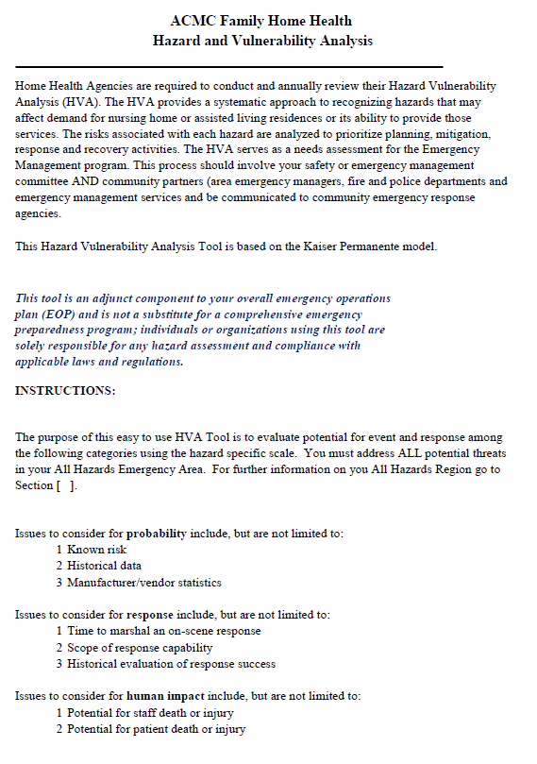
SUBJECT: | HOME HEALTH – HAZARD AND VULNERABILITY ANALYSIS | FILING #: EMG 11.00
 | HOME HEALTH – HAZARD AND VULNERABILITY ANALYSIS | PAGE: 2
DEPARTMENT: HOME HEALTH |  | OF: 7
 |  | EFFECTIVE:
APPROVED BY: SAFETY COMMITTEE |  | REVISED:

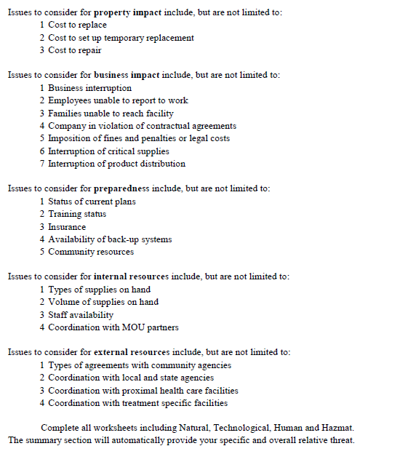

SUBJECT: | HOME HEALTH – HAZARD AND VULNERABILITY ANALYSIS | FILING #: EMG 11.00
 | HOME HEALTH – HAZARD AND VULNERABILITY ANALYSIS | PAGE: 3
DEPARTMENT: HOME HEALTH |  | OF: 7
 |  | EFFECTIVE:
APPROVED BY: SAFETY COMMITTEE |  | REVISED:
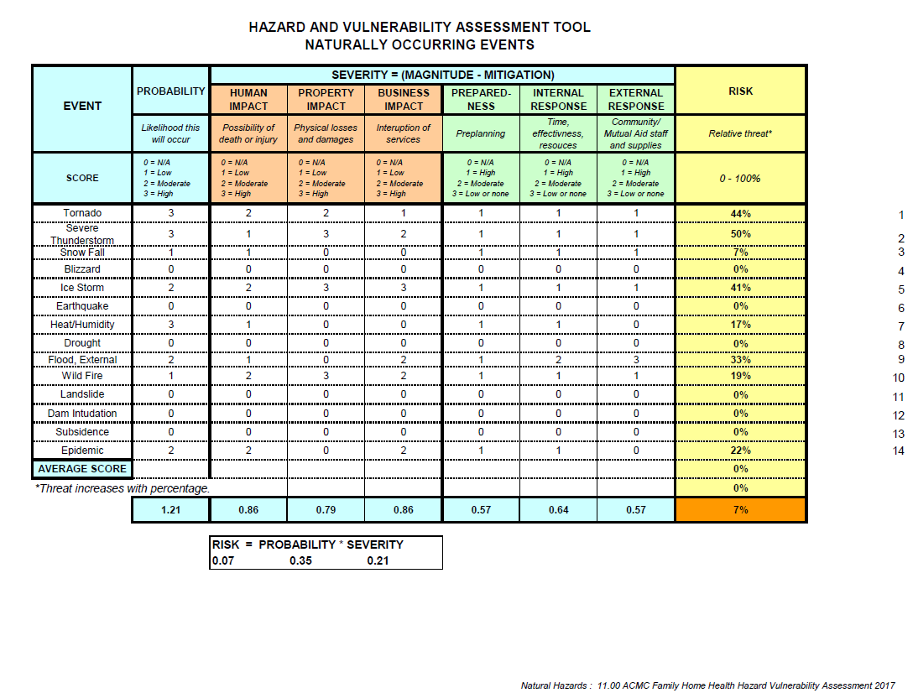

SUBJECT: | HOME HEALTH – HAZARD AND VULNERABILITY ANALYSIS | FILING #: EMG 11.00
 | HOME HEALTH – HAZARD AND VULNERABILITY ANALYSIS | PAGE: 4
DEPARTMENT: HOME HEALTH |  | OF: 7
 |  | EFFECTIVE:
APPROVED BY: SAFETY COMMITTEE |  | REVISED:

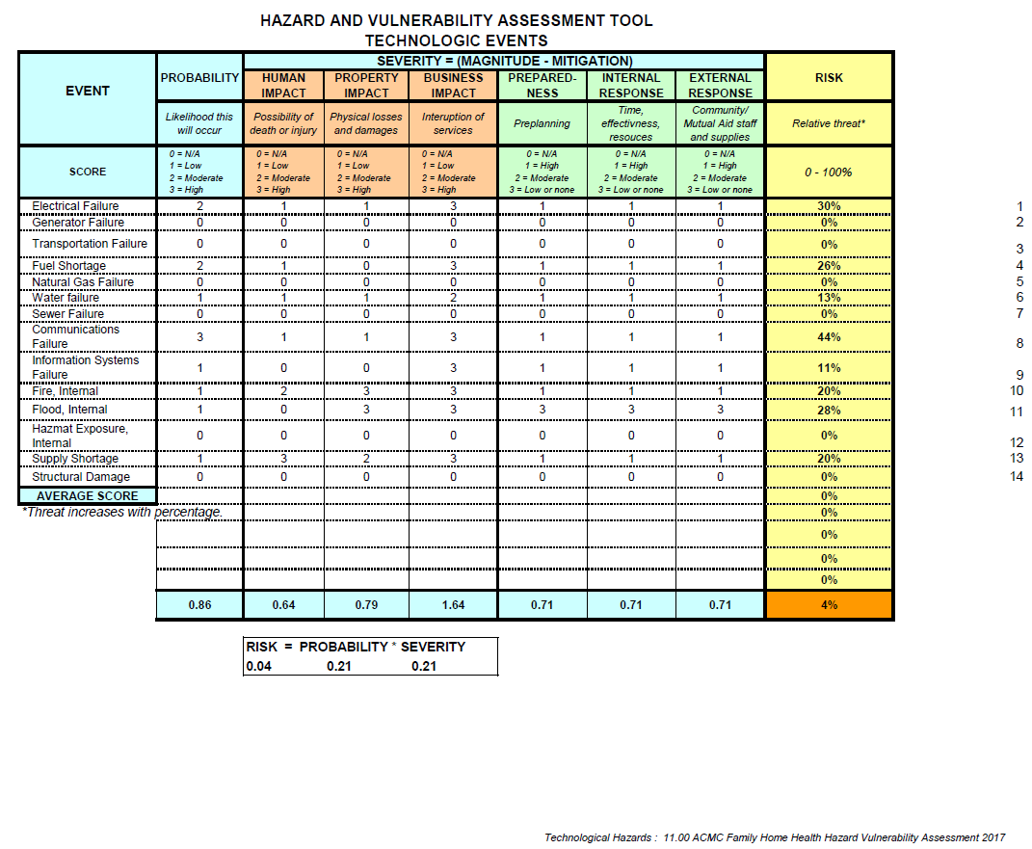

SUBJECT: | HOME HEALTH – HAZARD AND VULNERABILITY ANALYSIS | FILING #: EMG 11.00
 | HOME HEALTH – HAZARD AND VULNERABILITY ANALYSIS | PAGE: 5
DEPARTMENT: HOME HEALTH |  | OF: 7
 |  | EFFECTIVE:
APPROVED BY: SAFETY COMMITTEE |  | REVISED:

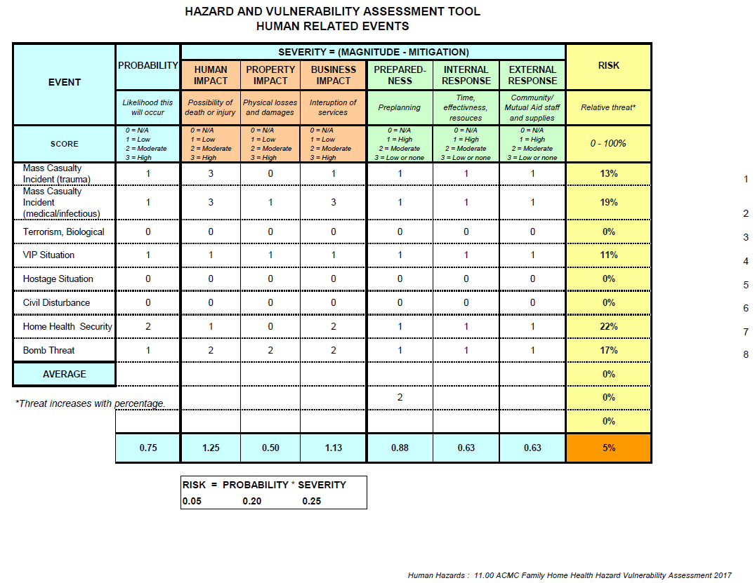

SUBJECT: | HOME HEALTH – HAZARD AND VULNERABILITY ANALYSIS | FILING #: EMG 11.00
 | HOME HEALTH – HAZARD AND VULNERABILITY ANALYSIS | PAGE: 6
DEPARTMENT: HOME HEALTH |  | OF: 7
 |  | EFFECTIVE:
APPROVED BY: SAFETY COMMITTEE |  | REVISED:

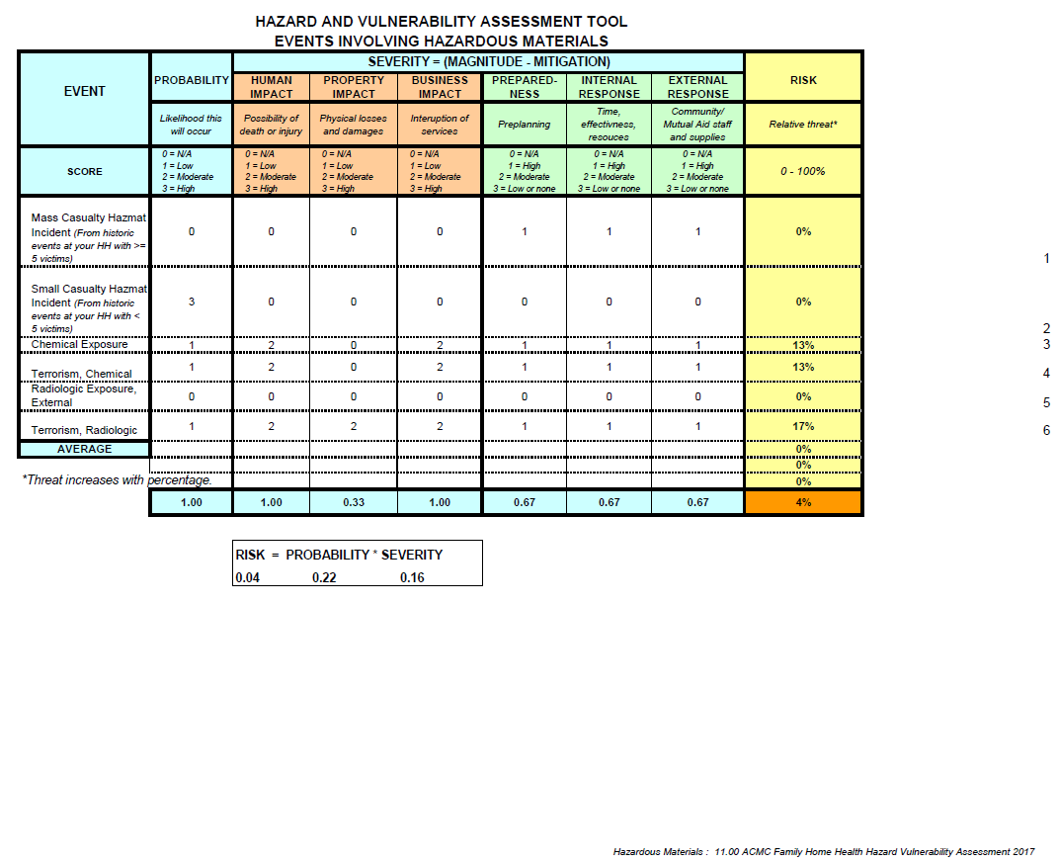

SUBJECT: | HOME HEALTH – HAZARD AND VULNERABILITY ANALYSIS | FILING #: EMG 11.00
 | HOME HEALTH – HAZARD AND VULNERABILITY ANALYSIS | PAGE: 7
DEPARTMENT: HOME HEALTH |  | OF: 7
 |  | EFFECTIVE:
APPROVED BY: SAFETY COMMITTEE |  | REVISED:
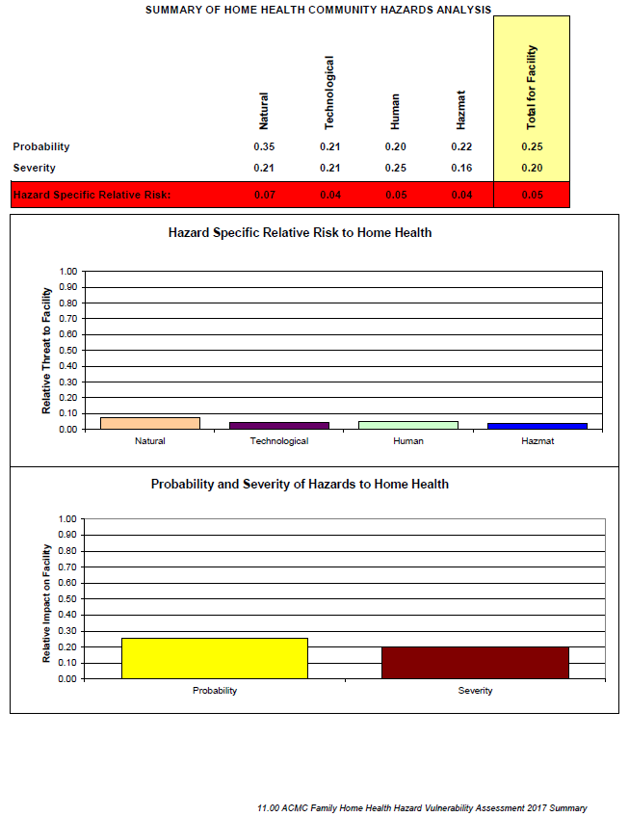

SUBJECT: | HOME HEALTH – EMERGENCY OPERATIONS PLAN | FILING #: EMG 11.01
 | HOME HEALTH – EMERGENCY OPERATIONS PLAN | PAGE: 1
DEPARTMENT: HOME HEALTH |  | OF: 11
 |  | EFFECTIVE: 11/14/2017
APPROVED BY: ACMC BOARD & PAC |  | REVISED:

SCOPE OF SERVICES:

ACMC Family Home Health Agency's Emergency Operations Plan's scope is to provide for a program that ensures effective mitigation, preparation, response and recovery to disasters or emergencies affecting the environment of care, and to assure continuation of care and/or services to the patient population served.

OBJECTIVE:

The objective of the Emergency Operations Plan is to effectively prepare for, manage an emergency and restore the Agency (HHA) to the same operational capabilities as pre-emergency levels.

DEFINITION:

- Emergency:

- A natural or human-made event that:

- Significantly disrupt the environment of care, i.e., damage to the organization’s building(s) and grounds due to severe winds, storms or earthquakes

- Significantly disrupts care, treatment and services, i.e., loss of utilities (such as power, water, or telephones) due to flood, civil disturbances, accidents or emergencies in the organization or the community it serves

- Results in sudden, significantly changed or increased demands for the organization’s services, i.e., bioterrorist attack, building collapse or plane crash in the organization’s community

SUBJECT: | HOME HEALTH – EMERGENCY OPERATIONS PLAN | FILING #: EMG 11.01
 | HOME HEALTH – EMERGENCY OPERATIONS PLAN | PAGE: 2
DEPARTMENT: HOME HEALTH |  | OF: 11
 |  | EFFECTIVE: 11/14/2017
APPROVED BY: ACMC BOARD & PAC |  | REVISED:

GOALS:

- The Goals of the Emergency Operations Plan Includes the Following:

- Identifying procedures to prepare and respond to potential disasters or emergencies

- Providing education to staff on the elements of the Emergency Operations Plan during orientation and annually thereafter

- Establishing and implementing procedures in response to an assortment of disasters and emergencies

- Identifying alternate sources for supplies and services in the event of a disaster or emergency

RESPONSIBILITY:

SPECIFIC PROCEDURES IN RESPONSE TO A VARIETY OF EMERGENCIES BASED ON A HAZARD VULNERABILITY ANALYSIS PERFORMED BY THE HHA:

ACMC Family Home Health Agency in coordination with Ashley County Medical Center has developed specific procedures in response to potential disasters and emergencies that may occur. Additionally, the HHA will perform routine hazard vulnerability analysis to identify areas of vulnerability and undertake provisions to lessen the severity and/or impact of a disaster or emergency that could affect the services provided by this organization.

- The HHA will establish priorities of the potential emergencies identified in the hazard vulnerability analysis which will need to have mitigation, preparation, response and recovery activities undertaken and procedures will be developed.

- List the potential disasters and emergencies that are specific to your location.

Flooding, Tornados, Severe Thunderstorm, Electrical Failure, Communications Failure

SUBJECT: | HOME HEALTH – EMERGENCY OPERATIONS PLAN | FILING #: EMG 11.01
 | HOME HEALTH – EMERGENCY OPERATIONS PLAN | PAGE: 3
DEPARTMENT: HOME HEALTH |  | OF: 11
 |  | EFFECTIVE: 11/14/2017
APPROVED BY: ACMC BOARD & PAC |  | REVISED:

DEFINE AND INTEGRATE THE HHA’S ROLE WITH THE COMMUNITYWIDE EMERGENCY MANAGEMENT EFFORTS TO PROMOTE INTER-OPERABILITY BETWEEN THE HHA AND THE COMMUNITY:

- Implementation of the HHA's Emergency Operations Plan will be conducted at least annually, either in response to an emergency or as a planned drill. If applicable, the HHA will participate in at least one communitywide drill annually that is relevant to the priority of emergencies identified in the hazard vulnerability analysis.

- The HHA’s Emergency Operations Plan identifies who is in charge of specific activities and when they are to assume oversight responsibilities.

- This HHA cooperates with all local, county and state emergency management drills. The Safety Director is a member of the countywide emergency management system and coordinates with other agencies any large scale drills. (Describe the level of cooperation that exists between the HHA and other disaster response agencies, i.e., fire department, police department, county disaster agencies in a specified geographic area.)

COMMAND STRUCTURE:

The command structure utilized by the ACMC Family Home Health in coordination with the communitywide command structure is with Ashley County Medical Center.

SUBJECT: | HOME HEALTH – EMERGENCY OPERATIONS PLAN | FILING #: EMG 11.01
 | HOME HEALTH – EMERGENCY OPERATIONS PLAN | PAGE: 4
DEPARTMENT: HOME HEALTH |  | OF: 11
 |  | EFFECTIVE: 11/14/2017
APPROVED BY: ACMC BOARD & PAC |  | REVISED:
COOPERATIVE PLANNING:

- ACMC Family HHA participates in cooperative planning for emergencies with the following healthcare organizations in our geographic area.

Phone Numbers Possibly Needed in an Emergency Situation:
Crossett Police Department (870)-364-4131
Crossett Fire Department ….(870)-364-2121
Crossett Ambulance Service………………………………………………………………………….(870)-364-2121
South Ark Ambulance Service………………………………….…..…...............................(870)-853-8033
Medical Center of South Arkansas (870)-864-3200
St. Francis Medical Center (Monroe, LA) (318)-327-4196
Morehouse General Hospital (Bastrop, LA) (318)-283-3609
Bradley County Hospital (870)-226-3731
Drew Memorial Hospital (870)-367-2411
Chicot Memorial Hospital (870)-256-5351
Arkansas Children’s Hospital, Little Rock, AR (501)-370-1100

Air Evac……………………………………………………………..………………………………………..….800-247-3822
Pafford Air One……………………………………………………..………………………………………..800-435-7663
Angel Flight 800-372-3637
Baptist Med Flight 800-227-1000
800-632-5433
Ashley County OEM (Office of Emergency Management)……………………....day (870)-853-2004
(501)-661-2136
Ashley County Emergency Coordinator (Tawana Miller)……………………………….(870)-940-0342
National Guard (870)-364-2023
Sheriff’s office (870)-853-2040
Ashley County Judge (870)-853-2000
FBI Field office (501)-221-9100
Arkansas Department of Emergency Management (870)-853-2070
Local Red Cross Coordinator…………….……………………..…………………………………….(870)-863-8196
Sandy Matheney, Chapter Director (cell) ……………..………………………………….…. (870)-866-5243
North Crossett Gas and Water.. (870)-364-2188

Ashley County Health Department……………………………………………….……………… (870)-364-2115
(870)-500-2630
Arkansas State Health Department (501)-661-2417
CDC Hospital Infections Program (404)-639-6413
Arkansas Bioterrorism Response Line (501)-280-4817
After hours and weekends……………………..….. (800)-554-5738
Bioterrorism Emergency Number (770)-488-7100
Arkansas Hospital Association (501)-224-7878
SUBJECT: | HOME HEALTH – EMERGENCY OPERATIONS PLAN | FILING #: EMG 11.01
 | HOME HEALTH – EMERGENCY OPERATIONS PLAN | PAGE: 5
DEPARTMENT: HOME HEALTH |  | OF: 11
 |  | EFFECTIVE: 11/14/2017
APPROVED BY: ACMC BOARD & PAC |  | REVISED:

Medical Staff Office Numbers

Felicia Brown……………………………………………………………………………………. (870)-853-8271
Luis Garcia……………………… (870)-364-4181
E.A. Gresham…………………………………………………………………………………… (870)-364-9111
Mark Malloy………………………………………………………………………………………(870)-364-9111
Kenneth Richards……………………………………………………………………………… (870)-364-8062
Barry Thompson……………………………………………………………………….…...….(870)-364-5746
Benjamin Walsh …………………………………………………………………………………(870)-364-9111
Bradley Walsh……………………………………………………………………………. …..…(870)-364-9111
Alan Wilson………………………………………………………………………….………...….(870)-364-0561
Warren McDonald ………………………………………………………………………………(870)-364-1490

Nurse Practioners

Cheryl Rabalais………………………………………………………………………………..…(870)-364-8062
Pamela Winston………………………………………………………………………….……..(870)-364-8062
Cindy Bryan……………………………………………………………………….……………… (870)-853-2871

SUBJECT: | HOME HEALTH – EMERGENCY OPERATIONS PLAN | FILING #: EMG 11.01
 | HOME HEALTH – EMERGENCY OPERATIONS PLAN | PAGE: 6
DEPARTMENT: HOME HEALTH |  | OF: 11
 |  | EFFECTIVE: 11/14/2017
APPROVED BY: ACMC BOARD & PAC |  | REVISED:

- During the cooperative planning sessions with these organizations, the following issues are discussed and identified:

- Elements of each organization’s command structures and operations centers

- List of names, responsibilities and phone numbers of individuals in each organization’s command structure

- List of resources that can be pooled/shared for response to emergency situations

- Mechanism to send information on patients and deceased individuals to cooperating organizations to help facilitate identification and location of victims of the emergency

INITIATING THE PLAN, INCLUDING DESCRIPTION OF PLAN ACTIVATION:

- The plan will be initiated when it has been determined that a disaster or emergency has occurred or has the potential for occurring.

- Definition of Emergency:

- An emergency is any unplanned event that can cause deaths or significant injuries to patients, staff or the public; or can shutdown the HHA, disrupt operations, cause physical or environmental damage or threaten the HHA’s financial standing or public image.

- When the HHA is notified of an emergency, the person receiving notification will immediately notify Ashley County Medical Center CEO, in the event of his/her absence, of the situation whether it be an internal or external emergency. The CEO or his/her designee will evaluate the emergency to determine whether the Emergency Operations Plan will be activated, with the Board of Directors immediately notified of positive activation at CEO discretion. If the plan is to be activated, the CEO or his/her designee will notify the staff.

SUBJECT: | HOME HEALTH – EMERGENCY OPERATIONS PLAN | FILING #: EMG 11.01
 | HOME HEALTH – EMERGENCY OPERATIONS PLAN | PAGE: 7
DEPARTMENT: HOME HEALTH |  | OF: 11
 |  | EFFECTIVE: 11/14/2017
APPROVED BY: ACMC BOARD & PAC |  | REVISED:

The Safety Director will notify the agency of additional outside agencies that may need to assist the HHA in the event of an internal emergency, i.e., fire department - flood or gas leak.

- The recovery phase will be initiated after a Damage Assessment has been conducted once the emergency is over. The recovery phase of the plan will be initiated by the Administrator or his/her designee.

NOTIFICATION OF STAFF WHEN EMERGENCY RESPONSE MEASURES ARE INITIATED:

In an emergency which is so wide-spread to be considered an emergency and/or involving mass casualties, all HHA staff, regardless of position are expected to report to the Ashley County Medical Center for duty as soon as it is feasible to travel. The HHA maintains a current callback list of all staff. The Administrator will initiate the callback list as necessary

IDENTIFICATION OF STAFF IN EMERGENCIES:

Staff on duty during activation of the Emergency Operations Plan will be identified by picture identification nametag which is to be worn at all times, by all staff while on duty.

MANAGEMENT OF PATIENTS DURING EMERGENCIES (I.E., MODIFICATION OR DISCONTINUATION OF SERVICES, AND CONTROL OF PATIENT INFORMATION):

- Active patient demographic and clinical data is updated and kept available for review during an emergency event, on an ongoing basis.

- The admission nurse/licensed therapist is responsible for identifying patients with special needs during the admission process and will document these needs for review during an emergency event.

- The HHA will keep and maintain a current list of contact information for staff, emergency services, hospitals and other appropriate community resources.

- On admission, each patient will be assigned a priority code, dictating patient emergency rating. A list of patient contact information will be obtained, as well as emergency planning options with patient and family. Information will be kept in patient’s chart as electronic format. Each calendar will be flagged with the priority code.
SUBJECT: | HOME HEALTH – EMERGENCY OPERATIONS PLAN | FILING #: EMG 11.01
 | HOME HEALTH – EMERGENCY OPERATIONS PLAN | PAGE: 8
DEPARTMENT: HOME HEALTH |  | OF: 11
 |  | EFFECTIVE: 11/14/2017
APPROVED BY: ACMC BOARD & PAC |  | REVISED:

- The Case Manager/Clinical Supervisor is responsible for maintaining an updated and current log of patients with special needs.

- During an actual event staff may use an abbreviated assessment for the patients. See 11.00-5

The following triage system would be initiated to ensure client/patient needs are met;
Class I-Potential to be life threatening without care. Requires ongoing treatment to preserve life. Unable to evacuate/transport self. Unable to withstand any interruption in power supply. No readily available caregiver or caregiver unable to provide needed care. Requires transportation to acute care facility or specialized shelter situation. (Example Ventilator dependent)
Class II-Not immediately life threatening but patient may suffer adverse effect without services. Visits may be postponed 24-48 hours with minimal adverse effect. Able to withstand up to 48 hours of power interruption. Unable to transfer/transport self or no transportation available from caregiver. (example: O2 dependent with severe COPD, insulin dependent and unable to self-inject: large open draining wound with potential for sepsis, IV antibiotics, etc.
Class III-Low potential for adverse effect if visits are delayed for 48 to 72 hours. Able to care for self or willing and able caregiver readily available. Transportation available from family friends, volunteers, or caregiver. (Example O2 dependent with adequate O2 supply and means to have tanks refilled. New insulin dependent diabetic who can self-inject and perform glucometer checks but needs home support or further education, tube feeding. etc.)

Class IV-Visits may be postponed 72 hours or more with little or no adverse effects. Willing and able caregiver readily available or patient independent in most ADLs. Transportation available from family, friends. (Example: Blood pressure monitoring Foley catheter changes, etc.)

SUBJECT: | HOME HEALTH – EMERGENCY OPERATIONS PLAN | FILING #: EMG 11.01
 | HOME HEALTH – EMERGENCY OPERATIONS PLAN | PAGE: 9
DEPARTMENT: HOME HEALTH |  | OF: 11
 |  | EFFECTIVE: 11/14/2017
APPROVED BY: ACMC BOARD & PAC |  | REVISED:

- During an emergency event, supervisory and field staff will contact active patients to evaluate and assist with the patient's arrangements concerning evacuation plans, if any. Patients are reminded at this time that ACMC Family HHA staff do not make home visits during a time of acute disaster and are instructed in arrangements provided by the county disaster team. Patients living in trailers or mobile homes may be advised to leave for the nearest shelter.

- Clinical Supervisors and/or designee will prepare hard copy lists of active patients and staff. One copy of each list and a copy of field staff assignments is distributed to the Administrator and to the Patient Care Services Director or designee

- Emergency Operations Plan instructions given to the patient/family should be documented in the patient's medical record.

WHEN A POTENTIAL DISASTER IS ANTICIPATED:
- Administrator and senior management staff closely monitor media communications and evaluate all potential disaster situations.

- Administrator or designee will inform office and supervisory staff of identified dangers.

- ACMC Family Home Health Director shall alert field staff via telephone and pager systems of identified dangers.

STAFF ACTIVITIES AND SUPPORT:

- The HHA will provide for staff support activities in the event of an emergency, which include, but may not be limited to:

- Housing/lodging needs

- Transportation needs

- Family support needs, as necessary

- Incident stress debriefing and counseling

SUBJECT: | HOME HEALTH – EMERGENCY OPERATIONS PLAN | FILING #: EMG 11.01
 | HOME HEALTH – EMERGENCY OPERATIONS PLAN | PAGE: 10
DEPARTMENT: HOME HEALTH |  | OF: 11
 |  | EFFECTIVE: 11/14/2017
APPROVED BY: ACMC BOARD & PAC |  | REVISED:

CONTINUING AND/OR RE-ESTABLISHING OPERATIONS FOLLOWING AN EMERGENCY:

- The HHA has mechanisms in place to restore the operational capabilities of the HHA to pre-emergency levels.

- Staff are to report to Ashley County Medical Center by telephone or in person as soon as possible after the acute emergency has passed.

- The Administrator and/or Patient Care Services Director or designee other shall verify staff reporting in against the Active Employee List.

- As staff becomes available, the Administrator and/or Patient Care Services Director or designee will assign staff to begin the assessment of patient circumstances.

- Patient care and/or services will not resume until the appropriate authorities have announced that it is safe to resume normal business activities.

- The Administrator will report any individuals not accounted for to the appropriate authorities.

BACKUP COMMUNICATION SYSTEM:

The HHA will provide for alternate communication methods in the event of a failure. Two-way radio equipment and cell phones shall be available in the event of an emergency.

ORIENTATION AND EDUCATION PROGRAM FOR THOSE WHO PARTICIPATE IN IMPLEMENTING THE PLAN:

Staff will attend orientation upon hire and an annual update of their specific roles and responsibilities and the skills they require to perform their duties during an emergency. Agency is responsible for in servicing staff at the organization wide Emergency Operations Plan.

SUBJECT: | HOME HEALTH – EMERGENCY OPERATIONS PLAN | FILING #: EMG 11.01
 | HOME HEALTH – EMERGENCY OPERATIONS PLAN | PAGE: 11
DEPARTMENT: HOME HEALTH |  | OF: 11
 |  | EFFECTIVE: 11/14/2017
APPROVED BY: ACMC BOARD & PAC |  | REVISED:

ANNUAL EVALUATION OF THE EMERGENCY OPERATIONS PLAN'S OBJECTIVES, SCOPE, PERFORMANCE AND EFFECTIVENESS:

- The annual evaluation of the Emergency Operations Plan will include a review of the scope according to the current accrediting organization standards to evaluate the degree in which the program meets accreditation standards and the current risk assessment of the HHA. A comparison of the expectations and actual results of the program will be evaluated to determine if the goals and objectives of the program were met.

- The performance and effectiveness of the Emergency Operations Plan shall be reviewed by the Administration and Board of Directors.

ADDITIONAL TOOL:

Society of Pediatric Nurses, Disaster Management for Children and Families, 05/07/2014, http://www.pedsnurses.org/p/cm/ld/fid=57&tid=28&sid=50

SUBJECT: | HOME HEALTH – EQUIPMENT AND SUPPLIES | FILING #: EMG 11.02
 | HOME HEALTH – EQUIPMENT AND SUPPLIES | PAGE: 1
DEPARTMENT: HOME HEALTH |  | OF: 2
 |  | EFFECTIVE: 11/14/2017
APPROVED BY: ACMC BOARD & PAC |  | REVISED:

POLICY:

- Procedures shall be established and followed to ensure the availability of supplies and equipment needed during an emergency.

- Secretary shall monitor if needed the quantities of resources and assets during an emergency/disaster.

PROCEDURE:

- Preparations must be made to provide adequate essential HHA supplies and equipment to permit expanded operation for at least 2 week(s) and to ensure the most efficient use of these resources.

- Preparations must include the following:

- Standardized emergency/disaster treatment techniques to ensure the most economical use of medical supplies.

- Assess available resources by:

- Estimating emergency material needs

- Performing an inventory of essential items on hand

- Determining probable shortages (allowing for improvisation and substitution whenever possible)

- Offset shortages by:

- Increasing current inventories of essential items to the degree possible

- Rotate supplies that are subject to deterioration.

- Assemble emergency supplies into sets and locate the sets for easy accessibility to the using area.

SUBJECT: | HOME HEALTH – EQUIPMENT AND SUPPLIES | FILING #: EMG 11.02
 | HOME HEALTH – EQUIPMENT AND SUPPLIES | PAGE: 2
DEPARTMENT: HOME HEALTH |  | OF: 2
 |  | EFFECTIVE: 11/14/2017
APPROVED BY: ACMC BOARD & PAC |  | REVISED:

- ACMC Family Home Health shall share surplus resources and assets with healthcare organizations inside and outside of the community, as appropriate.

- Resources/assets to be shared may include:

- Personal protective equipment

- Medical equipment

- Medical supplies

SUBJECT: | HOME HEALTH – MANAGEMENT OF PATIENTS DURING DISASTER | FILING #: EMG 11.03
 | HOME HEALTH – MANAGEMENT OF PATIENTS DURING DISASTER | PAGE: 1
DEPARTMENT: HOME HEALTH |  | OF: 1
 |  | EFFECTIVE: 11/14/2017
APPROVED BY: ACMC BOARD & PAC |  | REVISED:
POLICY:

- HHA staff will not evacuate patients from their homes.

- HHA staff will not visit patient homes until local law enforcement states that travel is safe. The ACMC CEO, in coordination with the Medical Director and ACMC Family Home Health Director, shall decide how to proceed with patient care during an emergency/disaster.

- Depending upon the type of emergency disaster, patient care, treatment and services may be:

- Rescheduled

- Modified

- Discontinued

- Patients and caregivers shall be notified (if possible) when there is a change in scheduling.

- If the HHA can no longer provide patient care, treatment or services, patients shall be referred to another HHA or hospital, as applicable.

- HHA may arrange transportation of patients to another HHA or hospital, as applicable.

SUBJECT: | HOME HEALTH – NOTIFICATION TO PATIENTS | FILING #: EMG 11.04
 | HOME HEALTH – NOTIFICATION TO PATIENTS | PAGE: 1
DEPARTMENT: HOME HEALTH |  | OF: 1
 |  | EFFECTIVE: 11/14/2017
APPROVED BY: ACMC BOARD & PAC |  | REVISED:

POLICY:

- HHA staff shall communicate Emergency Operations Plan to patients and families as appropriate.

- Patient and family communication shall be addressed:

- Verbally by staff

- By print material given at the time of admission

- By phone calls, emails

SUBJECT: | HOME HEALTH – ABBREVIATED ASSESSMENT TOOL | FILING #: EMG 11.05
 | HOME HEALTH – ABBREVIATED ASSESSMENT TOOL | PAGE: 1
DEPARTMENT: HOME HEALTH |  | OF: 2
 |  | EFFECTIVE: 11/14/2017
APPROVED BY: ACMC BOARD & PAC |  | REVISED:
AGENCY NAME_________________________________________________________________
Abbreviated Assessment
(M0040) Patient Name: ___________________________________________________________

Date:______________

(M0064) SS# ________________________

Address: _______________________________________________________________________

(M0066) D.O.B: __________________ (M0069) Gender: _________________________________

Primary Physician:________________________________________________________________

Primary Problem/Reason for Admission: ______________________________________________

_______________________________________________________________________________

Significant Medical History: _________________________________________________________

_______________________________________________________________________________

_______________________________________________________________________________

Assessment:
Temp: ______ HR: _____ Rhythm ________ BP_______ Resp: ______

Lung Sounds:_______ SOB_________ Edema_______ Pain:________

Location: ____________
Infection control precautions: MRSA____ C-dif______ VRE ______ Other ____________________

Type of precautions:
Standard _____ Airborne______ Contact ______

Other Pertinent Finding:___________________________________________________________
_______________________________________________________________________________

Mental Status:_______________________ Functional Status/Activities: ______________________
_______________________________________________________________________________
Clinician Signature/Title/Date: _______________________________________________________
Diet/Nutritional Status/Hydration: _____________________________________________________
SUBJECT: | HOME HEALTH – ABBREVIATED ASSESSMENT TOOL | FILING #: EMG 11.05
 | HOME HEALTH – ABBREVIATED ASSESSMENT TOOL | PAGE: 2
DEPARTMENT: HOME HEALTH |  | OF: 2
 |  | EFFECTIVE: 11/14/2017
APPROVED BY: ACMC BOARD & PAC |  | REVISED:

Support System/Assistance: ________________________________________________________
Home Environment: _______________________________________________________________
Safety Concerns: _________________________________________________________________
Equipment: _______________ Homebound Status: ______________________________________
Emergency contact name /phone: _____________________________________
Treatments and Visit Frequency: ______________________________________________________ _________________________________________________________________________________
Goals: ________________________________________________
Advanced Directives: __________________________________________
Allergies: ____________________________________________________
Medications

Drug | Dosage | Frequency | Route

____________________________________________________________________________________
Clinician Signature

SUBJECT: | HOME HEALTH – UTILITY SYSTEMS FAILURE OR DISRUPTION | FILING #: EMG 11.06
 | HOME HEALTH – UTILITY SYSTEMS FAILURE OR DISRUPTION | PAGE: 1
DEPARTMENT: HOME HEALTH |  | OF: 2
 |  | EFFECTIVE: 11/14/2017
APPROVED BY: ACMC BOARD & PAC |  | REVISED:

POLICY:

- Utility system components, which meet ACMC Family Home Health criteria for essential equipment, shall have emergency procedures in the event a malfunction or failure occurs. Utility system components considered criteria for essential equipment include life support, infection prevention and control, support of the environment, equipment support or communication whose malfunction or failure may result in an adverse patient outcome.

- The Director is responsible for coordinating activities and ensuring procedures are developed that specify the action to be taken during the failure of major utility services. Emergency procedures shall include:

- Procedures to follow when a utility system malfunctions

- Alternate sources of essential utilities

- Shut-off procedures and controls of malfunctioning system

- Procedures for notifying staff in the affected areas

- How to obtain repair services

PROCEDURE:

- In the event of a utility system failure, the following procedure shall be followed by clinical department staff.

- Procedures to follow until the utility system can be restored to normal function, i.e., water distribution failure, where and how to obtain bottled water, water conservation methods, rationing.

- Conditions in which the utility may be shut off

- Assign authority to use the shut-off controls

- How to report a failure or interruption

- Obtaining emergency repair services

- Specific information on emergency clinical interventions
SUBJECT: | HOME HEALTH – UTILITY SYSTEMS FAILURE OR DISRUPTION | FILING #: EMG 11.06
 | HOME HEALTH – UTILITY SYSTEMS FAILURE OR DISRUPTION | PAGE: 2
DEPARTMENT: HOME HEALTH |  | OF: 2
 |  | EFFECTIVE: 11/14/2017
APPROVED BY: ACMC BOARD & PAC |  | REVISED:

Procedures to be followed until restoration of utilities:

- Contact Entergy and notify them of the outage 1-800-ENTERGY.

- Notify Ashley County Medical Center administration of water and/or power outage.

- Water is to be conserved when available.

- In the event of power failure ACMC Family Home Health staff will contact patients per cell phones.

- If electricity needs to be cut off the main power for the agency is located to the left of the back door. Pull down the lever from the on position to the off position.

- All personnel of ACMC Family Home Health in a major disaster will be moved to Ashley County Medical Center.

- Ashley County Emergency Coordinator-Tawana Miller (870-940-0342) may be notified by ACMC Administration to obtain supply and assistance.

- State Health Department
1300 W 5th Ave, Crossett, AR 71635
(870) 364-2115

SUBJECT: | HOME HEALTH – COMMUNICATIONS PROCESSES DURING AN EMERGENCY/DISASTER | FILING #: EMG 11.07
 |  | PAGE: 1
DEPARTMENT: HOME HEALTH |  | OF: 3
 |  | EFFECTIVE: 11/14/2017
APPROVED BY: ACMC BOARD & PAC |  | REVISED:
POLICY:

- Emergency management communications must be efficient, reliable and properly maintained.

- Communications must be maintained within the HHA, Ashley County Medical Center, with patients and families and to critical community partners.

- Common terminology (that is, the use of plain English) shall be used by all HHA staff, local emergency management, law enforcement, EMS, fire departments and public health staff.

- ACMC Family Home Health’s back-up communication processes include each person using their personal cell phone, AWIN and fax. AWIN will be kept in Directors office.

- AWIN will be tested first Tuesday of every month using common terms. AWIN will be charged at all times. (Example: Radio 4 Loud and clear)

- Ashley County Medical Center/ACMC Family Home Health resources directory shall be maintained.

PROCEDURE:

- The telephone system must be safeguarded from overloading during an emergency/disaster whenever possible.

- Back-up communication processes and technologies shall be in place, i.e., cell phones, land lines, wireless local area network (LAN), bulletin boards, fax machines, satellite phones, ham radios, 800 MHz radios, text messaging.

SUBJECT: | HOME HEALTH – COMMUNICATIONS PROCESSES DURING AN EMERGENCY/DISASTER | FILING #: EMG 11.07
 |  | PAGE: 2
DEPARTMENT: HOME HEALTH |  | OF: 3
 |  | EFFECTIVE: 11/14/2017
APPROVED BY: ACMC BOARD & PAC |  | REVISED:

- Two-way radio equipment (i.e., HEAR System) and operators who are familiar with the equipment shall be available in the event of an emergency.

- All incoming and outgoing messages will be routed through the Command Center.

- Communication will be limited to messages essential to emergency operations.

- Incoming and external communication shall include:

- Other Hospital Command Centers in the contiguous geographic area

- Alternate care sites

- Community emergency services

- Fire department

- Police

- Other officials with emergency responsibilities

- When telephone extensions to the Command Center are tied up, incoming calls will be switched to messenger staff who will copy the messages and route them to the Command Center.

- All messenger-borne and radio-transmitted messages will be on 8x11/letter-sized paper showing:

- The date and time sent or received

- The names and titles of the addressee and the sender

SUBJECT: | HOME HEALTH – COMMUNICATIONS PROCESSES DURING AN EMERGENCY/DISASTER | FILING #: EMG 11.07
 |  | PAGE: 3
DEPARTMENT: HOME HEALTH |  | OF: 3
 |  | EFFECTIVE: 11/14/2017
APPROVED BY: ACMC BOARD & PAC |  | REVISED:

- A message log will be maintained by a clerk in the Command Center.

- HHA staff shall communicate with the office and patients via phone, internet, email or fax.

- When the Emergency Operations Plan is activated, staff shall be notified using the Emergency Management Call-Back Tree, as appropriate.

- Staff will be asked to come to Ashley County Medical Center as needs become known.

- A Responder List shall be maintained.

- All physicians who have referred patients shall be notified that the Emergency Operations Plan has been activated.

SUBJECT: | HOME HEALTH – EMERGENCY MANAGEMENT HANDOUT | FILING #: EMG 11.08
 | HOME HEALTH – EMERGENCY MANAGEMENT HANDOUT | PAGE: 1
DEPARTMENT: HOME HEALTH |  | OF: 2
 |  | EFFECTIVE: 11/14/2017
APPROVED BY: ACMC BOARD & PAC |  | REVISED:
PATIENT AND FAMILY EDUCATION HANDOUT
EMERGENCY MANAGEMENT

- Always be prepared for a sudden emergency. Be sure to have enough necessities on hand and ask family and/or friends for any help.
- You may be notified of a possible emergency by NOAA weather radio, commercial radio and television stations and/or door-to-door warning from local emergency officials. Follow their instructions!
- Call 911 for any medical emergencies.
- Select an emergency contact to provide transportation if you need medical emergency care.
- Assemble a survival kit which should include the following at a minimum:
- First aid kit
- Three (3) days worth of medications, including a list of the medications you take regularly and their dosages, the name of the physician prescribing it and a list of any allergies
- If you use insulin, pre-fill syringes for three (3) days
- If you use medical supplies, have an extra three (3) day supply available
- List of physicians and relatives/friends who should be notified should you be injured
- List of important documents, including any documents for your pets, in a water-proof container
- Store a flashlight, battery operated radio and extra batteries in case of a power loss
- Whistle
- Manual can opener
- Have cash (including coins) on hand to help you through the emergency period
- ATM machines and banks will not be in operation without electricity and stores will not be able to accept credit cards.
- Keep important documents together
- If you use oxygen, arrange for a back-up unit.
SUBJECT: | HOME HEALTH – EMERGENCY MANAGEMENT HANDOUT | FILING #: EMG 11.08
 | HOME HEALTH – EMERGENCY MANAGEMENT HANDOUT | PAGE: 2
DEPARTMENT: HOME HEALTH |  | OF: 2
 |  | EFFECTIVE: 11/14/2017
APPROVED BY: ACMC BOARD & PAC |  | REVISED:
- Store three (3) days worth of non-perishable food and water; you will need one (1) gallon of water per day per person.
- Store pet food, if applicable.
- You will also need:
- Change of clothing
- Blanket or sleeping bag
- Personal hygiene supplies
- Phone numbers of relatives and/or friends
- Insurance agent’s name and telephone number
- Have your supplies packed and ready in one place before an emergency/natural disaster strikes. Be sure the container that you put your emergency supplies into has an ID tag or is marked with your name.
- Label any equipment, such as wheelchairs, canes or walkers.
- Arrange for a back-up power source for any medical equipment that operates on electricity.
- Make arrangements to stay with relatives or friends in the event of an emergency.
- If necessary, make arrangements in advance for special transportation and/or to stay at a shelter.
- If you are instructed to evacuate your home:
- Call ACMC Family Home Health Agency and give the address and telephone number where you can be reached
- Turn off electricity and water
- Leave immediately, even if the weather is nice
- Stay away from any electrical wires
- Remember to lock your windows and doors when you evacuate
- ACMC Family Home Health will arrange or help arrange delivery of extra supplies, back-up equipment, i.e., generators for patients with oxygen, “gravity” equipment for infusion of intravenous fluids.
Please be aware that during an emergency, ACMC Family Home Health staff
will NOT be providing service in areas that have been designated as unsafe!

SUBJECT: | HOME HEALTH – TORNADO-WINDSTORM (CODE WHITE) | FILING #: EMG 11.09
 | HOME HEALTH – TORNADO-WINDSTORM (CODE WHITE) | PAGE: 1
DEPARTMENT: HOME HEALTH |  | OF: 2
 |  | EFFECTIVE: 11/14/2017
APPROVED BY: ACMC BOARD & PAC |  | REVISED:

ACMC Family Home Health Director or Designee is responsible for planning personnel coverage, supply and equipment requirements, and the security of their areas, except as otherwise outlined, in severe weather conditions; each department will develop safety measures specific to their own departments.

PHASES OF OPERATION:

1. Tornado Watch: Severe weather conditions are expected in the area and personnel should be on the alert for actual warnings. Preliminary precautions to safeguard life and property should be taken.

2. Tornado Warning: Severe weather conditions are imminent. Complete all possible precautions immediately to safeguard life and property.

3. All Clear: Severe weather conditions no longer exist in the area.

CONTROL CENTER:

The control center for the duration of the emergency will be located in the Office of the Administrator.

After Code White has been paged at Ashley County Medical Center, Emergency Room Switchboard will notify, ACMC Family Home Health of the Code White status.

INSTRUCTIONS FOR TORNADO WATCH PHASE:

Preliminary precautions will consist of reviewing procedures defined in the “Instructions for Warning Phases” section, should weather conditions become imminent.

INSTRUCTIONS FOR WARNING PHASES:

1. Control Center will be in operation in the office of the ACMC Administrator until the “All Clear” is announced.

2. All personnel are to get away from windows and possible flying glass.

3. Office secretary/Nursing staff will gather patient census, current list of contact information, computers, Call log, Schedule log, patient calendar, patient rovers (if possible), hospitals and community resources until Code White is clear.
SUBJECT: | HOME HEALTH – TORNADO-WINDSTORM (CODE WHITE) | FILING #: EMG 11.09
 | HOME HEALTH – TORNADO-WINDSTORM (CODE WHITE) | PAGE: 2
DEPARTMENT: HOME HEALTH |  | OF: 2
 |  | EFFECTIVE: 11/14/2017
APPROVED BY: ACMC BOARD & PAC |  | REVISED:

4. Any electrical equipment that is not necessary should be turned off.

5. All employees and visitors will be moved away from windows as an additional precaution against hazards of broken glass.

6. Check flashlights and other emergency equipment to ensure that they are operational: procure spare batteries and lights as necessary.

7. In the event of damage, report to the Administrator, by names, employees available for emergency duties outside assigned departments. All requests for additional employees shall be submitted to the Director of Personnel Services.

8. Engineering Department will issue to the department, as needed, spare batteries, flashlights and other necessary supplies and equipment.

9. Employees should be advised that if they are required to remain on duty beyond their normal work schedule, appropriate compensation will be made.

ACTUAL DAMAGE TO HOME HEALTH:

Should ACMC Family Home Health sustain damage from an actual tornado or wind storm, Internal Disaster plan will be implemented and staff will relocate to Ashley County Medical Center for further instructions. Notify ACMC Administrator if assistance is needed to relocate to Ashley County Medical Center.

INSTRUCTIONS FOR ALL CLEAR:

1. Notification will be from the Administrator’s office by phone, messengers, or paging system, “Code White clear.”

2. Switchboard will notify ACMC Family Home Health that Code White is clear.

3. At that time, the immediate danger of severe weather will have moved on.

4. Employees having performed long, arduous hours of duty will be relieved as soon as possible.

5. In the event of Tornado Warning, Home Health employees who are in the office will take cover in the rear of the building in the restroom area where no windows until severe weather has passed. Employees who are traveling should get to a safe area until severe weather has passed. Employees should not continue to travel or try to outrun the storm.
6. Normal operations shall be resumed as quickly as possible.
SUBJECT: | HOME HEALTH – FLOODING OF ROADWAYS | FILING #: EMG 11.10
 | HOME HEALTH – FLOODING OF ROADWAYS | PAGE: 1
DEPARTMENT: HOME HEALTH |  | OF: 3
 |  | EFFECTIVE: 11/14/2017
APPROVED BY: ACMC BOARD & PAC |  | REVISED:
PURPOSE:

To outline a planned, coordinated strategy to promote the safety and continuation of care, treatment and/or services to ACMC Family Home Health patients in the event of flooding of roadways.

POLICY:

- ACMC Family Home Health staff shall be educated on the policy of the flooding of roadways yearly.

- ACMC Family Home Health patients shall be informed of the Natural Disaster Plan during the orientation.

TERMINOLOGY:

- Flood Watch: Flooding is possible in your area.

- Flash Flood Watch: Flash flooding (rapidly rising water) is possible. Be prepared to move to higher ground.

- Flood Warning: Flooding is occurring or will occur soon. If advised to evacuate. Do so immediately.

- Flash Flood Warning: A flash flood is occurring; seek higher ground immediately. Never attempt to drive through flooded roads.

PROCEDURE:

- Access of all roadways will be monitored by Director and/or Designee.

- Patients will be rescheduled as needed.

- As water recedes and roadways open those patient will be rescheduled.

- No personnel is to drive across any roadway or bridges that are flooded.

- If conditions are too unsafe for employees visits may be canceled and patients notified.

SUBJECT: | HOME HEALTH – FLOODING OF ROADWAYS | FILING #: EMG 11.10
 | HOME HEALTH – FLOODING OF ROADWAYS | PAGE: 2
DEPARTMENT: HOME HEALTH |  | OF: 3
 |  | EFFECTIVE: 11/14/2017
APPROVED BY: ACMC BOARD & PAC |  | REVISED:

Internal Floods

- Upon identification of flooding in a building, initiate emergency preparedness plan and assess area for structural damage.

- If able, move items that are in danger of damage to a secure location.

- Turn off all electrical appliances if able.

- Activate emergency communication with staff alerting them not to report to the office until clear.

External Flooding

- If any flood watch or warning is announced for your area, the following should be initiated:
- Evaluate patients’ demographics and access to homes in case of flooding.
- Triage patient visits prior to flooding, if possible.
- Assess all patients’ ability to respond to floods and potential evacuation.
- Assess all patients’ level of supplies (medicine, medical supplies, oxygen, food, water).
- Ensure patients have communication available for emergency updates via television, radio or telephone.
- Encourage patients to have a “grab and go” kit including medication, medication list, health information, contact information, charged batteries, cell phone, flashlight, durable medical equipment/medical supplies, change of clothing, cash, food and water.
- Ensure patient knows evacuation locations and plan.

Flood Watch is Issued and you are in the patients home:
- If able, move to a higher floor of home.
- Arrange transportation in case an evacuation is ordered.

Flood Warning is Issued and you are in the patients home:
- Follow the above actions and stay alert to news stations for evacuation alerts.
- If EVACUATION alert is given, gather “grab and go” kit and evacuate immediately.
- Once you are safely at the evacuation area, notify the home care office.

SUBJECT: | HOME HEALTH – FLOODING OF ROADWAYS | FILING #: EMG 11.10
 | HOME HEALTH – FLOODING OF ROADWAYS | PAGE: 3
DEPARTMENT: HOME HEALTH |  | OF: 3
 |  | EFFECTIVE: 11/14/2017
APPROVED BY: ACMC BOARD & PAC |  | REVISED:

Flash Flood Watch is Issued and you are in a patient’s home:
- Be alert to signs of flash flooding (rapidly rising water).
- Be prepared to move to higher ground.
- Never drive onto roads that are covered with water.

Flash Flood Warning is Issued and you are in a patient’s home:
- EVACUATE IMMEDIATELY (you may only have seconds to escape).
- Move to an area away from streams, creeks, rivers, and storm drains.
- Do not drive around barricades.
- Do not drive onto roads that are covered with water.
- If car stalls in rapidly rising water, abandon car and climb to higher ground immediately.

After the Flood
- Listen to reports to learn when it is safe to return.
- Listen to reports to learn if the water supply is safe to drink.
- Avoid floodwaters. Floodwaters are often contaminated and may be electrically charged.
- Inspect property and building for structural damage, sewer system damage, and well water contamination. Do not enter a building if the framing or foundation are damaged.
- Clean and disinfect everything that got wet. Discard all food that came in contact with floodwaters, including canned goods.
- Notify your supervisor that you have returned to your home.

SUBJECT: | HOME HEALTH – WINTER WEATHER MANAGEMENT | FILING #: EMG 11.11
 | HOME HEALTH – WINTER WEATHER MANAGEMENT | PAGE: 1
DEPARTMENT: HOME HEALTH |  | OF: 3
 |  | EFFECTIVE: 11/14/2017
APPROVED BY: ACMC BOARD & PAC |  | REVISED:
POLICY:
Winter weather can cause dangerous situations for staff and patients. Winter weather can range from accumulating snow to ice conditions. Winter weather can make driving hazardous and cause barriers to entry into patients’ homes. Prior to performing visits, assess if the patient has been able to clear sidewalks and driveways of ice and snow.

Terminology
Severe Winter Storm: A severe winter storm is a storm that produces four or more inches of snow in a 12-hour period or six or more inches during a 24-hour period.

Winter Storm Watch: Indicates that severe winter weather may affect your area

Winter Storm Warning: Indicates that a winter storm is occurring, or will occur, in your area.

Freezing Rain: Rain that freezes when it hits the ground, creating a coating of ice on roads, walkways, trees, and power lines.

Sleet: Rain that turns to ice pellets before reaching the ground. Sleet causes moisture on roads to freeze and become slippery.

Ice Storms: Occur when freezing rain falls from clouds and freezes immediately when it touches the ground.

PROCEDURE
During winter season all staff should prepare and assess vehicles for winter weather conditions:
- Vehicle: Make sure to use windshield fluid with a freeze factor below 32 degrees F and antifreeze.
- Always have a full tank of gas. Assess tire tread for wear and replace if needed.
- Equipment: Include an emergency kit with jumper cables, flares, windshield ice scraper, shovel/broom, ice melt or kitty litter, flashlight, blankets, change of clothing, food and water, charged cell phone, and first aid kit.
- Before storm season arrives, identify individuals with four-wheel drive vehicles and the ability to use alternative means of transportation. Director can contact Engineering for assistance as needed.

SUBJECT: | HOME HEALTH – WINTER WEATHER MANAGEMENT | FILING #: EMG 11.11
 | HOME HEALTH – WINTER WEATHER MANAGEMENT | PAGE: 2
DEPARTMENT: HOME HEALTH |  | OF: 3
 |  | EFFECTIVE: 11/14/2017
APPROVED BY: ACMC BOARD & PAC |  | REVISED:

Initiate communication with patients including:
- Evaluate patients’ demographics and assess main roads/snow removal plan.
- Evaluate patients’ level of supplies (medicine, medical supplies, oxygen, food and water).
- Update patient acuity and assess visit schedule needs for next 1-2 days. Use patient classification system for determining triage of patients.

During Winter Event

- The ACMC Family Home Health Director/Designee will review classification of patients and help with assigning patients per the classification system.

- Triage patient visits based on classification system.

- Monitor emergency weather and road condition reports.

- Prior to patient visit, inquire if there is safe access to home (e.g., ice/snow accumulation prohibiting entry).

- All incoming and outgoing messages will be routed to the Director.

- Two-way radio equipment shall be available in the event of an emergency.

- Communication will be limited to messages essential to emergency operations.

- Incoming and external communication shall include:

- Any communications from Ashley County Medical Center

- Alternate care sites

- Community emergency services

- Fire department

- Police

- Other officials with emergency responsibilities

SUBJECT: | HOME HEALTH – WINTER WEATHER MANAGEMENT | FILING #: EMG 11.11
 | HOME HEALTH – WINTER WEATHER MANAGEMENT | PAGE: 3
DEPARTMENT: HOME HEALTH |  | OF: 3
 |  | EFFECTIVE: 11/14/2017
APPROVED BY: ACMC BOARD & PAC |  | REVISED:

- When telephone extensions to the Director are tied up, incoming calls will be switched to messenger staff who will copy the messages and route them to the Director.

- All messenger-borne and radio-transmitted messages will be on 8x11/letter-sized paper showing:

- The date and time sent or received

- The names and titles of the addressee and the sender a message log will be maintained by the secretary in the Home Health Office.

- HHA staff shall communicate with the office and patients via phone, internet, email or fax.

- When the Emergency Operations Plan is activated, staff shall be notified using the Emergency Management Cascade Tree, as appropriate.

- Staff will be notified and asked to come to ACMC Family Home Health or Ashley County Medical Center as needs become known.

- A Responder List shall be maintained and a copy given to Administrator and Director of Nursing at Ashley County Medical Center.

SUBJECT: | HOME HEALTH – EVACUATIONS OF AGENCY | FILING #: EMG 11.12
 | HOME HEALTH – EVACUATIONS OF AGENCY | PAGE: 1
DEPARTMENT: HOME HEALTH |  | OF: 1
 |  | EFFECTIVE: 11/14/2017
APPROVED BY: ACMC BOARD & PAC |  | REVISED:
PURPOSE:

To outline a planned, coordinated strategy to promote the safety and continuation of care, treatment and/or services to ACMC Family Home Health patients in the event of mandatory evacuation of building.

POLICY:

- ACMC Family Home Health staff shall be educated on the policy of the evacuation and what would warrant evacuation of building.

- ACMC Family Home Health patients shall be informed of the Natural Disaster Plan during the orientation.

PROCEDURE:

- Office secretary/Nursing staff/Weekend Staff will gather patient census, current list of contact information, cascade call list, computers, patient call log, schedule book, patient calendar, general supplies that will be needed to care for patients and patient rovers (if possible).
- Contact Director

- If on weekend, weekend staff is to notify ACMC Family Home Health Director.

- Turn off all lights.

- Reschedule patients

- If conditions are too unsafe for employees visits may be canceled and patients notified.

All patients should be assigned a priority code from 1-4 in accordance with the acuity of their status. That code should be documented in the upper right hand corner of the weekly calendar
logs.

Events that could warrant evacuation of ACMC Family Home Health:
- Fire of surrounding buildings
- Toxic Fumes
- Office of Emergency Management Evacuation
- Fire
SUBJECT: | HOME HEALTH – CONTINGENCY PLAN IN CASE OF AGENCY CLOSURE | FILING #: EMG 11.13
 | HOME HEALTH – CONTINGENCY PLAN IN CASE OF AGENCY CLOSURE | PAGE: 1
DEPARTMENT: HOME HEALTH |  | OF: 1
 |  | EFFECTIVE: 11/14/2017
APPROVED BY: ACMC BOARD & PAC |  | REVISED:

PURPOSE:

To establish uniform procedures under which patients will be cared for in the event the agency closes.

POLICY:

- ACMC Family Home Health staff shall be educated on the policy of contingency of agency closure.

- ACMC Family Home Health patients shall be informed at least one month in advance of the closing, and will be given names of other home care provider agencies that provide services in the area, so that they may make a choice of home care providers.

- In the event the Board of Governors and CEO of Ashley County Medical Center makes the decision to close ACMC Family Home Health all patients will be notified.

PROCEDURE:

- Case Managers in charge of their patients will be responsible for notifying the patient, and/or caregiver, and patient’s physician of plan for closure of agency.

- Documentation of notification of closure will be documented in patient’s electronic health record.

- Documentation of patient’s choice of provider and the referral to the new agency and when referral was made will be documented in the medical record.

- Once closure of the agency the patients’ medical record will be transferred to the care of Ashley County Medical Center’s Health Information Department.

SUBJECT: | HOME HEALTH – INFLUENZA PANDEMIC OUTBREAK | FILING #: EMG 11.14
 | HOME HEALTH – INFLUENZA PANDEMIC OUTBREAK | PAGE: 1
DEPARTMENT: HOME HEALTH |  | OF: 5
 |  | EFFECTIVE: 11/14/2017
APPROVED BY: ACMC BOARD & PAC |  | REVISED:
POLICY:

- When pandemic influenza is in the community, HHA shall contact patients before the home visit to determine whether persons in the household have an influenza-like illness.

- If patients with pandemic influenza are in the home, the following will occur as appropriate:

- Nonessential services shall be postponed.

- Staff who are not at increased risk for complications of pandemic influenza shall be assigned to care for HHA patients.

- HHA staff who enter homes where there is a person with an influenza-like illness shall follow the standard and droplet precautions.

- Infection Prevention and Control Measures:

- HHA staff who enter homes where there is a person with an influenza-like illness shall adhere to Standard and Droplet precautions with scrupulous attention to hand hygiene.

- The current US Department of Health and Human Services influenza plan includes the following recommendations, which shall be adhered to by the organization’s staff:

- Standard Precautions should be combined with Droplet Precautions when providing care, treatment and services to patients with diagnosed or suspected influenza.

- Staff shall:

- Adhere to appropriate hand hygiene protocols before, during and after providing patient care, treatment and services

- Wear disposable gloves when providing patient care, treatment and services

SUBJECT: | HOME HEALTH – INFLUENZA PANDEMIC OUTBREAK | FILING #: EMG 11.14
 | HOME HEALTH – INFLUENZA PANDEMIC OUTBREAK | PAGE: 2
DEPARTMENT: HOME HEALTH |  | OF: 5
 |  | EFFECTIVE: 11/14/2017
APPROVED BY: ACMC BOARD & PAC |  | REVISED:

- Wear non-permeable gowns or aprons if contact with a patient’s respiratory secretions is likely (i.e., nebulizer treatments, suctioning; cough inducing procedures, or if it is necessary to hold the patient close, such as a pediatric patient)

- Wear masks, goggles or face shields when providing care, treatment and services to patients with diagnosed or suspected influenza; N95 masks are NOT required

- Discard all personal protective equipment (PPE) after use in an appropriate receptacle before leaving the patient’s immediate area

- Apply the organization’s Infection Prevention and Control Plan when providing patient care, treatment and services

- If the supply of personal protective equipment is in short supply, priorities for the use of PPE are established by the organization and communicated to all members of the healthcare team providing care, treatment and services to patients. It is imperative that in these instances hand hygiene be strictly adhered to.

- Contaminated medical/biohazardous waste is to be disposed of in accordance with the organization’s policy and procedure and/or local or state regulations for handling and disposal of medical waste, including used needles and other sharps, and non-medical waste.

- Reusable dishes and utensils should be washed separately from those used by other members of the household, in a dishwasher if available, or with warm water and soap and allowed to air dry.

- If disposable dishes and utensils are used, these may be discarded with other general waste.

SUBJECT: | HOME HEALTH – INFLUENZA PANDEMIC OUTBREAK | FILING #: EMG 11.14
 | HOME HEALTH – INFLUENZA PANDEMIC OUTBREAK | PAGE: 3
DEPARTMENT: HOME HEALTH |  | OF: 5
 |  | EFFECTIVE: 11/14/2017
APPROVED BY: ACMC BOARD & PAC |  | REVISED:

- The use of Standard Precautions is recommended for handling and cleaning linen and laundry that might be contaminated with bodily secretions of patients suspected or diagnosed with influenza.

- The patient’s immediate area should be cleaned as per the organization’s policy and procedure. Special attention should be given to frequently touched surfaces, i.e., TV controls, telephones, bathrooms.

- Laboratory specimens are to be collected, handled and transported according to the organization’s policies and procedures.

- Disposable equipment for patient care, treatment and services, i.e., stethoscopes, blood pressure cuffs, shall be provided for the exclusive use of individual patients to the extent possible, given the organization’s resources.

- Reusable patient equipment shall be handled, cleaned and reprocessed in accordance with Standard Precautions, the organization’s policies and procedures, and manufacturers’ guidelines.

- Staff Education and Competency Evaluation:

Staff and volunteers shall be educated during orientation and at least annually, or more often if necessary, about the epidemiology and prevention of influenza.

- Non-clinical staff, such as administrative, medical records and billing office staff, should be included in education programs when a pandemic is expected.

- Patient Education:

- Instruct the family in pandemic influenza symptoms in a language and format they can easily understand, and to notify the physician about the onset of symptoms.

- Patients/families shall be instructed:

- In appropriate strategies to decrease/minimize the risk of transmission of influenza

SUBJECT: | HOME HEALTH – INFLUENZA PANDEMIC OUTBREAK | FILING #: EMG 11.14
 | HOME HEALTH – INFLUENZA PANDEMIC OUTBREAK | PAGE: 4
DEPARTMENT: HOME HEALTH |  | OF: 5
 |  | EFFECTIVE: 11/14/2017
APPROVED BY: ACMC BOARD & PAC |  | REVISED:

- To designate a primary caregiver, ideally someone that does not have an underlying condition that places them at increased risk of severe influenza disease

- To inform staff if they develop symptoms of respiratory infection

- To use disposable tissues to cover the mouth and nose when coughing and/or sneezing

- To adhere to correct handwashing procedures

- To limit/discourage visitors to the home

- If actively coughing, to remain at least three (3) feet away from others

- To avoid crowds

- To wear a surgical mask if transport is necessary, i.e., physician appointments

- Instruct the patient/family regarding the importance of physically separating the patient from other persons living in the home, if feasible, i.e., separate bedroom and bathroom. If physical separation is not possible, instruct the patient/family to limit or avoid patient contact, especially with individuals who may be at high risk of developing an influenza infection (i.e., infants and children, immunocompromised individuals) and to limit patient ambulation within the home as much as possible.

- Instruct the patient not to leave the home during the period when he/she is most likely to be infectious to others, i.e., five (5) days after the onset of symptoms. When movement outside the home is absolutely necessary, i.e., for medical care, the patient should be instructed to adhere to cough etiquette (cover the mouth and nose when coughing and sneezing), and to wear a surgical mask if available. Public transportation should not be used.

- Persons who have not been exposed to pandemic influenza and who are not essential for patient care or support should not enter the home while persons are actively ill with pandemic influenza.

SUBJECT: | HOME HEALTH – INFLUENZA PANDEMIC OUTBREAK | FILING #: EMG 11.14
 | HOME HEALTH – INFLUENZA PANDEMIC OUTBREAK | PAGE: 5
DEPARTMENT: HOME HEALTH |  | OF: 5
 |  | EFFECTIVE: 11/14/2017
APPROVED BY: ACMC BOARD & PAC |  | REVISED:
- If unexposed persons must enter the home, they should avoid close contact with the patient, and should, if at all possible, remain at least three (3) feet away from the patient.

- Instruct all persons in the household in the proper procedure for hand hygiene, i.e., handwashing with soap and running water, or using an alcohol-based hand rub before and after contact with an influenza patient and the environment in which care is provided.

- Although no studies have assessed the use of masks at home to decrease the spread of infection, use of surgical masks by the patient/family member during interactions is of benefit.

- Gloves and gowns should be worn by household members providing care when handling body fluids and when handling soiled laundry. Soiled laundry should be held away from the body to avoid contamination. Hand hygiene should be performed after handling soiled laundry.

- Tissues used by the patient should be placed in a bag and disposed with other household waste. Consider placing a bag at the bedside for this purpose.

- Environmental surfaces in the home should be cleaned in accordance with the organization’s policy and procedure.

- The bathroom used by the patient should be cleaned using utility gloves, at least on a daily basis and/or whenever it becomes soiled with body fluids.

- Evidence of patient education shall be documented in the patient’s medical record.

SUBJECT: | HOME HEALTH – COVID-19 PANDEMIC | FILING #: EMG 11.15
 | HOME HEALTH – COVID-19 PANDEMIC | PAGE: 1
DEPARTMENT: HOME HEALTH |  | OF: 4
 |  | EFFECTIVE: 02/13/2018
APPROVED BY: ACMC BOARD & PAC |  | REVISED:
PURPOSE:

To provide guidelines for interactions between patients and healthcare providers to prevent the transmission of infectious agents associated with healthcare delivery.

DEFINITIONS:

- The term nosocomial infection is retained to refer only to infections acquired in hospitals.

- Healthcare associated infection (HAI) refers to infections associated with healthcare delivery in any setting (i.e., hospitals, long term care facilities, ambulatory settings, home care). This term reflects the inability to determine with certainty where the pathogen is acquired since patients may be colonized with, or exposed to, potential pathogens outside of the healthcare setting, before receiving healthcare, or may develop infections caused by those pathogens when exposed to the conditions associated with delivery of healthcare. Additionally, the new terminology reflects the fact that patients frequently move among the various settings within a healthcare system.

- Respiratory Hygiene/Cough Etiquette is a new addition to the practice recommendations for Standard Precautions. While Standard Precautions generally apply to the recommended practices of healthcare staff during patient care, Respiratory Hygiene/Cough Etiquette applies broadly to all persons who enter a healthcare setting, including healthcare staff, patients and visitors.

POLICY:

- Standard Precautions are designed for care of all patients in facilities, regardless of diagnosis or presumed infection status, to reduce the risk of transmission from both recognized and unrecognized sources of infection.

- Standard Precautions combine the features of universal precautions and body substance isolation. Standard Precautions apply to all patients regardless of their diagnosis or suspected infection status. Standard Precautions apply to the following:

- Blood

- All body fluids, secretions and excretions, except sweat, whether or not they contain visible blood

SUBJECT: | HOME HEALTH – COVID-19 PANDEMIC | FILING #: EMG 11.15
 | HOME HEALTH – COVID-19 PANDEMIC | PAGE: 2
DEPARTMENT: HOME HEALTH |  | OF: 4
 |  | EFFECTIVE: 02/13/2018
APPROVED BY: ACMC BOARD & PAC |  | REVISED:

- Non intact skin

- Mucous membranes

- Standard Precautions include:

- Hand Hygiene (See policy and procedure)

- Personal Protective Equipment:

- Personal Protective Equipment (PPE) is used to protect staff from contact with infectious agents, and to prevent staff from carrying these infectious agents from patient to patient.

- Gloves:

- To be worn when touching blood, body fluids, secretions, excretions, mucous membranes, non-intact skin and other contaminated items, i.e., equipment. Gloves do NOT take the place of hand hygiene. Hands are to be washed after removing gloves may use hand sanitizer unless hands are visibly contaminated.

- Gloves should be changed between tasks and procedures on the same patient after contact with material that may contain a high concentration of microorganisms.

- Gowns:

- To be worn during procedures and patient-care activities when contact with blood, body fluids, secretions or excretions is anticipated to prevent soiling or contamination of clothing and to protect skin. Gowns are to be removed before leaving the patient’s environment.

- Mouth, Nose, Eye Protection:

- Masks, goggles, face shields and combinations of each, according to the need anticipated by the task performed, to protect the mucous membranes of the eyes, nose and mouth during procedures and patient-care activities that are likely to generate splashes or sprays of blood, body fluids, secretions and excretions

SUBJECT: | HOME HEALTH – COVID-19 PANDEMIC | FILING #: EMG 11.15
 | HOME HEALTH – COVID-19 PANDEMIC | PAGE: 3
DEPARTMENT: HOME HEALTH |  | OF: 4
 |  | EFFECTIVE: 02/13/2018
APPROVED BY: ACMC BOARD & PAC |  | REVISED:
- Respiratory Hygiene/Cough Etiquette:

- Healthcare staff shall be educated on the importance of source control measures to contain respiratory secretions to prevent droplet and fomite transmission of respiratory pathogens, especially during seasonal outbreaks of viral respiratory tract infections (i.e., influenza, RSV, adenovirus, parainfluenza virus) in communities.

- The following measures to contain respiratory secretions in patients and accompanying individuals who have signs and symptoms of a respiratory infection, beginning at the point of initial encounter in the home:

- Educated that with symptoms of a respiratory infection patient is to cover their mouths/noses when coughing or sneezing, use and dispose of tissues, and perform hand hygiene after hands have been in contact with respiratory secretions.

- Keep tissues close, as well as no-touch receptacles for disposal of said tissues.

- Instructions on performing hand hygiene or alcohol-based hand rubs where sinks are unavailable.

- During periods of increased prevalence of respiratory infections in the community face masks may be worn.

- Safe Injection Practices:

- The following recommendations apply to the use of needles, and cannulas that replace needles, and, where applicable intravenous delivery systems:

- Use aseptic technique to avoid contamination of sterile injection equipment.

- Do not administer medications from a syringe to multiple patients. Needles, cannula and syringes are sterile, single-use items; they should not be reused for another patient nor to access a medication or solution that might be used for a subsequent patient.

- Use fluid infusion and administration sets for one patient only, and dispose appropriately after use. Consider a syringe or needle/cannula contaminated once it has been used to enter or connect to a patient’s intravenous infusion bag or administration set.

- Use single-dose vials for parenteral medications whenever possible.
SUBJECT: | HOME HEALTH – COVID-19 PANDEMIC | FILING #: EMG 11.15
 | HOME HEALTH – COVID-19 PANDEMIC | PAGE: 4
DEPARTMENT: HOME HEALTH |  | OF: 4
 |  | EFFECTIVE: 02/13/2018
APPROVED BY: ACMC BOARD & PAC |  | REVISED:

- Do not administer medications from single-dose vials or ampules to multiple patients or combine leftover contents for later use.

- If multiple dose vials must be used, both the needle or cannula and syringe used to access the multiple dose vial must be sterile.

- Do not use bags or bottles of intravenous solution as a common source of supply for multiple patients.

- Staff Safety:

- Federal and state requirements for protection of healthcare staff from exposure to blood borne pathogens shall be adhered to.

- Patient resuscitation:

- Use mouthpiece, resuscitation bag, and other ventilation devices to prevent contact with mouth and oral secretions.

- Patient-Care Equipment and Instrument/Devices:

- Established policies and procedures for containing, transporting and handling patient-care equipment and instruments/devices that may be contaminated with blood or body fluids shall be followed.

- PPE (i.e., gloves, gown) shall be worn and selected according to the level of anticipated contamination, when handling patient-care equipment and instruments/devices that is visibly soiled or may have been in contact with blood or body fluids.

- EPA-registered disinfectants that have microbiocidal activity against the pathogens most likely to contaminate the patient-care environment shall be used in accordance with manufacturer’s instructions.

- Multi-use electronic equipment, including those items that are used by patients, items used during delivery of patient care, and mobile devices that are moved in and out of patient homes shall be cleaned after each use.

- Textiles and Laundry:

- Used textiles and fabrics shall be handled with minimum agitation to avoid contamination of air, surfaces and persons.

SUBJECT: | HOME HEALTH – FIRE  DISCOVERING OR SIGN OF FIRE | FILING #: EMG 11.16
 | HOME HEALTH – FIRE  DISCOVERING OR SIGN OF FIRE | PAGE: 1
DEPARTMENT: HOME HEALTH |  | OF: 1
 |  | EFFECTIVE: 02/13/2018
APPROVED BY: ACMC BOARD & PAC |  | REVISED:
PURPOSE:

To assure that staff are aware of correct procedure for actual fires or sign of fire.

POLICY:

Fire Drills will be regarded as an actual fire.

- Remove patient or visitors from immediate danger.
- Close all doors to confine fir to immediate area.
- Dial 911 and report fire:
- Address and where fire is located
- Size of fire
- Notify Ashely County Medical Center of fire and that agency has called 911.
- If you determine size of fire controllable, and you have a way of escape, reenter are with fire extinguisher, pull pin to activate, point at base of fires while standing 8-10 feet away and attempt to extinguish fire.
- If you determine fire to not be controllable leave the building out the front entrance wait for Fire Department

SUBJECT: | HEALTH & FAMILY CLINICS – ELECTRICAL FAILURE | FILING #: EMG 12.00
 | HEALTH & FAMILY CLINICS – ELECTRICAL FAILURE | PAGE: 1
DEPARTMENT: RURAL HEALTH & FAMILY CLINICS |  | OF: 1
 |  | EFFECTIVE: 04/17/19
APPROVED BY: SAFETY COMMITTEE |  | REVISED:
PURPOSE: To ensure patient and employee safety and quality patient care

POLICY:

- Electrical power failure may occur at any time of day for various reasons, whether or not there are storms in the area.
- Staff will keep flashlights available in the event of power failure.
- Without electrical power, phones and computers also will not work.
- Staff may use cell phones for work related phone calls during a power outage.
- If the power outage is expected to last for several hours, patients will be notified, and appointments may be rescheduled.
- Staff should have paper available to complete documentation of patient care that was going on at the time of the power outage, and enter necessary information into the computer as soon as possible.

SUBJECT: | HEALTH & FAMILY CLINICS – ICE STORM | FILING #: EMG 12.01
 | HEALTH & FAMILY CLINICS – ICE STORM | PAGE: 1
DEPARTMENT: RURAL HEALTH & FAMILY CLINICS |  | OF: 1
 |  | EFFECTIVE: 04/17/19
APPROVED BY: SAFETY COMMITTEE |  | REVISED:
PURPOSE: To ensure safety of patients and staff in the event of an ice storm in the area

POLICY:

- If an ice storm has been developing overnight and it has been announced that schools are closed, the clinic may remain closed.
- The ACMC CEO will make the final determination as to whether the clinic is to be closed.
- When road conditions become icy during the day, staff will frequently check for weather updates.
- If icy road warnings are issued, appointments may be rescheduled and staff sent home at the approval of the CEO.
- Frozen water systems or building damage will be reported to Administration.

SUBJECT: | HEALTH & FAMILY CLINICS – SEWER FAILURE | FILING #: EMG 12.02
 | HEALTH & FAMILY CLINICS – SEWER FAILURE | PAGE: 1
DEPARTMENT: RURAL HEALTH & FAMILY CLINICS |  | OF: 1
 |  | EFFECTIVE: 04/17/19
APPROVED BY: SAFETY COMMITTEE |  | REVISED:
PURPOSE: To ensure clean environment and quality patient care

POLICY:

- In the event that sewer is found to not be functioning properly, staff will immediately notify the Clinic Manager.
- Clinic Manager and staff will determine which drains are not functioning, or if all drains are not functioning.
- Clinic Manager or designee will then notify ACMC Engineering to determine if the problem is in the building of with the city’s system.
- Clinic Manager will notify ACMC Administration.
- If Engineering determines that the problem is with the city’s system, Engineering will notify Crossett Water Commission.
- If the sewer system is completely non-functional appointments will be rescheduled.
- Engineering staff will determine if it is safe for any staff to stay in the building.
- Staff may possibly be sent home if the problem is severe.

SUBJECT: | HEALTH & FAMILY CLINICS – SEVERVE THUNDERSTORM | FILING #: EMG 12.03
 | HEALTH & FAMILY CLINICS – SEVERVE THUNDERSTORM | PAGE: 1
DEPARTMENT: RURAL HEALTH & FAMILY CLINICS |  | OF: 1
 |  | EFFECTIVE: 04/17/19
APPROVED BY: SAFETY COMMITTEE |  | REVISED:
PURPOSE: To ensure safety of patients and staff in the event of severe thunderstorms in the area

POLICY:

- Severe thunderstorms may have advanced warning or arrive suddenly. There will likely be no advance notification of severe thunderstorm warning ACMC Switchboard, Police or Sheriff’s office, as occurs with tornado warnings
- Severe thunderstorm warnings may be received by patients coming in, cell phones, TV or radio, or at the first sound of loud thunder and lightning.
- Upon notification of a severe thunderstorm warning, all patients, visitors, and staff will be encouraged to get away from the windows due to danger of lightning.
- Staff will be on alert for possible hail or dangerous lightning.
- If possible, radio or cell phones will be kept at hand for weather updates.
- Clinic operations will continue with staff being on alert for further weather developments.
- Patients and families will be encouraged to stay inside until the severe weather has passed.
- No staff member should go outside checking for severity of the storm.
- When the storm seems to have passed, staff will obtain updates by listening to weather reports on phones, radio or television. If it is determined that severe weather has passed, patients and visitors will be allowed to leave, or clinic operations will resume.
- In event of damage to the building, Clinic Manager will notify ACMC Administration.
- ACMC Director of Engineering will evaluate any building damage.

SUBJECT: | HEALTH & FAMILY CLINICS – TORNADO | FILING #: EMG 12.04
 | HEALTH & FAMILY CLINICS – TORNADO | PAGE: 1
DEPARTMENT: RURAL HEALTH & FAMILY CLINICS |  | OF: 1
 |  | EFFECTIVE: 04/17/19
APPROVED BY: SAFETY COMMITTEE |  | REVISED:
PURPOSE: To ensure safety of patients and staff in the event of tornadoes in the area

POLICY:

- A tornado watch is defined as weather conditions that are favorable for a tornado to develop. A tornado warning is defined as weather conditions where a tornado has actually been sighted in the county.
- Notification of tornado warning may be received by ACMC Switchboard, Police or Sheriff’s office, staff or patients’ cell phones, or radio announcements.
- Upon notification of a tornado warning, all patients, visitors, and staff will be moved into the pediatric patients’ hallway.
- Patients and visitors in the front lobby will also be moved into the hallway.
- The intent of moving to the hallway is to get away from possible flying glass and objects blown through the glass.
- Staff will pull chairs from adjoining rooms for patients and families.
- If possible, radio or cell phones will be kept at hand for weather updates.
- Patients and families will be encouraged to stay inside until the severe weather has passed.
- No staff member should go outside looking for location of a funnel cloud.
- Clinic manager or Nurse Manager will make sure all patients, staff and visitors are accounted for.
- When the storm seems to have passed, staff will obtain updates by calling ACMC Switchboard or listening to weather reports on phones, radio or television. If it is determined that severe weather has passed, patients and visitors will be allowed to leave, or clinic operations will resume.
- In event of damage to the building, Clinic Manager will notify ACMC Administration.
- If employees, patients or visitors are injured, they may be encouraged to report to ACMC Emergency Department. An ambulance will be called if severity of injury requires it.
- ACMC Director of Engineering will evaluate any building damage.

SUBJECT: | HEALTH & FAMILY CLINICS – HAZARD VULNERABILITY ASSESSMENT | FILING #: EMG 12.05
 | HEALTH & FAMILY CLINICS – HAZARD VULNERABILITY ASSESSMENT | PAGE: 1
DEPARTMENT: RURAL HEALTH & FAMILY CLINICS |  | OF: 10
 |  | EFFECTIVE: 04/17/19
APPROVED BY: SAFETY COMMITTEE |  | REVISED:

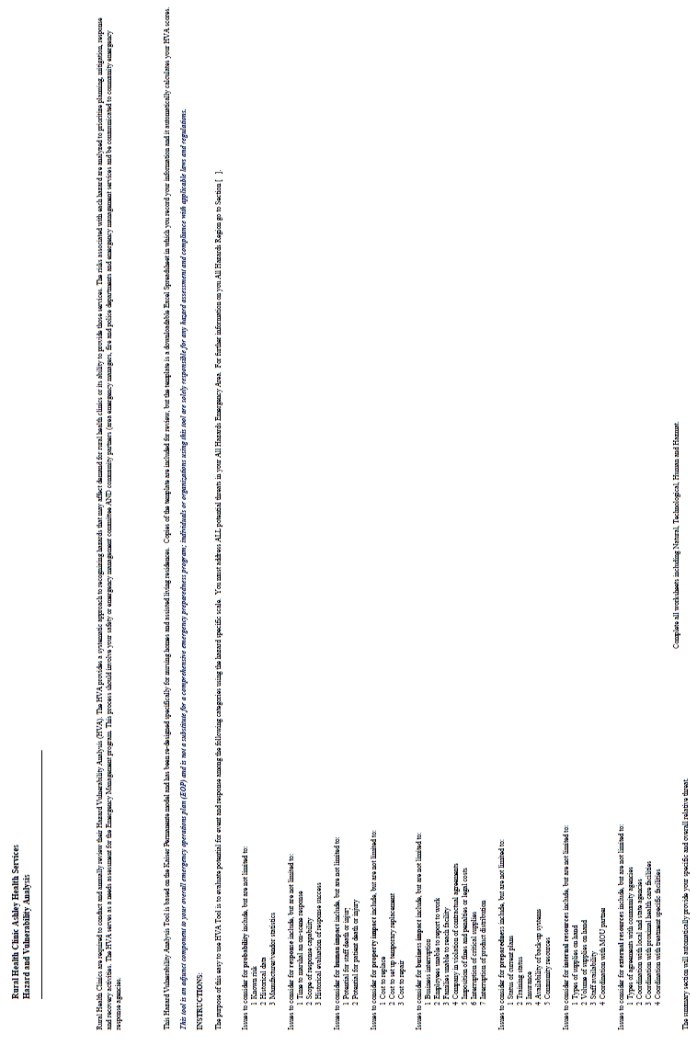

SUBJECT: | HEALTH & FAMILY CLINICS – HAZARD VULNERABILITY ASSESSMENT | FILING #: EMG 12.05
 | HEALTH & FAMILY CLINICS – HAZARD VULNERABILITY ASSESSMENT | PAGE: 2
DEPARTMENT: RURAL HEALTH & FAMILY CLINICS |  | OF: 10
 |  | EFFECTIVE: 04/17/19
APPROVED BY: SAFETY COMMITTEE |  | REVISED:
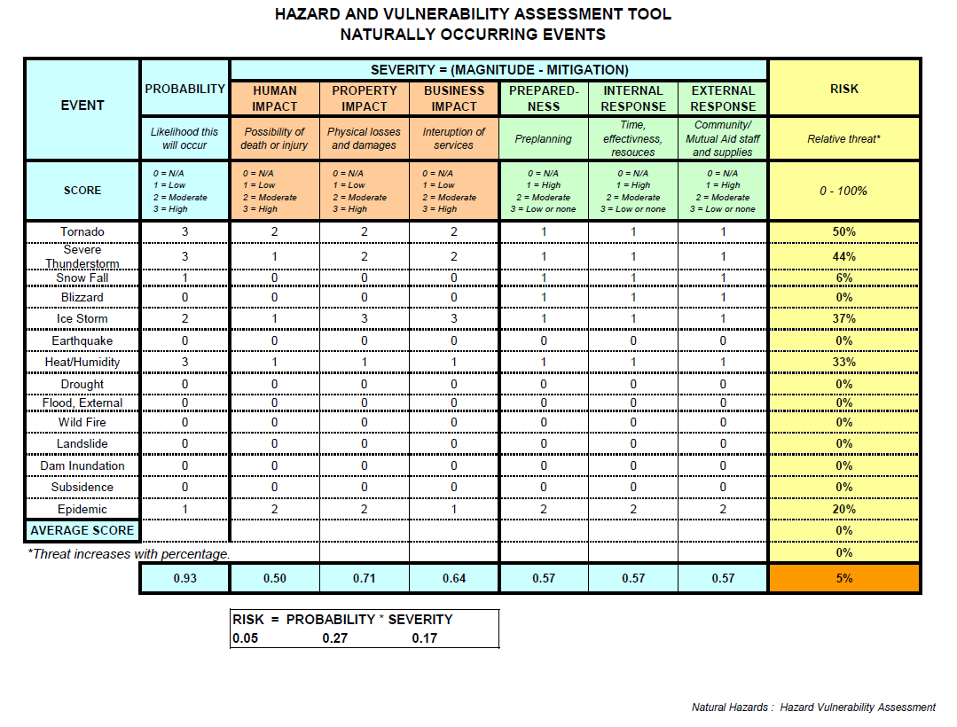

SUBJECT: | HEALTH & FAMILY CLINICS – HAZARD VULNERABILITY ASSESSMENT | FILING #: EMG 12.05
 | HEALTH & FAMILY CLINICS – HAZARD VULNERABILITY ASSESSMENT | PAGE: 3
DEPARTMENT: RURAL HEALTH & FAMILY CLINICS |  | OF: 10
 |  | EFFECTIVE: 04/17/19
APPROVED BY: SAFETY COMMITTEE |  | REVISED:


SUBJECT: | HEALTH & FAMILY CLINICS – HAZARD VULNERABILITY ASSESSMENT | FILING #: EMG 12.05
 | HEALTH & FAMILY CLINICS – HAZARD VULNERABILITY ASSESSMENT | PAGE: 4
DEPARTMENT: RURAL HEALTH & FAMILY CLINICS |  | OF: 10
 |  | EFFECTIVE: 04/17/19
APPROVED BY: SAFETY COMMITTEE |  | REVISED:
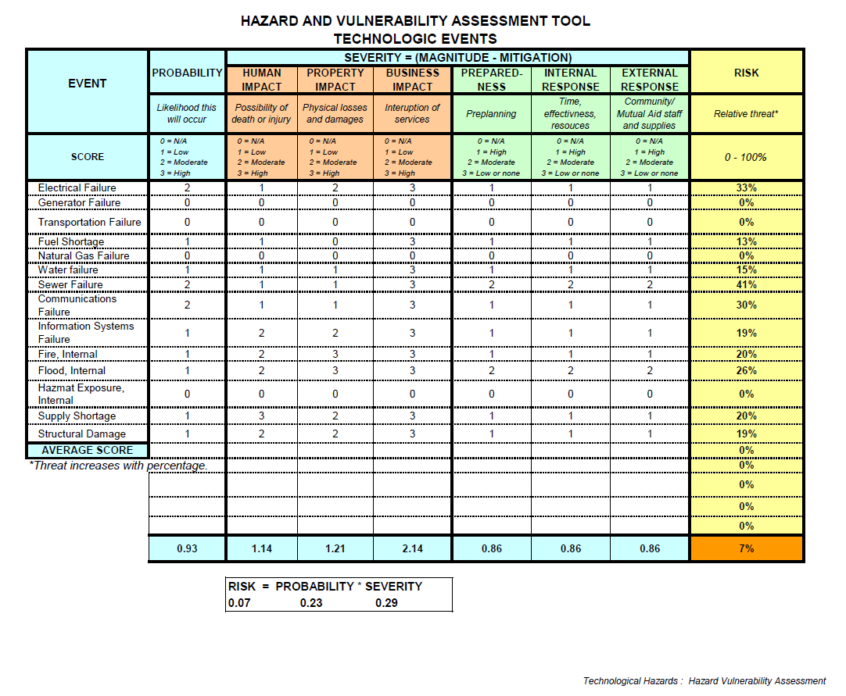

SUBJECT: | HEALTH & FAMILY CLINICS – HAZARD VULNERABILITY ASSESSMENT | FILING #: EMG 12.05
 | HEALTH & FAMILY CLINICS – HAZARD VULNERABILITY ASSESSMENT | PAGE: 5
DEPARTMENT: RURAL HEALTH & FAMILY CLINICS |  | OF: 10
 |  | EFFECTIVE: 04/17/19
APPROVED BY: SAFETY COMMITTEE |  | REVISED:


SUBJECT: | HEALTH & FAMILY CLINICS – HAZARD VULNERABILITY ASSESSMENT | FILING #: EMG 12.05
 | HEALTH & FAMILY CLINICS – HAZARD VULNERABILITY ASSESSMENT | PAGE: 6
DEPARTMENT: RURAL HEALTH & FAMILY CLINICS |  | OF: 10
 |  | EFFECTIVE: 04/17/19
APPROVED BY: SAFETY COMMITTEE |  | REVISED:
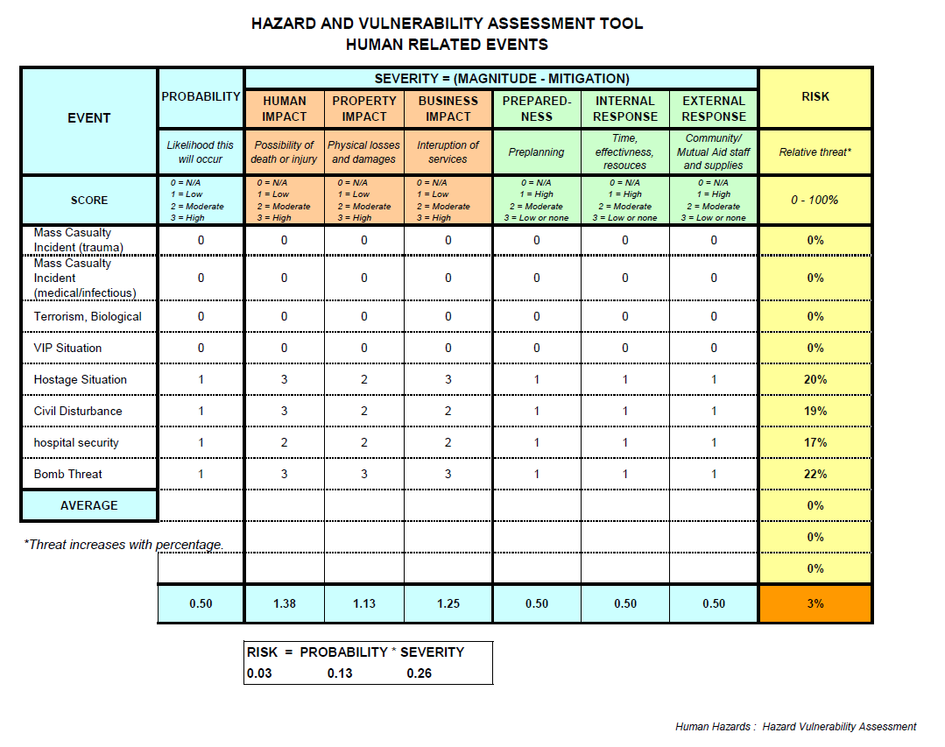

SUBJECT: | HEALTH & FAMILY CLINICS – HAZARD VULNERABILITY ASSESSMENT | FILING #: EMG 12.05
 | HEALTH & FAMILY CLINICS – HAZARD VULNERABILITY ASSESSMENT | PAGE: 7
DEPARTMENT: RURAL HEALTH & FAMILY CLINICS |  | OF: 10
 |  | EFFECTIVE: 04/17/19
APPROVED BY: SAFETY COMMITTEE |  | REVISED:


SUBJECT: | HEALTH & FAMILY CLINICS – HAZARD VULNERABILITY ASSESSMENT | FILING #: EMG 12.05
 | HEALTH & FAMILY CLINICS – HAZARD VULNERABILITY ASSESSMENT | PAGE: 8
DEPARTMENT: RURAL HEALTH & FAMILY CLINICS |  | OF: 10
 |  | EFFECTIVE: 04/17/19
APPROVED BY: SAFETY COMMITTEE |  | REVISED:
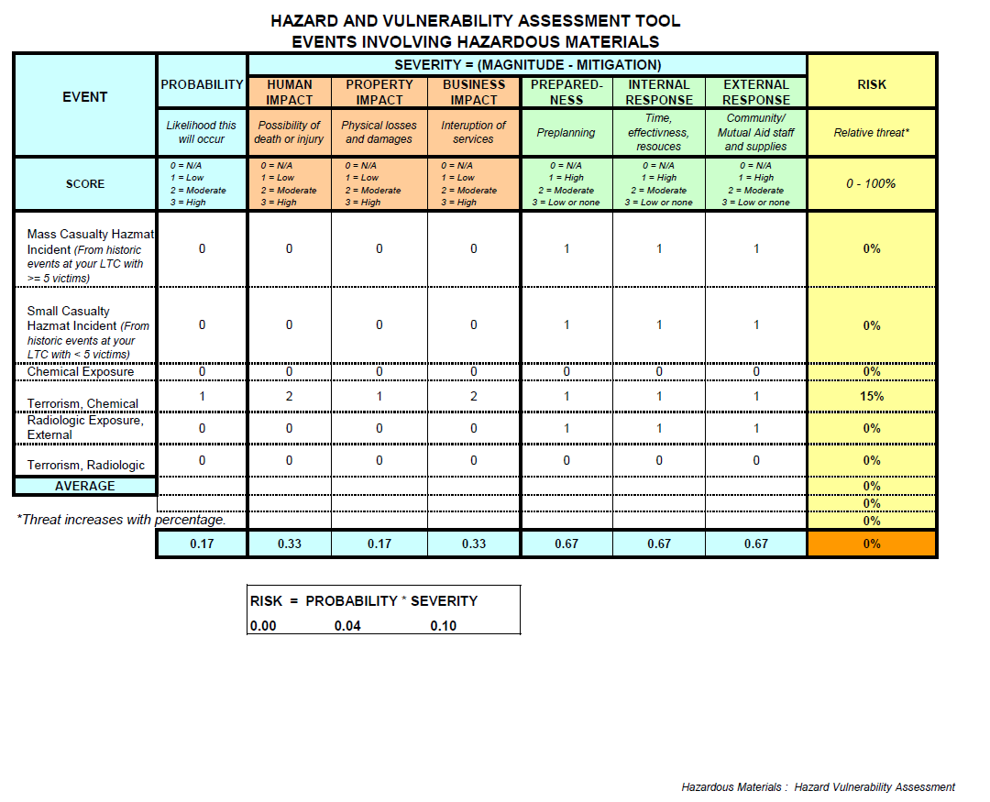

SUBJECT: | HEALTH & FAMILY CLINICS – HAZARD VULNERABILITY ASSESSMENT | FILING #: EMG 12.05
 | HEALTH & FAMILY CLINICS – HAZARD VULNERABILITY ASSESSMENT | PAGE: 9
DEPARTMENT: RURAL HEALTH & FAMILY CLINICS |  | OF: 10
 |  | EFFECTIVE: 04/17/19
APPROVED BY: SAFETY COMMITTEE |  | REVISED:


SUBJECT: | HEALTH & FAMILY CLINICS – HAZARD VULNERABILITY ASSESSMENT | FILING #: EMG 12.05
 | HEALTH & FAMILY CLINICS – HAZARD VULNERABILITY ASSESSMENT | PAGE: 10
DEPARTMENT: RURAL HEALTH & FAMILY CLINICS |  | OF: 10
 |  | EFFECTIVE: 04/17/19
APPROVED BY: SAFETY COMMITTEE |  | REVISED:
